Multi cloud with DevOps and K8S:

How to setup k8s cluster:

There are several ways to set up a Kubernetes cluster, and the choice of method depends on your specific needs, infrastructure, and level of control.

1. Manual Installation:
2. Kubeadm
3. Kops (Kubernetes Operations)
4. Minikube
5. Kind (Kubernetes in Docker)
6. Rancher
7. K3s
8. Managed Kubernetes Services (e.g., EKS, GKE, AKS)
9. Community Kubernetes Distributions
10. Custom Solutions
11. **Manual Installation:**



* You can set up a Kubernetes cluster manually by installing and configuring all the necessary components, including the control plane and worker nodes.
* This method provides maximum control but is the most complex and time-consuming.

1. **Kubeadm:**

* Kubeadm is a tool that simplifies the process of bootstrapping a Kubernetes cluster. It automates the setup of the control plane and worker nodes.
* It is a popular choice for quickly creating Kubernetes clusters for testing and learning.

Kubeadm:

Type: Command-line tool.

Purpose: Kubeadm automates the process of setting up a basic Kubernetes cluster.

Features: Simplifies the bootstrapping of a Kubernetes control plane and worker nodes.

Control Plane Management: Kubeadm is focused on control plane initialization and node bootstrapping.

Use Cases: Ideal for setting up Kubernetes clusters quickly for testing and learning purposes.

Customization: Offers limited cluster customization options and is often used as a starting point for more complex setups

1. **Kops (Kubernetes Operations):**

* Kops is a command-line tool for creating and managing production-ready Kubernetes clusters.
* It is especially useful for cloud-based installations on AWS, GCE, and other cloud providers.

**Kops (Kubernetes Operations):**

**Type**: Command-line tool.

**Purpose**: Kops is primarily used for managing production-ready Kubernetes clusters.

**Features**: It allows you to create, destroy, upgrade, and maintain Kubernetes clusters on various cloud providers.

**Control Plane Management:** Kops handles control plane setup and management.

**Use Cases:** Best suited for deploying and managing Kubernetes clusters in production environments.

**Customization**: Provides more flexibility to customize cluster configurations.

1. **Minikube:**

* Minikube is a tool that sets up a single-node Kubernetes cluster on your local machine. It is primarily used for local development and testing.

1. **Kind (Kubernetes in Docker):**

* Kind is a tool that runs Kubernetes inside Docker containers. It is useful for creating lightweight, multi-node Kubernetes clusters for testing and development.

**Rancher:**

* Rancher is a container management platform that simplifies the deployment and management of Kubernetes clusters. It offers a user-friendly web interface for cluster management.

Rancher:

Type: Web-based container management platform.

Purpose: Rancher simplifies the deployment and management of Kubernetes clusters.

Features: Provides an intuitive web-based interface for managing containerized applications and multiple Kubernetes clusters.

Control Plane Management: Rancher simplifies the management of multiple Kubernetes clusters across different cloud providers.

Use Cases: Suited for organizations that want a user-friendly, centralized management platform for their Kubernetes clusters.

Customization: Offers various customization options through its web interface.

1. **K3s:**

* K3s is a lightweight Kubernetes distribution designed for resource-constrained environments and edge computing.
* It provides an easy way to set up a small-footprint Kubernetes cluster.

Type: Lightweight, certified Kubernetes distribution.

Purpose: K3s is designed for resource-constrained environments and edge computing.

Features: Optimized for performance and resource efficiency while maintaining full Kubernetes compatibility.

Control Plane Management: K3s provides a lightweight control plane and simplified setup.

Use Cases: Ideal for scenarios where you need a Kubernetes cluster with a smaller footprint, such as IoT and edge devices.

Customization: Offers some customization options but is lighter in features compared to full Kubernetes distributions.

1. **Managed Kubernetes Services (e.g., EKS, GKE, AKS):**

* Cloud providers like Amazon Web Services (AWS), Google Cloud Platform (GCP), and Microsoft Azure offer managed Kubernetes services.
* These services take care of the control plane for you, making it easy to set up and manage Kubernetes clusters on their respective cloud platforms.

EKS (Amazon Elastic Kubernetes Service):

Type: Managed Kubernetes service by AWS.

Purpose: EKS simplifies running Kubernetes clusters in the AWS cloud.

Features: AWS manages the control plane, allowing users to focus on applications and worker nodes.

Control Plane Management: AWS handles control plane operations.

Use Cases: Best for those who want a fully managed Kubernetes service on AWS without managing the control plane.

Customization: Offers Kubernetes customization but abstracts many infrastructure details.

1. **Community Kubernetes Distributions:**

* There are various community-driven Kubernetes distributions, each with its own features and target use cases.
* Examples include OpenShift, RKE (Rancher Kubernetes Engine), and more.

1. **Custom Solutions:**

* Some organizations with unique requirements or infrastructure opt to build custom solutions for setting up Kubernetes clusters. This may involve using configuration management tools like Ansible, Terraform, or custom scripts.

What is a DOcker?

Diff b/w VM and Containers?

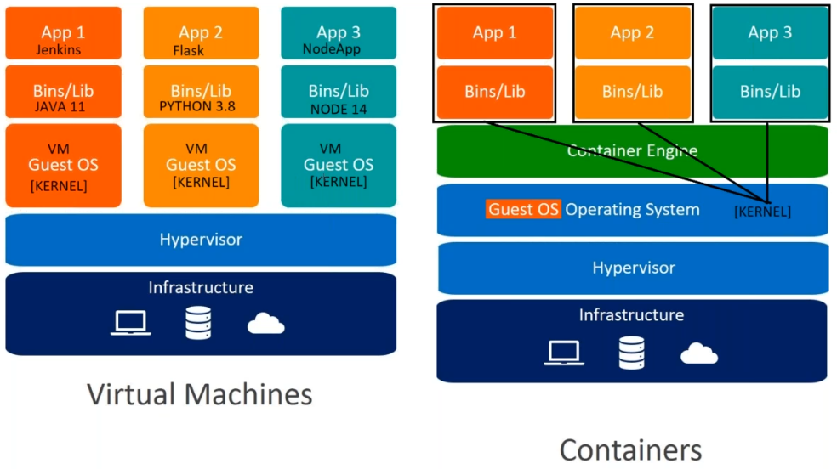

1. Infracture
2. Hypervisior
3. Guest OS (KERNAL)
4. Bins/Lib
5. App

Problem with Developers + Ops Team when used VM’s. so the problem resolved with Containers. It’s a process only.

The word “container” doesn’t mean anything super precise. Basically there are a few new Linux kernel features (“namespaces” and “cgroups”) that let you isolate processes from each other. When you use those features, you call it “containers”.

How to verify process in servers: #ps –ef

Note: Have a one wonder full concept🡪 NS & CGroup

**How to install Docker in Ubunt server?**

Go to browser🡪 get docker.com🡪 it will open one scritp.

Then login to server🡪 #curl <https://get.docker.com/> (enter, you will see the entire script)

Then run that script 🡪 #curl <https://get.docker.com/> | bash (here bash will run the entire script)

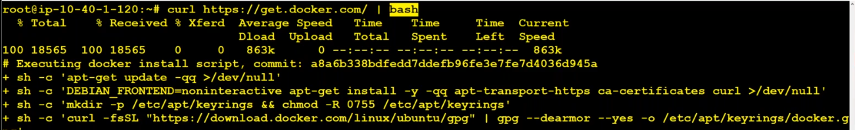

After Installation verify the Docker version: #docker version

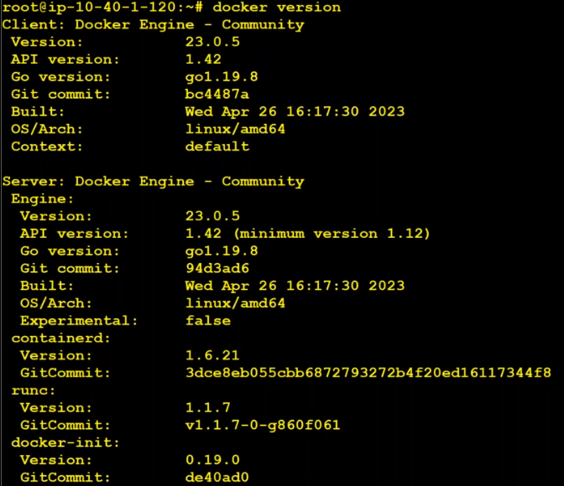

How to verify docker is a process.

#watch –n 1 lsns –t pid ( here it will open process running every one minitue)

For verify 🡪 open duplicate tab🡪 run one docker container

#docker run --rm –d --name mycontainer –p 8080:80 nginx:latest && docker ps

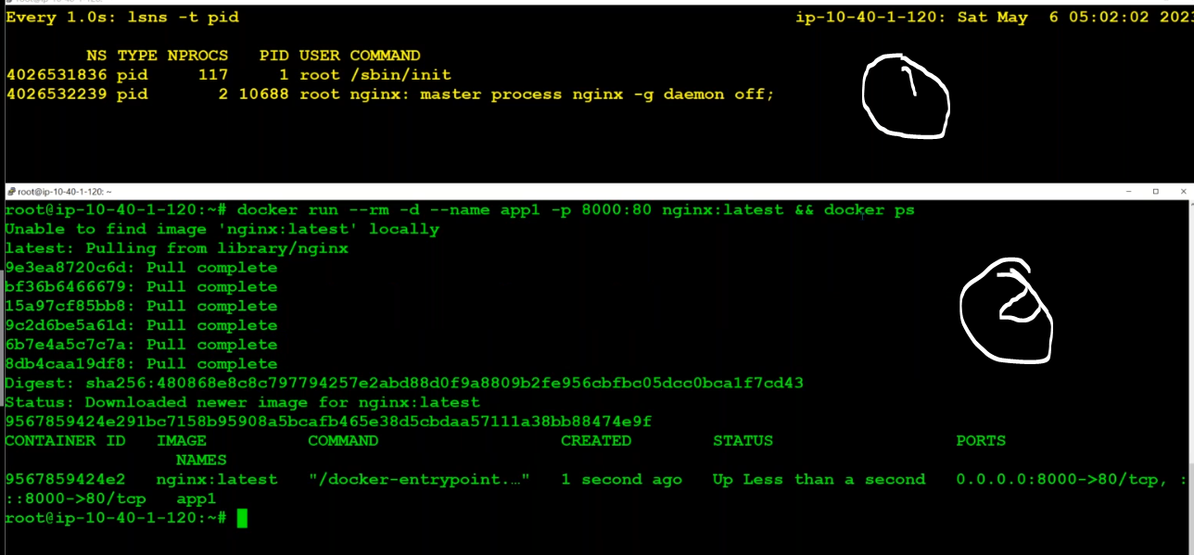

# docker run --rm -d --name myapache -p 8081:80 ubuntu/apache2 && docker ps

Run one more container apache2 image, then observe lsns pid , here it’s created two name spaces.

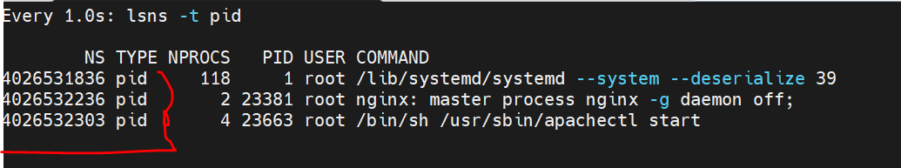

Verify the processers:

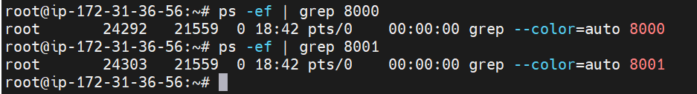

Verify the running PID using netstat comamnd

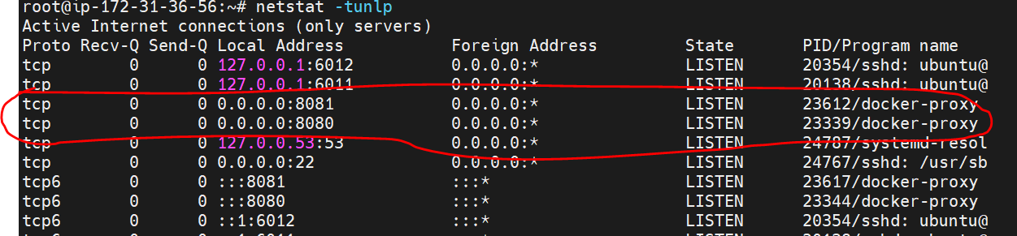

Why Container orchestration introduced?

Ex: have a team with 10 members, but there is no TL, how the team will work. Need one Tl for controlling the team.

Here also have required one lead for controlling the containers, when deploy with multi-

containers.

Difference between Docker swarm and K8S?

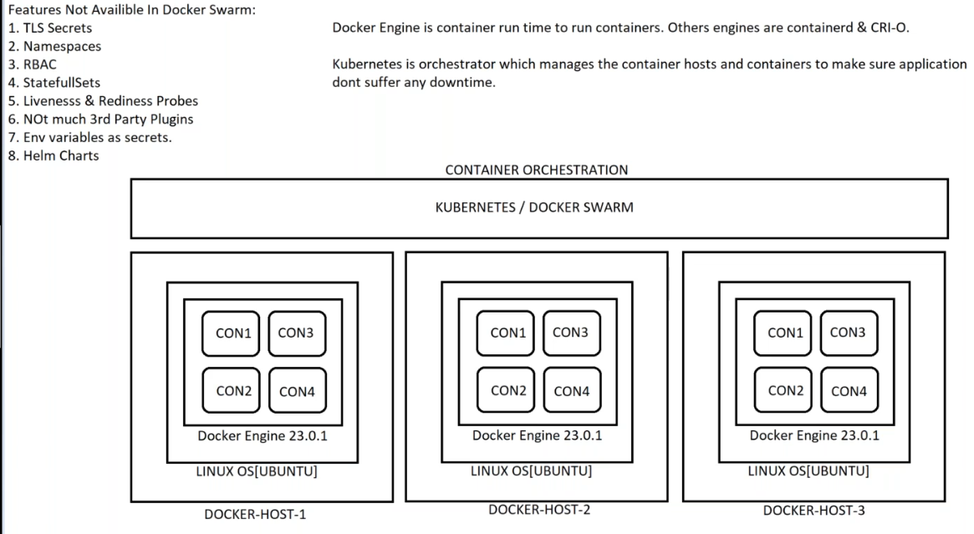

Qns: If container is deleted what about the data?

Actually in container not stored any kind of data, it’s a process only, data stored in another place. If container is deleted , it will recreate and access the data where the data is stored.

K8S cluster types:

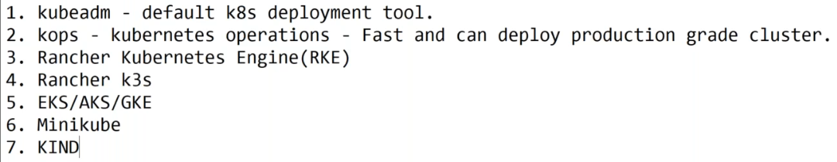

Rancher for On-prime

K3S 🡪 minimum configuration

If We deploy kops k8s cluster, below things are configured. These all are one time activity.

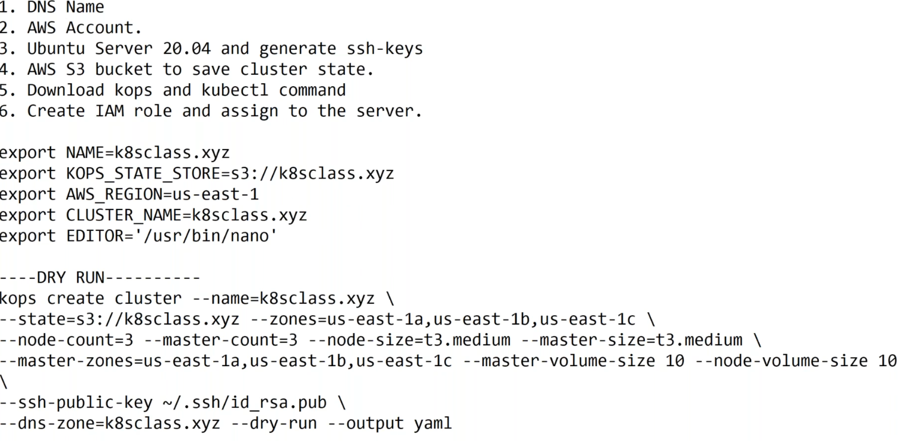

**Step 1: Create Domain and configure with Route53**

1. DNS Name (k8stech.xyz it’s my domain)

How to configure AWS R53 to Go Daddy.

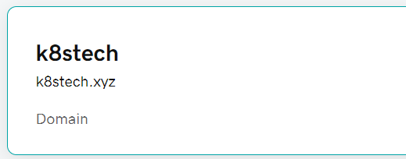

1. go to aws -🡪 R53🡪 create hosted zone🡪copy the NS (Name spaces)

Step 2: login to go daddy🡪 your domain🡪 Name spaces🡪edit🡪 update with your R53 Ns.

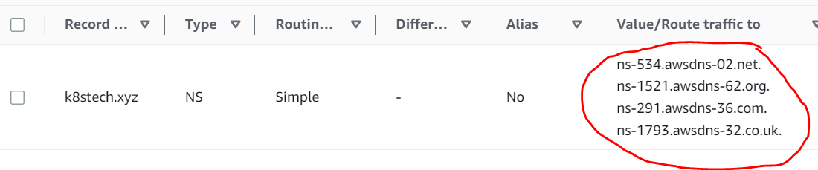

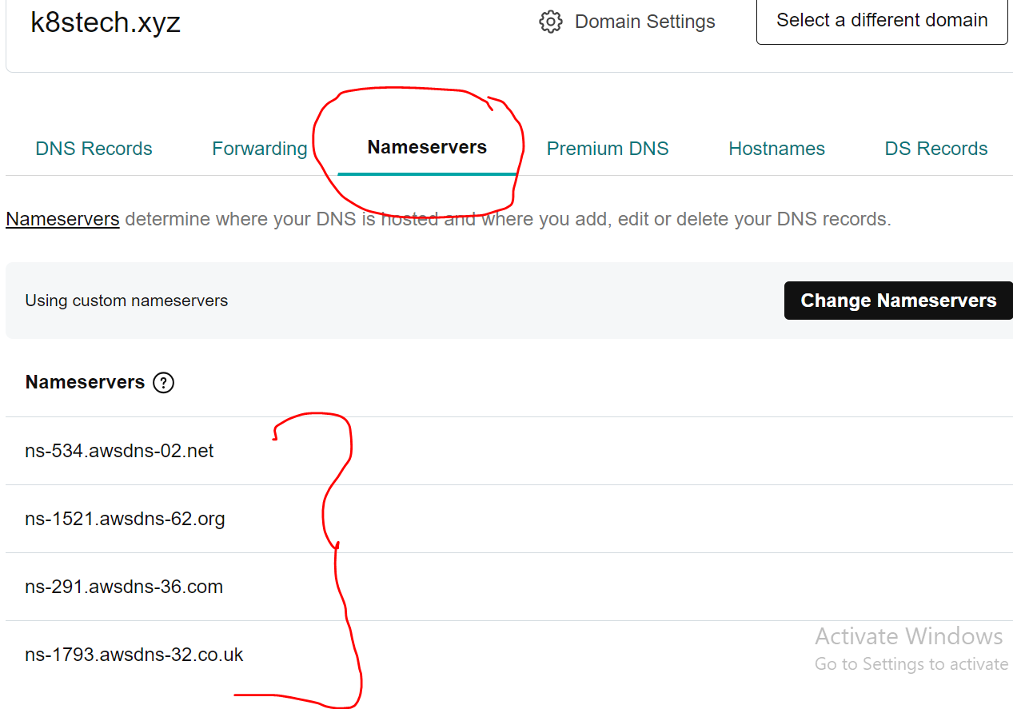

1. Then create record 🡪 with server IP. Then access the application with R53 domain.

How to verify: go to browser then verify and go to browser🡪 google.dig (domain internet Gropper) 🡪 give your domain here then choose “any” option, it will display the backend application server IP.

Note: When you host your application with domain , sometimes it will not reflect immediately, it will take couple minutes time.

**Step 2: No Need to create S3 bucket, just provide the name.**

**Step 3: Create IAM role**

Create IAM Role and assign admin permissions ( it you want create cluster required admin permissions )

Go to IAM 🡪 roles🡪 create role🡪 choose AWS Service 🡪 choose use cases (EC2) 🡪 click next 🡪 choose the Administrator permission🡪 next🡪 give the role name🡪then create the role.

**Step 4: Assign role to server**

Note: will use default as of now, in Real time need to create a custom VPC.

Launch Ubunt server with 20.04 and assign the role (what we have to created and generate the SSh-Key) and assign the role.

How to assign the role to Ubuntu server?

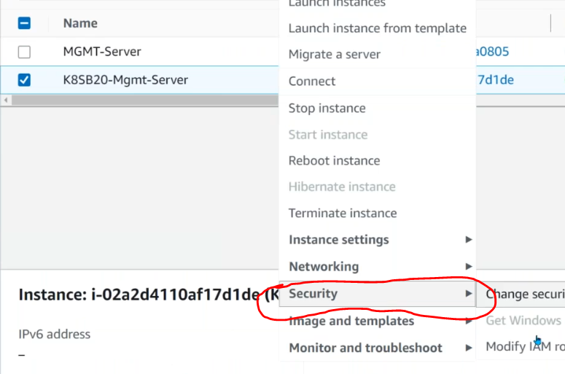

**Then generate SSH-Keys:** these keys will be used by the k8s nodes.

How to generat the keys:

$ssh-keygen

Note: kops will send this key to all servers in the cluster.

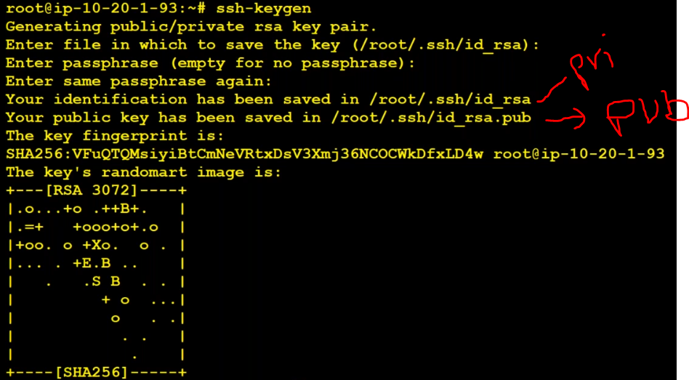

Step 5: Download Kops and kubectl to /usr/local/bin

#cd /usr/local/bin

Go to browser🡪 search with “kops github” 🡪 choose releases🡪 copt link Linux 64 bit

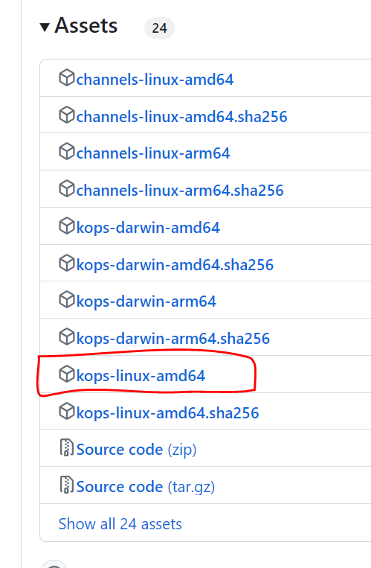

#wget <https://github.com/kubernetes/kops/releases/download/v1.28.0/kops-linux-amd64>

Then login to server 🡪 # switch the directory to /usr/local/bin

Then execute command: #wget <url>



Then verify : ls –l

Don’t’ have a read/write permissions, give the permissions

#chmod 700 <file-name>

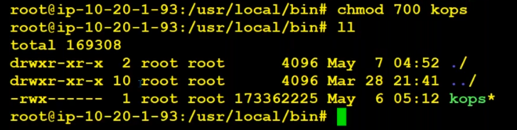

Note: kops is for create the cluster and update the cluster.

But if we need to run any operation’s inside the cluster need to install kubectl ( interface channel)

How to Download and Install kubectl in server:

Go to browser🡪 kubectl download🡪 open kubernetes official website🡪 copy below command.

URL: [Install and Set Up kubectl on Linux | Kubernetes](https://kubernetes.io/docs/tasks/tools/install-kubectl-linux/)

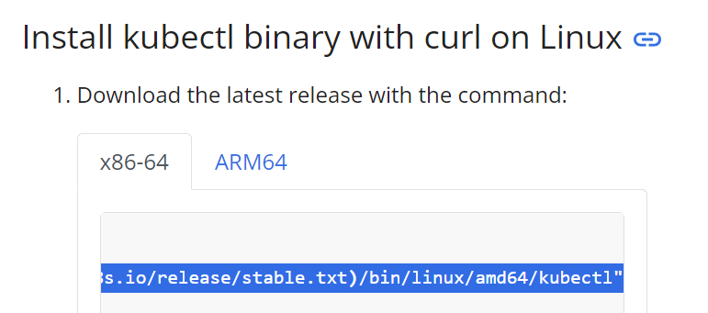

Run the below command in /usr/local/bin directory.

curl -LO [https://dl.k8s.io/release/**$(**curl -L -s https://dl.k8s.io/release/stable.txt**)**/bin/linux/amd64/kubectl](https://dl.k8s.io/release/$(curl%20-L%20-s%20https://dl.k8s.io/release/stable.txt)/bin/linux/amd64/kubectl)

curl -LO [https://dl.k8s.io/release/**$(**curl -L -s https://dl.k8s.io/release/stable.txt**)**/bin/linux/amd64/kubectl.sha256](https://dl.k8s.io/release/$(curl%20-L%20-s%20https://dl.k8s.io/release/stable.txt)/bin/linux/amd64/kubectl.sha256)

curl -LO [https://dl.k8s.io/release/**$(**curl -L -s https://dl.k8s.io/release/stable.txt**)**/bin/linux/amd64/kubectl.sha256](https://dl.k8s.io/release/$(curl%20-L%20-s%20https://dl.k8s.io/release/stable.txt)/bin/linux/amd64/kubectl.sha256)

chmod +x kubectl

kubectl version --client



After Installation, verify kubectl installed or not?

#kubectl version

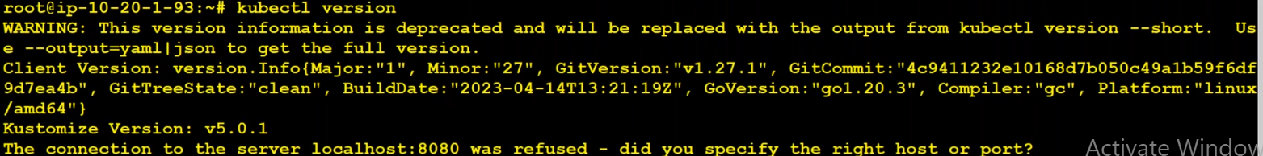

**Step 6: Edit .bashrc for environment variables:**

Go to root directory for .bashrc file

# cd /root (here will find .bashrc file)

#ls –la

Then edit the file with vi/nano editor

export NAME=sumi.buzz

export KOPS_STATE_STORE=s3://sumi.buzz

export AWS_REGION=ap-south-1

export CLUSTER_NAME=sumi.buzz

export EDITOR='/usr/bin/nano'

#export K8S_VERSION=1.6.4

alias k=kubectl

Then #source .bashrc

Then verify: #env (here it will display all the given export details)

**Step 7: create a cluster using kops and generate cluster file:**

**Note: If we make a cluster, need manifest file with all the details, so that will run Dry run command.**

**NOTE: should have k8stech.xyz domain in R53**

Final script , it’s working:

NOTE: execute the script in /root

Before execute the script must crate the s3 bucket with given name.

#kops create cluster --name=sumi.buzz \

--state=s3://kopssumi.buzz --zones=us-east-1 \

--node-count=3 --master-count=1 --node-size=t2.small --master-size=t2.medium \

--master-zones=us-east-1a --master-volume-size 10 --node-volume-size 10 \

--ssh-public-key ~/.ssh/id_rsa.pub \

--dns-zone=sumi.buzz --dry-run --output yaml > cluster.yaml

Use this one:

kops create cluster --name=sumi.buzz \

--state=s3://kopssumi.buzz --zones=ap-south-1a \

--node-count=3 --master-count=1 --node-size=t2.small --master-size=t2.medium \

--master-zones=ap-south-1a --master-volume-size 10 --node-volume-size 10 \

--ssh-public-key ~/.ssh/id_rsa.pub \

--dns-zone=sumi.buzz --dry-run --output yaml

#! /bin/bash

kops create cluster --name=k8stech.xyz \

--state=s3://k8stech.xyz --zones=ap-south-1a \

--node-count=3 --master-count=1 --node-size=t2.small --master-size=t2.medium \

--master-zones=ap-south-1a --master-volume-size 10 --node-volume-size 10 \

--ssh-public-key ~/.ssh/id_rsa.pub \

--dns-zone=k8stech.xyz --yes --dry-run --output yaml > cluster.yaml

NOTE: If delete kube/config file run below command

kops update cluster k8stech.xyz --yes --state=s3://k8stech.xyz --yes

**Step 8: create a cluster use below comand**

**#kops create -f cluster.yaml**

**NOTE: If you face below issues run given comamnd**

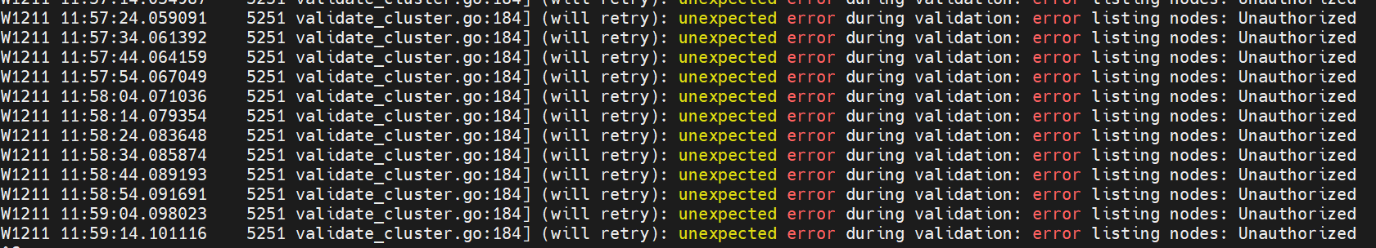

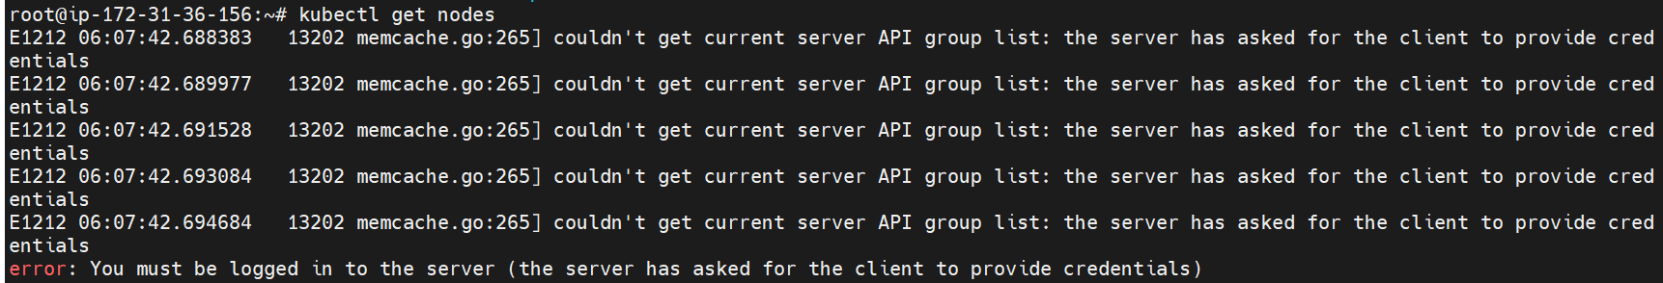

**#kops export kubecfg --admin**

**(It will resolve)**

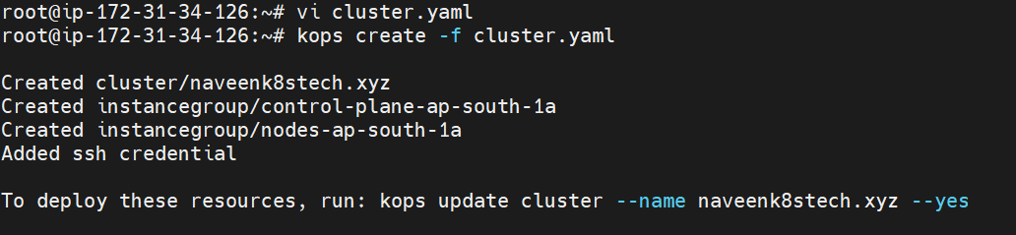

Step 9: Execute kops update run command (above command)

**# kops update cluster --name k8stech.xyz --yes**

NOTE: after execute this below command wait for some time, cluster will be ready.

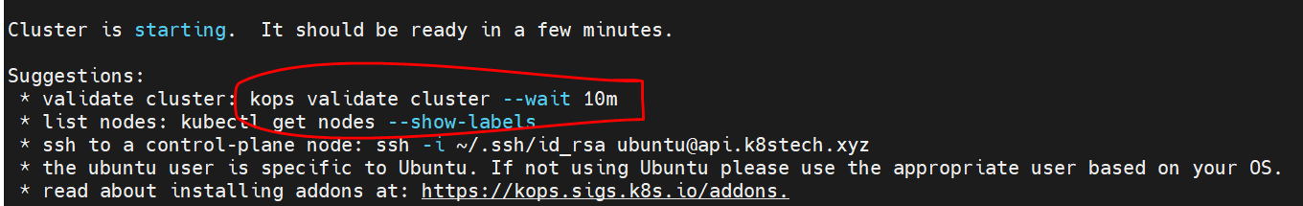

**#kops validate cluster --wait 10m**

**#ssh to a control-plane node: ssh -i ~/.ssh/id_rsa ubuntu@api.k8stech.xyz**

NOTE: it will start the cluster setup.

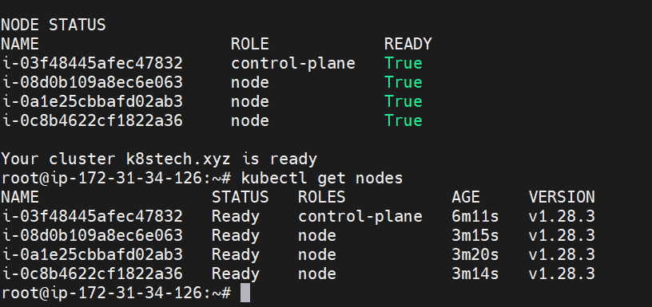

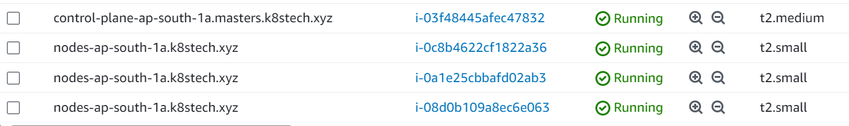

Verify S3 bucket, all the configuration files stored in s3 bucket.

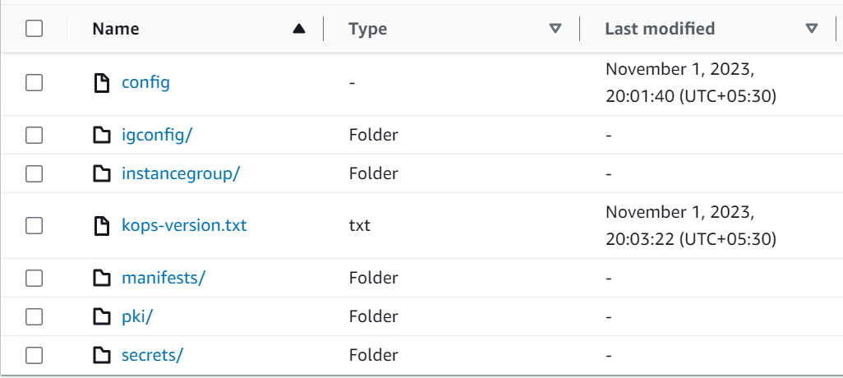

NOTE: if we want delete cluster use below command:

#kops delete -f cluster.yaml --yes

Verify kubectl and k8s cluster version:

#kubectl version

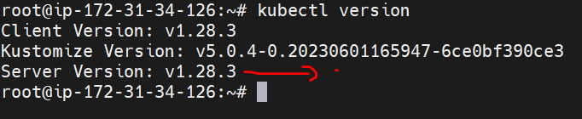

Verify in R53, it will created records with control plane nodes.

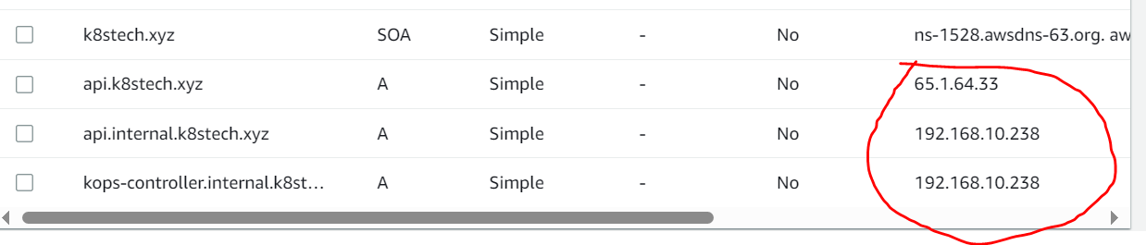

**Kubectl bash completion:**

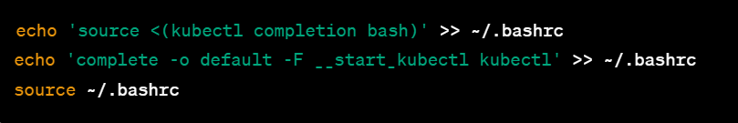

echo 'source <(kubectl completion bash)' >>~/.bashrc

echo 'complete -o default -F __start_kubectl ku' >>~/.bashrc

Then execute exit command, after execute above commands.

#exit

Then switch into root user 🡪 #sudo –i

Then verify with # ku cluster-info ( it will get pop-up commnds)

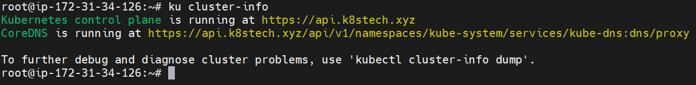

**SMOKE TESTING:**

Smoke testing is a type of software testing that is conducted to check the basic functionality of a software application. The primary purpose of smoke testing is to ensure that the software build is stable enough for more comprehensive testing. It is typically performed early in the software development lifecycle or after a new build of the software is created.

**Cluster Smoke Testing:**

kubectl version --short

kubectl get nodes

kubectl get nodes --no-headers

kubectl cluster-info

kubectl cluster-info dump

kubectl get ns

kubectl config set-context --current --namespace=default

kubectl get pods

kubectl get pods -n kube-system

ku describe pod kube-apiserver-ip-172-20-114-198.ec2.internal -n kube-system

ku logs kube-apiserver-ip-172-20-114-198.ec2.internal -c kube-apiserver -n kube-system

kubectl get service -A

kubectl run pod01 --image=image

kubectl expose pod pod01 --port=8000 --target-port=80 --type=NodePort

kubectl get pods -o wide

kubectl get pods -o wide --no-headers

kubectl create deployment deploy01 --image=sreeharshav/rollingupdate:v5 --dry-run -o yaml

kubectl create deployment deploy01 --image=sreeharshav/rollingupdate:v5 --replicas 3

kubectl scale deployment deploy01 --replicas=6

ku cordon ip-172-20-103-135.ec2.internal

ku drain ip-172-20-103-135.ec2.internal

ku drain ip-172-20-38-30.ec2.internal

ku uncordon ip-172-20-103-135.ec2.internal

ku uncordon ip-172-20-38-30.ec2.internal

Delete a master server and run the kubectl get nodes to check the connectivity and KOPS will deploy a new cluster.

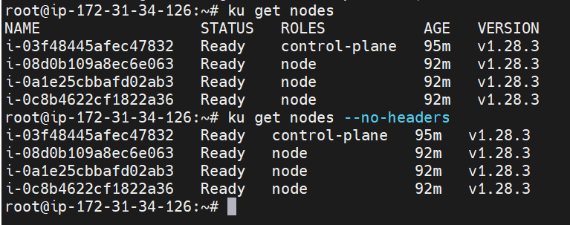

#ku get nodes

#ku get nodes –no-headers

#ku get ns OR #ku get namespaces

#ku get pods –n kube-system

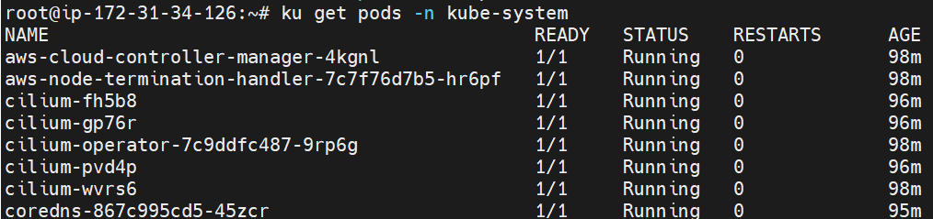

#ku get pods –n kube-system –o wide | grep –I api

# ku get pods –n kube-system –o wide | grep –I sch

#ku get pods –n kube-system –o wide | grep –I etcd

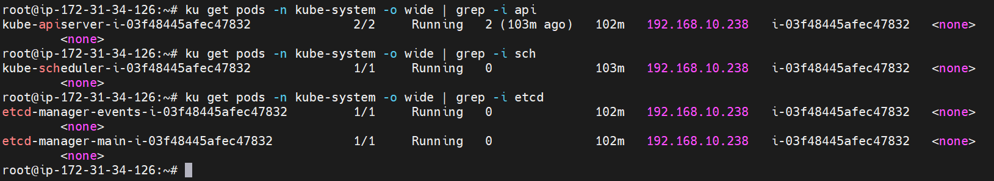

How to get all kube-system pods at a single command:

#ku get pods –n kube-system –o wide | grep –E ‘etcd|sch|api’

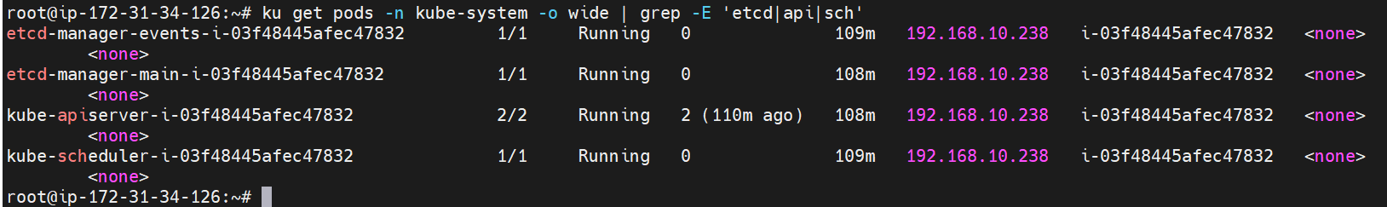

Pod Creation:

1. Imperative
2. Declarative

#kubectl run mypod –image nginx:latest

How will get declarative manifest file from Imperative command:

#ku run mypod –image nginx:latest –dry-run –o yaml

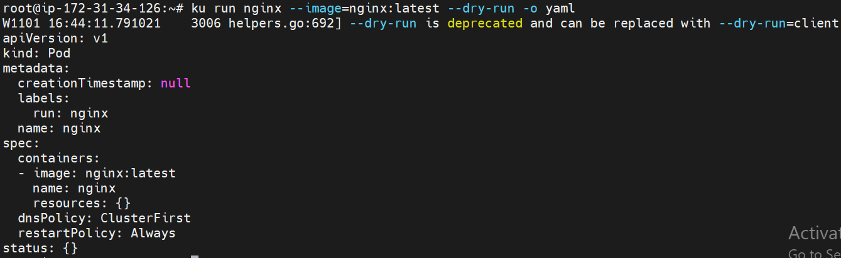

How to expose the pods outside of the cluster: to make a service

How to create a service:

1. Declarative

# ku expose pod <podname> --port 80 –target-port 80 –type <service-type>

#ku expose pod mypod –port 80 –target-port 80 –type NodePort

1. Imperative:

# ku expose pod mypod --port 80 --target-port 80 --name=my-service-np --type NodePort -o yaml --dry-run

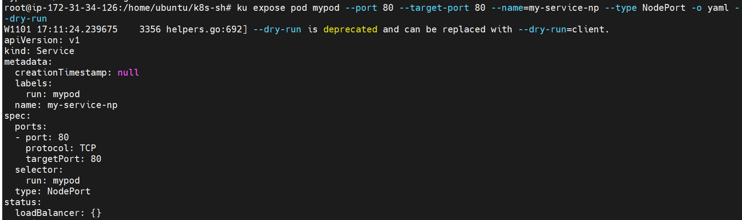

How to apply this manifest to create a service

# echo ‘apiVersion: v1

kind: Service

metadata:

labels:

run: mypod

name: my-service-np

spec:

ports:

- port: 80

protocol: TCP

targetPort: 80

selector:

run: mypod

type: NodePort’ | ku apply –f –

It will create a service, after create verify: #ku get svc

How to know that service is create to particular pod only?

Describe service: #ku descrive svc <serice-name>

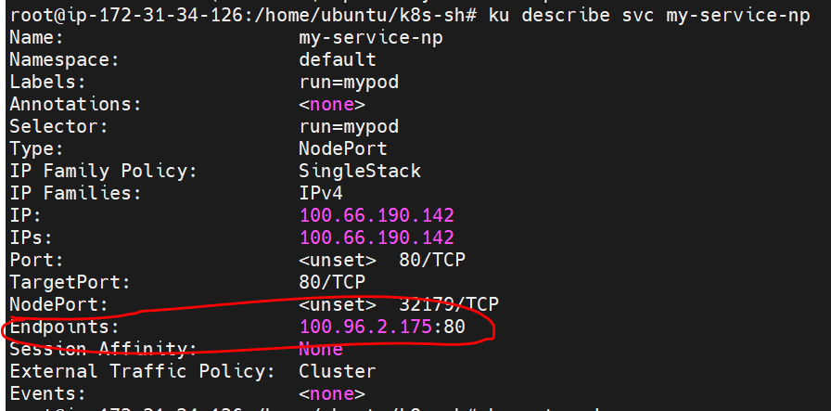

Then get pod details:

# ku get pods -o wide | grep -i mypod



Both Ip’s are same node.

How to access outside from the cluster:

Need to expose PORT in SG:

NOTE: once verify the Master node SG and Worker node SG, both are different.

Go to node sg🡪 expose port, then will go to browser verify with PublicDNS

How to delete all pods: #ku delete pod –all

**Deployment:**

Why we use deployment In place of pod creation?

Deployment creation: #ku create deployment

#ku create deployment naveen-dep --image nginx:latest --replicas 3

Verify: #ku get deployment

# ku get pods

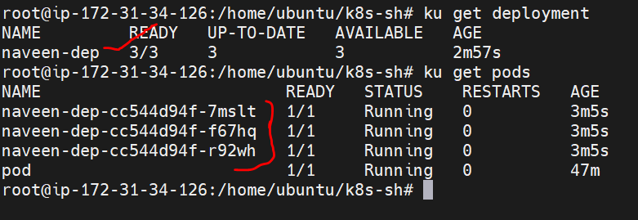

How to scale the replicas:

#ku scale deployment <deployment-name> --replicas <count>

#ku scale deployment navee-app –replicas 6

NOTE: If I delete any worker node, who will take care of recreate the node?

kops controller will create a new node immediately for high availability.

#ku get pods –n kube-system

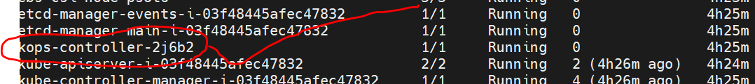

How to get all deployments: #ku get deployments.apps

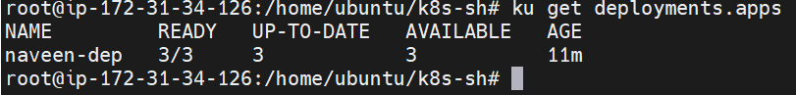

How to get all services like pods, svc, depl etc.. in k8s cluster:

#ku get all

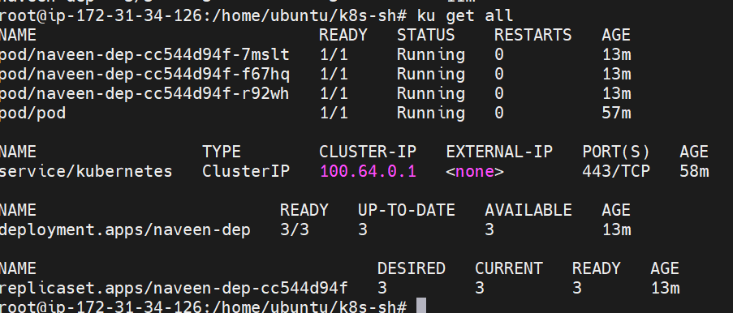

Here will see all created services.

Verbose:

A higher verbosity level will provide more detailed information and debugging output, which can be useful for troubleshooting or gaining more insights into what kubectl is doing.

#kubectl get pods --v=6,7,8,9

This command would run kubectl get pods with a verbosity level of 3, which would provide more detailed information about the operation

Note: will use 6-9 levels.

**K3S cluster Setup:**

A K3s cluster is a Kubernetes cluster that is created and managed using K3s, a lightweight and certified Kubernetes distribution. K3s is designed to be easy to set up and manage, making it well-suited for resource-constrained environments, edge computing, and other scenarios where simplicity and efficiency are essential.

1. Launch EC2 server (#sudo apt-get update)
2. Install Docker

Curl <https://get.docker.com> | bash

Verify the Docker commands

1. Install k3s cluster (before Install verify with #kubectl get nodes)  
   curl -sfL https://get.k3s.io | sh –

Verify: #kubectl get nodes /#watch kubectl get nodes

https://get.k3s.io: This is the URL from which the installation script for K3s is downloaded. The script is typically a shell script that sets up and installs K3s.

cat /var/lib/rancher/k3s/server/token

How to verify how many resources are available in k8s:

#ku api-resources

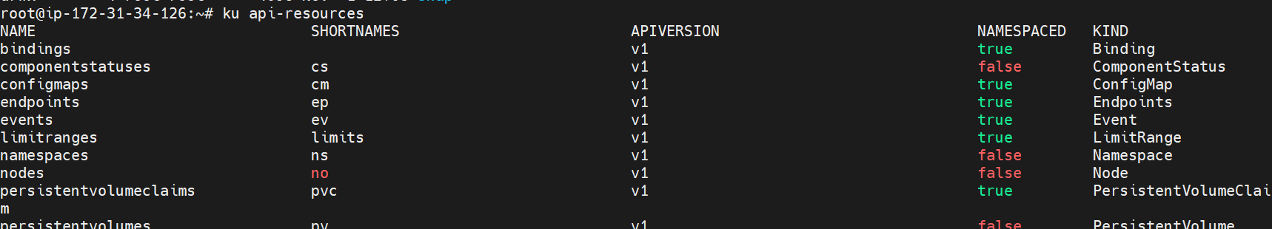

How to know NS resources:

# ku api-resources --namespaced=true

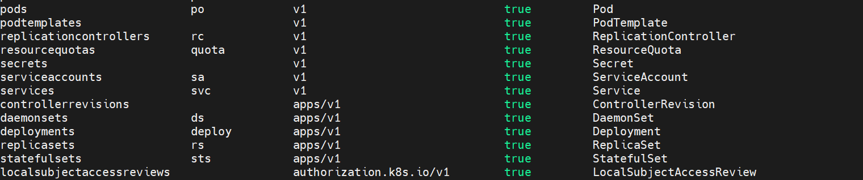

Note: when your write a Manifest file that time it is use full for the apiVersion.

How to know how many fields will use for pod creation:

# ku explain pod

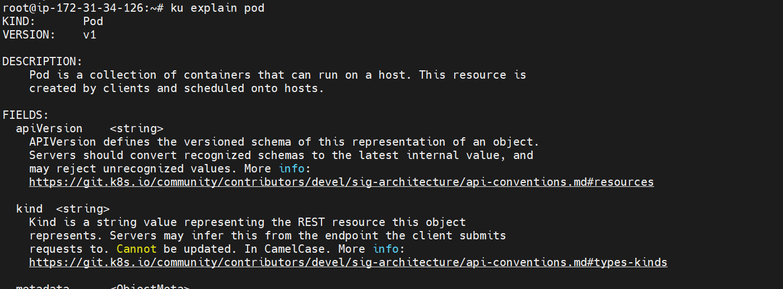

How to know what fields will use under spec:

# ku explain pod.spec

# ku explain pod.spec.volumes

# ku explain deploy.kind

How to create a custom NS:

#kubectl create ns my-ns

How to run a pod in my custom ns:

#ku run my-pod –n my-ns –image=nginx

#ku get pods -n my-ns

NOTE: when we execute default get pods it will not display the alpha ns pods. When we execute below command it will display alpha pods also default.

# kubectl config set-context --current --namespace=my-ns

Then verify with #ku get pods ( it will display all the pods)

**Kubens:**

kubens is not a built-in Kubernetes command, but it's a handy utility provided by the open-source tool called kubectx and kubens. These tools make it easier to switch between Kubernetes clusters and namespaces in your Kubeconfig.

**kubectx:** This tool allows you to quickly switch between different Kubernetes clusters configured in your Kubeconfig file. It lists the available clusters and allows you to set the current context to the desired cluster.

**kubens:** This tool simplifies switching between namespaces within the currently configured cluster. It lists the available namespaces and allows you to switch the context to the desired namespace.

These tools are not part of the official Kubernetes distribution but are popular among Kubernetes users for making context and namespace management more convenient.

To use kubectx and kubens, you need to install them on your system, and they work in conjunction with the kubectl command. You can find them on GitHub and install them based on your operating system:

GitHub repository for **kubectx** and **kubens**: <https://github.com/ahmetb/kubectx>

How to download: user above git hub link and download linux 64 bit.

Then untar the zip file

#tar xvzf <tarfile>

Then remove the tar file and Licence file.

#rm –rf tar-file licence

#kubens (here it will show all the ns)

#kubens default

#kubens my-ns

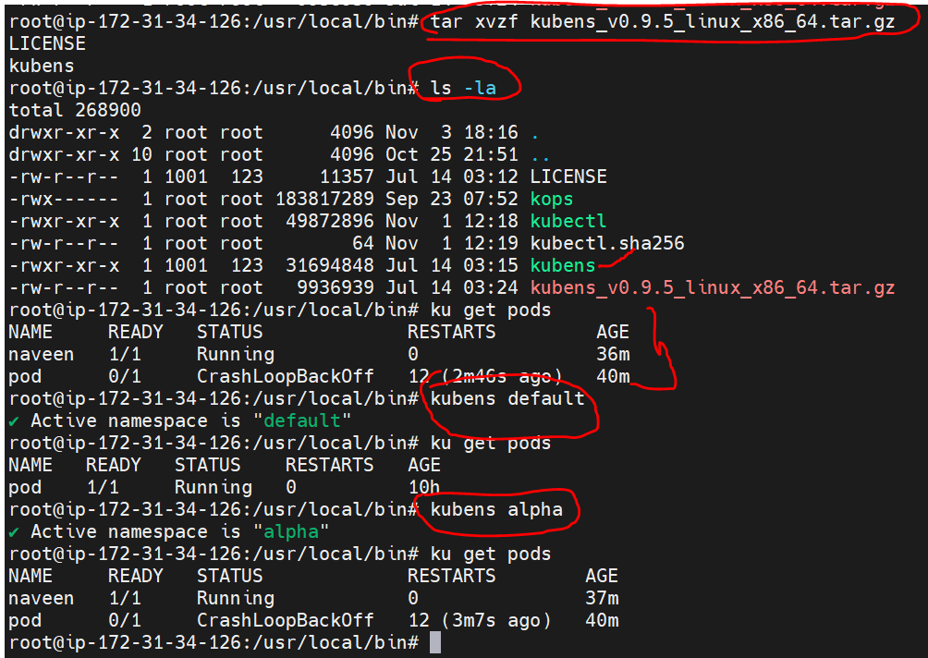

Will observe above dig for changing the NS.

**Port forwarding:**

In Kubernetes, port forwarding is a mechanism that allows you to access a specific port on a container within a pod running in your cluster, directly from your local machine. Port forwarding is commonly used for debugging, testing, or gaining access to services running in a Kubernetes pod without exposing them to the wider network.

#kubectl port-forward <pod-name> <local-port>:<remote-port>

#kubectl port-forward my-pod 8080:80

NOTE: using this with out creating a service, will verify the application.

QNS: When you have created a service for pod, when we describe the service it will give pod ip as well.

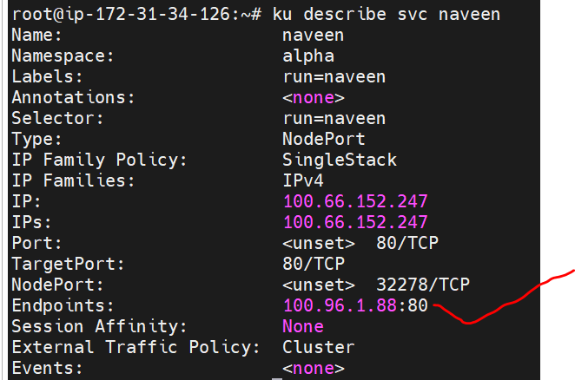

When we are deleting the pod the Endpoints will shows none. (interview qns)

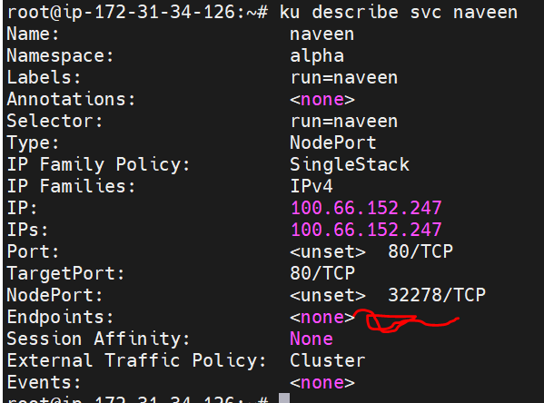

In the above , service is availabel but pod is not existed. That is the reason application will not access.

Qns: If we have a two images with same like nginx, if you try to create a pod what will be happen.

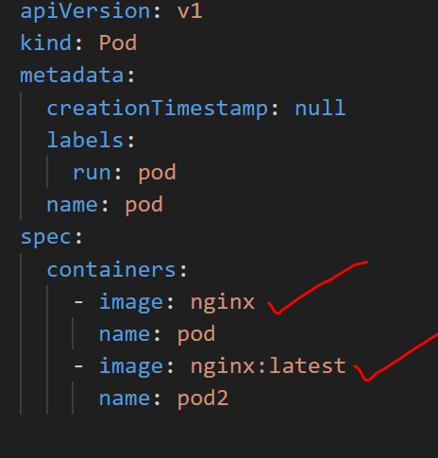

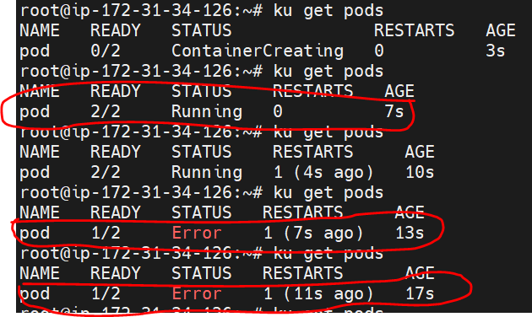

For verify: #ku describe pod pod1



The "CrashLoopBackOff" state in a Kubernetes pod indicates that the container(s) within the pod are repeatedly crashing immediately after starting. This is a common issue that can occur for various reasons. To troubleshoot and resolve this issue, you can follow these steps:

1. **Check Pod Logs:**

Use the kubectl logs command to view the logs of the pod's container. This can provide valuable information about what is causing the container to crash.

Example: kubectl logs <pod-name>

1. **Examine Events:**

Use the kubectl describe command to inspect the events related to the pod. This can provide additional details about why the pod is failing.

Example: kubectl describe pod <pod-name>

1. **Review Container Configuration:**

Double-check the container configuration in the pod's YAML file. Ensure that the image, command, and resources (CPU and memory limits) are correctly specified.

Look for issues such as incorrect image names, missing required environment variables, or invalid command instructions.

1. **Check Resource Constraints:**

Ensure that the pod's resource requests and limits are appropriately set. If a container exceeds its resource limits, it may be terminated.

Look for issues like exceeding memory or CPU limits.

1. **Look for Dependencies:**

If your container depends on other services or resources, ensure that those dependencies are available and correctly configured.

Verify that network and storage resources are accessible.

1. Check Persistent Storage:

If your application relies on persistent storage, verify that the volume mounts and storage classes are correctly configured. Issues with storage can cause containers to crash.

1. **Check Application Code:**

If you are running custom application code, check for errors in your code that may be causing the container to crash. Application-level issues like unhandled exceptions can lead to crashes.

1. **Upgrade or Rollback Image:**

It's possible that the image being used is flawed or contains bugs. Try upgrading to a more recent version of the image or rolling back to a known working version.

Qns: can we create two sevices for one pod?

Yes we create with two different ports.

Logs verify two services logs at a time:

#ku logs service1 –c service2 –f (open browser and access the app, will see the logs)

The kubectl logs command with the **--previous** flag allows you to retrieve logs from a previous container instance in a pod that had multiple restarts. This can be helpful for diagnosing issues or reviewing historical logs. The -c flag is used to specify the container within the pod.

Here's the syntax for using kubectl logs with the --previous flag

#kubectl logs <pod-name> -c <container-name> --previous

How to delete all pods and svc: #ku delete pods,svc –all

Qns: IN the real time we are not creating single pods, we will deploy pods with replicas.

**What is Sidecar containers:**

* In Kubernetes, a sidecar container is a design pattern where an additional container is deployed alongside the main application container within the same pod.
* These sidecar containers are tightly coupled with the main container and provide auxiliary functionalities, such as logging, monitoring, or data processing, to enhance or support the primary application.

Key characteristics of sidecar containers in Kubernetes:

**Co-location:** Sidecar containers run within the same pod as the main application container. They share the same network namespace, which means they can communicate with each other through localhost, and they can access the same volumes.

**Separate Responsibilities:** The main application container is responsible for the core functionality of the pod, while the sidecar container handles specific additional tasks. This separation of responsibilities allows you to isolate concerns and make each container's role distinct.

**Parallel Execution:** Sidecar containers run in parallel with the main application container. This means they can be started, stopped, and restarted independently.

**Use Cases:**

**Logging:** A sidecar container can collect, format, and forward logs to a centralized logging system, freeing the main application from handling log-related tasks.

**Monitoring:** Sidecar containers can collect metrics, trace data, and other monitoring information and send it to monitoring systems.

**Security:** Security-related tasks, such as certificate renewal or authentication, can be handled by a sidecar container.

**Data Processing:** You can have a sidecar container responsible for data transformations, encoding, or decoding as part of an ETL process.

**Proxying:** A sidecar container can act as a proxy to intercept, inspect, or manipulate network traffic to and from the main application container.

**Sharing Resources:** Sidecar containers can share storage volumes and networking resources with the main container. This allows for efficient data exchange and communication.

**Replicaset:** If we change anything in manifest file, replicaset will not update the configuration. So that will delete the pod and willrecreate.

Pods are not update automatically, when we are changed the configuration file. Need to delete each one pod and recreate the pods.so that no one can use replicaset.

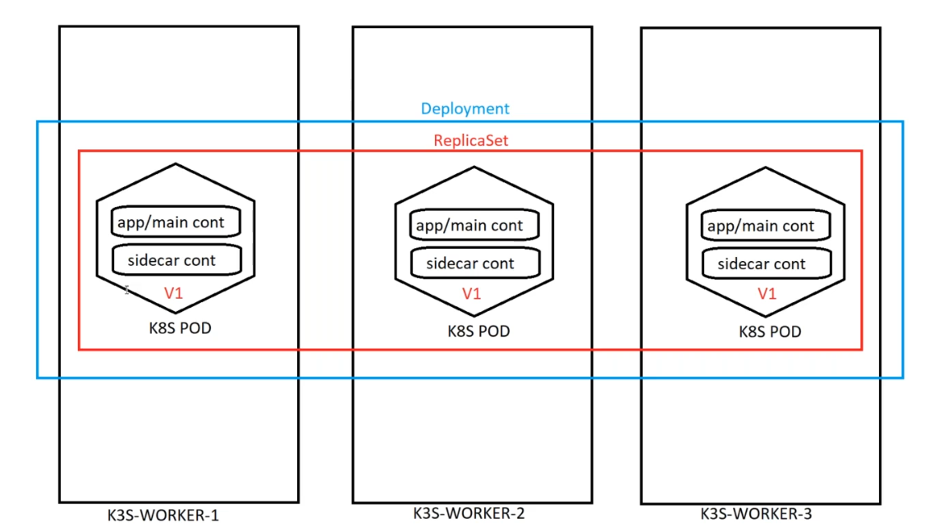

Everyone using Deployment, when we created the deployment replicaset also will create.

Create deploy: # ku create deploy mydeploy --image nginx:latest --replicas 3 -o yaml

Verify: #ku get pods

#ku get deploy

Then edit the deploy for testing see the diff between replicaset and deploy.

#ku edit deploy <deploy-name>

Then change the image 🡪 like nginx to any one new image (ashokit/javawebapp)

Then verify: #ku get pods ( here observe previous pods all deleted and created new pods check with pod name)

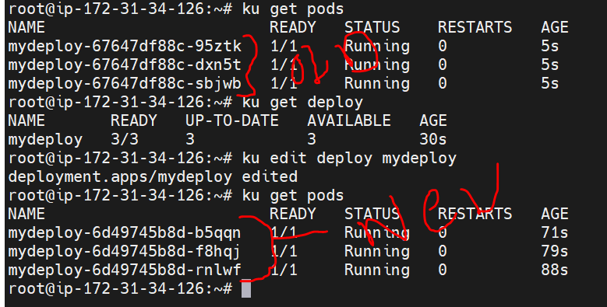

**Deployments:**

Qns: if I execute the $ku get pods in linux server it’s working, but when I execute in power shell it’s not working why?

The main thing is there is no kube/config file in your local machine for powershell.

#cat ~/ .kube/config

In this file all the cluster details existed.

When we execute the #ku get pods the command will take the information from the config file.

**Note: for auto fill the the commands need to edit .bashrc file and give below line.**

Source <(kubectl completion bash)

**What is the diff b/w labels and annotations?**

* In Kubernetes, labels and annotations are key-value pairs that you can attach to resources, such as pods, services, nodes, and more, to provide additional metadata and information about those resources.
* Both labels and annotations are used to help organize, categorize, and add context to Kubernetes objects, but they serve slightly different purposes.

NOTE: Labels are important, without labels no k8s.

Labels size max 63 characters only.

Annotatons mx size 253 characters.

Labels are used for identifying and selecting resources. They are primarily used by selectors, which are criteria used to filter and group resources. For example, you can label your pods with environment information (e.g., "production" or "development") and then create services or deployments that target only the pods with a specific label.

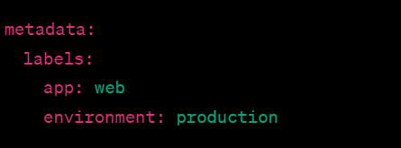

Annotations:

* Annotations are used to store non-identifying information or metadata about resources. Unlike labels, annotations are not used by selectors for resource selection. Annotations are typically used for adding notes or descriptions to resources that are meant to be read by humans or external tools.
* Annotations can be used to store information like version numbers, build information, and descriptions that are not used for operational purposes.
* Annotations are also key-value pairs and are often set in the resource's metadata section.

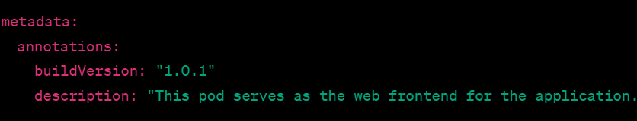

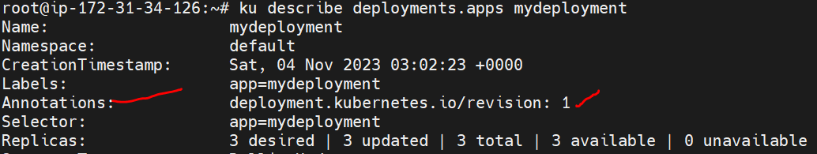

When we create pod it will display only pod name.

But when we create pod using deployment it will give come pod name with some extra content like below.

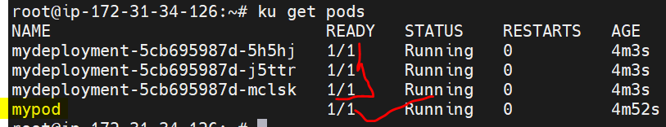

mydeployment-5cb695987d-5h5hj

here🡪 mydeployment= deployment name

5cb695987d = Replicaset name

5h5hj = pod name

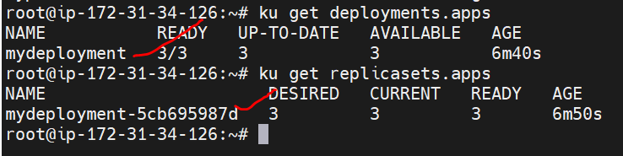

What is replicaSet: Always it will maintain desired count of pods.

====================================================================

12/11 V: 5

* As per application deploy we are not creating the pods, because it will be fail (if you have no of pods no problem) so that will create replica set.
* RS make sure that desired number of pods run at all the time.
* When we updated an application then need to rool-out , replica set will not update the image.
* So that have to use the Deployment type for deploy the application In the cluster.
* Deployment will create the RS and create the pods (99.99% using deployment mode only).
* Daemon sets/ statefull sets are used in the deployment model.
* When we execute the command like : kubectl get nodes (the command will get information from the ~/.kube/config file) In this file existed all the information about the cluster.

**Now Create one Deployment:**

# ku create deployment mydepl --image sreeharshav/rollingupdate:v1 --replicas 3 --dry-run -o yaml

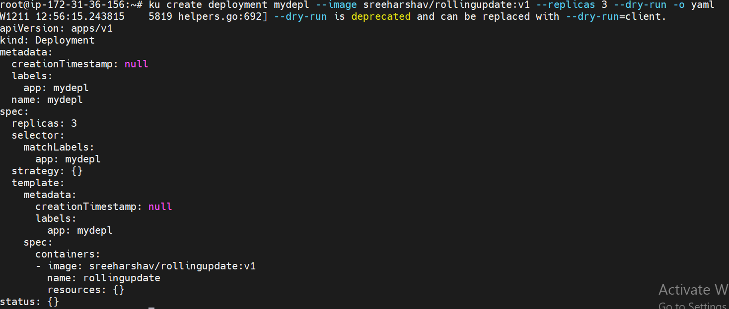

What is label and Annotation?

Lable: Labels are key/value pairs that are attached to objects such as Pods. Labels are intended to be used to specify identifying attributes of objects that are meaningful and relevant to users, but do not directly imply semantics to the core system. Labels can be used to organize and to select subsets of objects. Labels can be attached to objects at creation time and subsequently added and modified at any time. Each object can have a set of key/value labels defined. Each Key must be unique for a given object.

Syntax and character set:

Labels are key/value pairs. Valid label keys have two segments: an optional prefix and name, separated by a slash (/). The name segment is required and must be 63 characters or less, beginning and ending with an alphanumeric character ([a-z0-9A-Z]) with dashes (-), underscores (_), dots (.), and alphanumerics between.

Annotations:

You can use Kubernetes annotations to attach arbitrary non-identifying metadata to objects. Clients such as tools and libraries can retrieve this metadata. Max size 253 characters.

Attaching metadata to objects :

You can use either labels or annotations to attach metadata to Kubernetes objects. Labels can be used to select objects and to find collections of objects that satisfy certain conditions. In contrast, annotations are not used to identify and select objects. The metadata in an annotation can be small or large, structured or unstructured, and can include characters not permitted by labels. It is possible to use labels as well as annotations in the metadata of the same object.

**Find the labels in kube-system NS:**

#ku get pods -n kube-system --show-labels

#ku get pods -n kube-system -l k8s-app=kube-scheduler

Where can use the labels?

root@ip-172-31-36-156:~# ku run testpod1 --image nginx:latest

pod/testpod1 created

root@ip-172-31-36-156:~# ku run testpod2 --image nginx:latest

pod/testpod2 created

root@ip-172-31-36-156:~# ku run testpod3 --image nginx:latest

then verify use labels:

root@ip-172-31-36-156:~# ku get pods --show-labels

NAME READY STATUS RESTARTS AGE LABELS

testpod1 1/1 Running 0 56s run=testpod1

testpod2 1/1 Running 0 50s run=testpod2

testpod3 1/1 Running 0 46s run=testpod3

create pods using manifest file with echo:

#echo ‘apiVersion: apps/v1

kind: Deployment

metadata:

creationTimestamp: null

labels:

app: mydepl

name: mydepl

spec:

replicas: 3

selector:

matchLabels:

app: mydepl

template:

metadata:

creationTimestamp: null

labels:

app: mydepl

spec:

containers:

- image: sreeharshav/rollingupdate:v1

name: rollingupdate ‘ | ku apply –f –

NOTE: echo ‘ manifest file’ | ku apply –f -



mydeployment-5cb695987d-5h5hj

here🡪 mydeployment= deployment name

5cb695987d = Replicaset name

5h5hj = pod name

Duty of replica set: always maintain desired number of pods.

If you target certain pods , then we will use the labels, without labels no K8S.

* Annotation will give for the extra information like n=below.
* 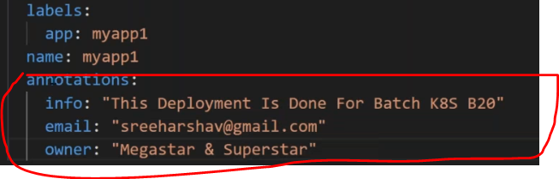

**Environment variables:**

Define an environment variable for a container

When you create a Pod, you can set environment variables for the containers that run in the Pod. To set environment variables, include the env or envFrom field in the configuration file.

The env and envFrom fields have different effects.

**env**

allows you to set environment variables for a container, specifying a value directly for each variable that you name.

**envFrom**

allows you to set environment variables for a container by referencing either a ConfigMap or a Secret. When you use envFrom, all the key-value pairs in the referenced ConfigMap or Secret are set as environment variables for the container. You can also specify a common prefix string.

In this create a Pod that runs one container. The configuration file for the Pod defines an environment variable with name DEMO_GREETING and value "Hello from the environment". Here is the configuration manifest for the Pod:

**apiVersion**: v1

**kind**: Pod

**metadata**:

**name**: envar-demo

**labels**:

**purpose**: demonstrate-envars

**spec**:

**containers**:

- **name**: envar-demo-container

**image**: gcr.io/google-samples/node-hello:1.0

**env**:

- **name**: DEMO_GREETING

**value**: "Hello from the environment"

- **name**: DEMO_FAREWELL

**value**: "Such a sweet sorrow"

Create a Pod based on that manifest:

#echo ‘ manifest file’ | ku apply –f –

List the running Pods:

#kubectl get pods -l purpose=demonstrate-envars

List the Pod's container environment variables:

#kubectl exec envar-demo – printenv

**How to know how many container are running in pod? Here will see entire info about pod.**

#ku describe pod <pod-name>

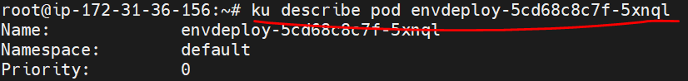

How to execute the container and see all the env details?

#ku eexec –it <pod-name> -- bash

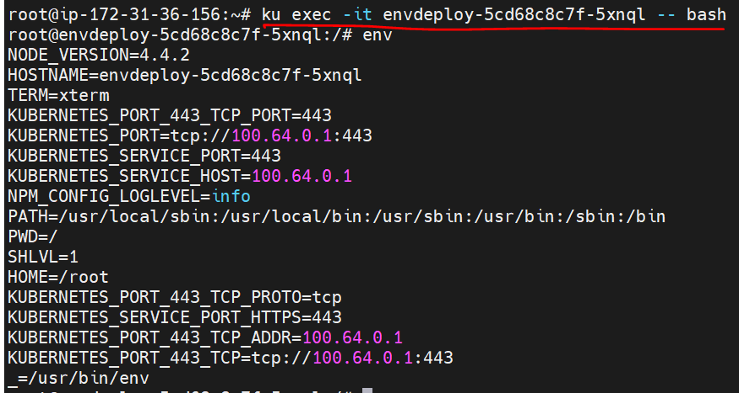

Note: If I have a more then one containes in the pod, how it will execute?

#ku exec –it <pod-name> -c <second container-name>-- bash

When we execute the command, that time it will take first container default.



Here rollingupdate is first container.

How describe the deployments?

#ku describe deployments <deployment-name>

#ku describe deployments envdeploy

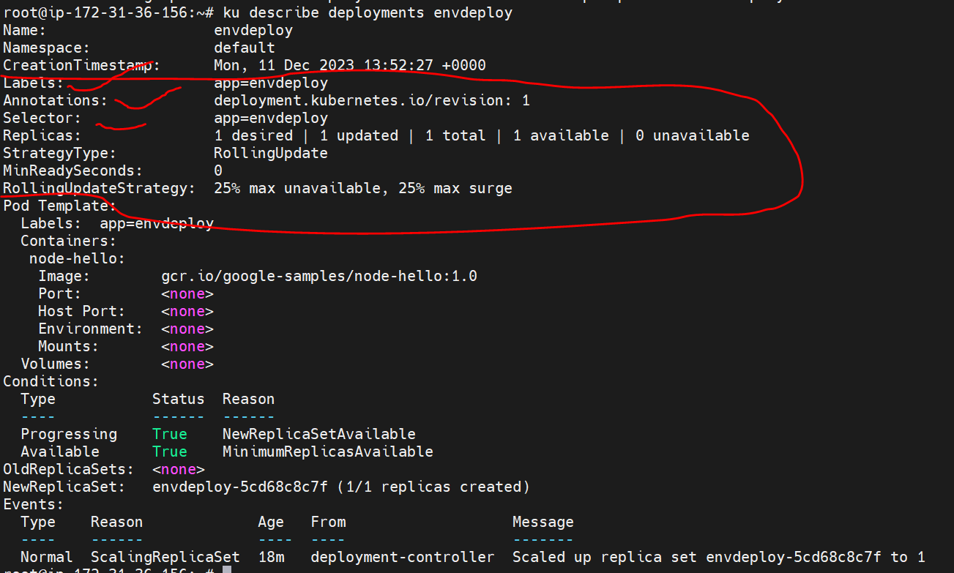

Here see the labels, annotations, selectors, RS and all the configuration about the deploymetns.

How to expose the deployment outside the cluster?

#ku expose deployments mydepl --name svc1 --port 8080 --target-port 80 --type NodePort

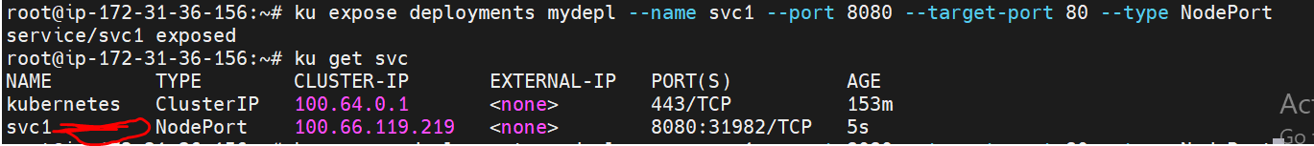

Then open port number in security group(all traffic will not accept in real-time), then go to browser and take DNS with port it will access the application.

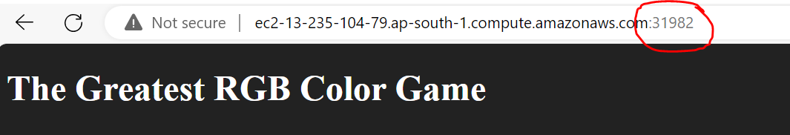

How to know pods deployed in which node?

#ku get nodes –o wide

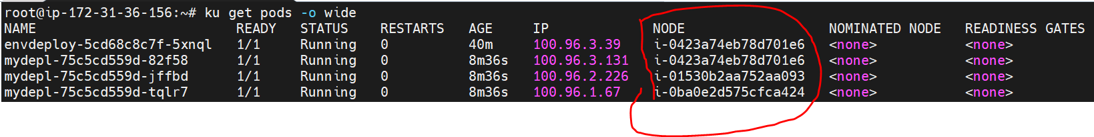

NOTE: we have a service Deployments with replica set 3, if we try to delete the pods, we are unable to delete the pods, because of have a replica set , without deleting deployment we can not delete pods.

#watch -n 1 kubectl get pods

The watch command is a useful utility that allows you to repeat a given command at regular intervals and view the output in real-time. In your example, you're using watch to repeatedly execute the kubectl get pods command every 1 second (-n 1) to monitor the status of Kubernetes pods.

For verification purpose have to use the watch command, test to delete the pod and will recreate immediately , because maintain desired count in replica set 3.RS keep monitoring pods always.

**What is the deployment strategy?**

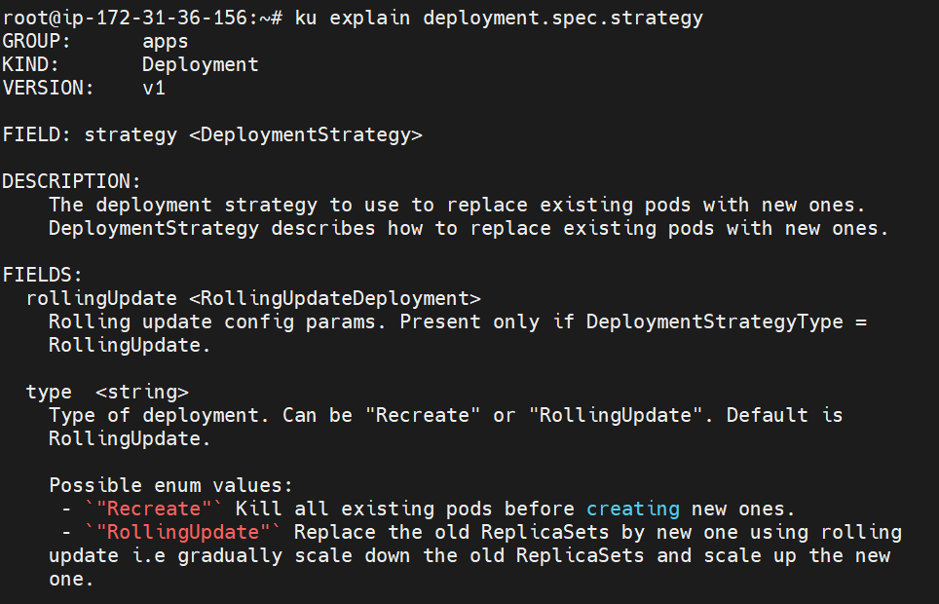

Rolling Updates?

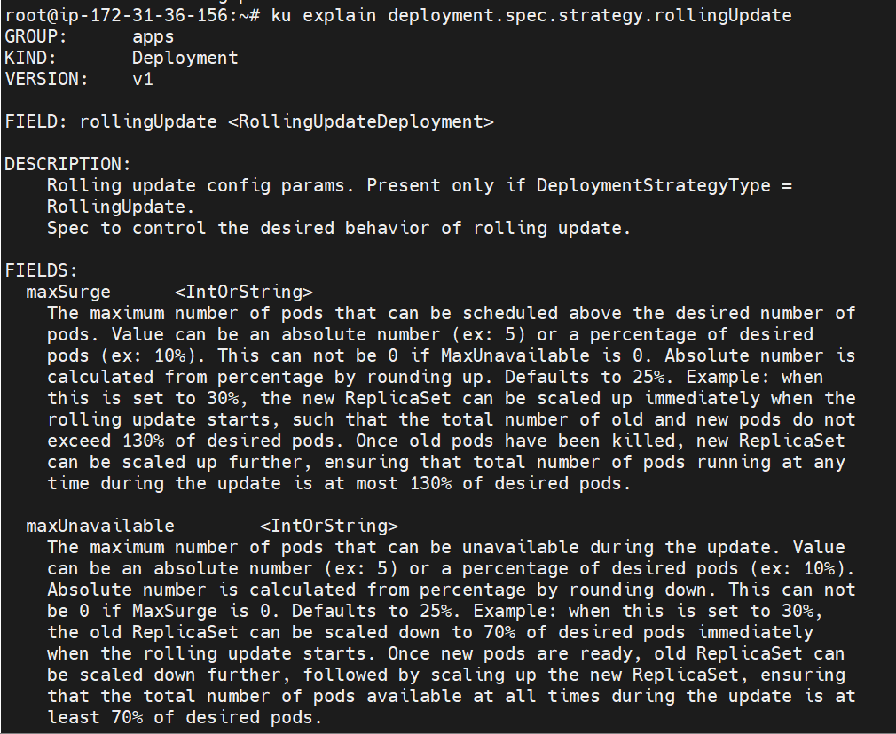

How to edit the image in manifest file through edit command:

#ku edit deployments.apps <deployment-name>

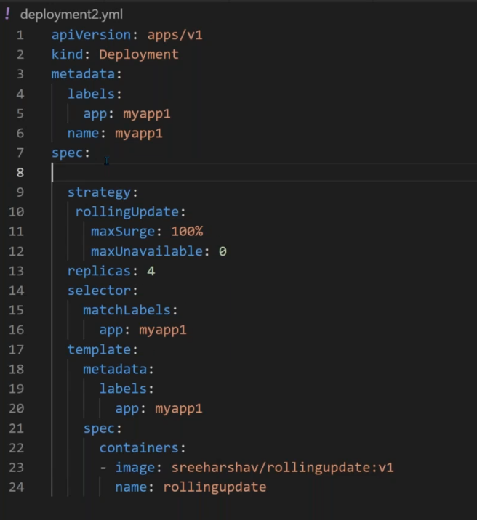

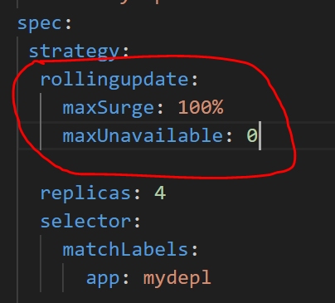

minReadySeconds: newely created pods time .

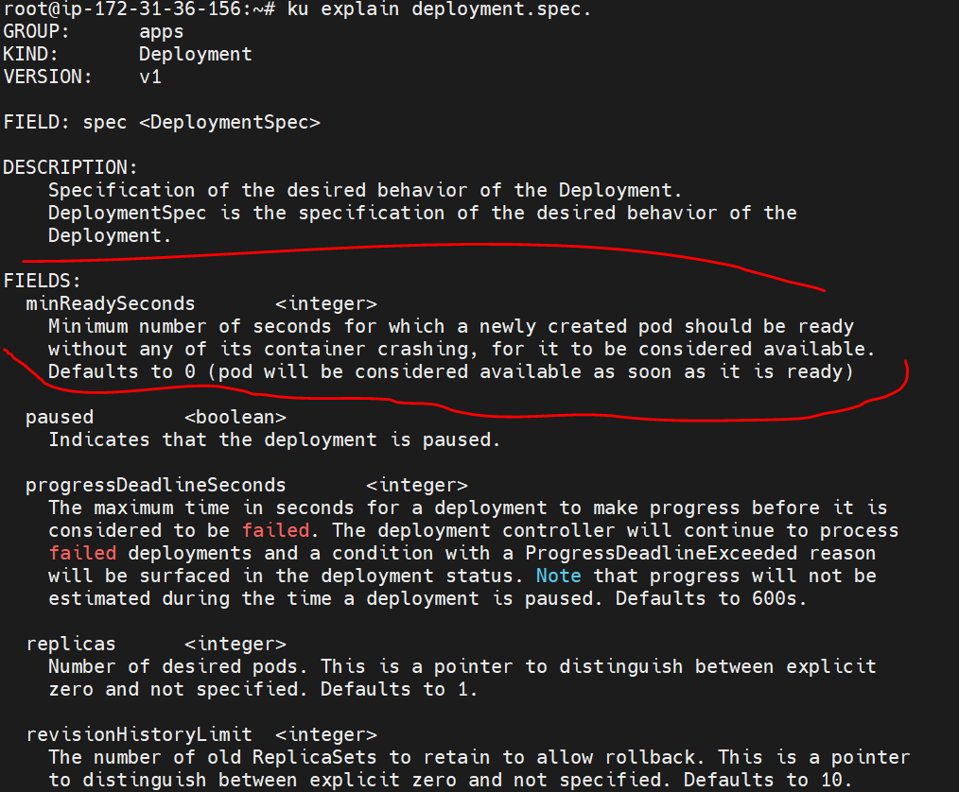

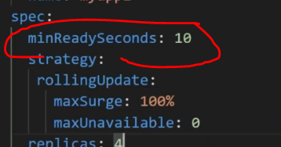

Note: minReadySeconds: 10 specifies the minimum number of seconds for which a new pod should be ready without any errors before the deployment considers it as available.

maxUnavailable: 1 and maxSurge: 1 are also part of the RollingUpdate strategy, determining how many pods can be unavailable and how many can be added above the desired replica count during the update process.

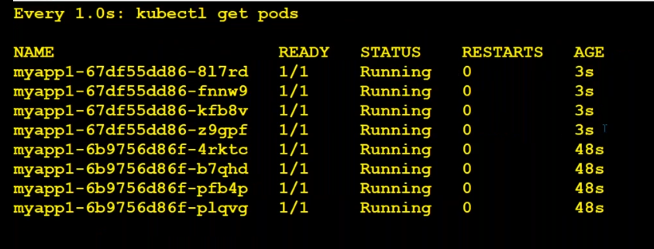

After 10 seconds terminating old pods.

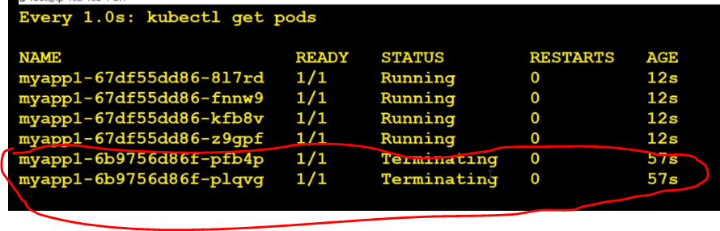

Note: here when we have given maxSurge=100% means it will create desired pods at a time and it will delete desired pods at a time.

* Now will try to delete one by one pod with minReadySeconds:10

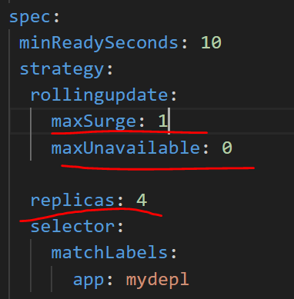

Here minReadySeconds:10

maxSurge:1 (Means it will create one pod and then it will delete one existing old pod why because desired count =4 so always maintain replicas=4 , after 10 seconds it will create one more new pod and it will delete second existing like this create new pods and delete existing old pods.)

How can I check the rollout status while create new pods and delete old pods:

#ku rollout status deployment/<deployment-name>

NOTE: if you have a deployment and service, now I want to delete pod , so first delete service then delete deployment then finally delete pods.

How to watch the pods creation and deletion:

#watch -n 1 kubectl get pods

How to know the rollout status of the pods:

#kubectl rollout status deployments/mydepl

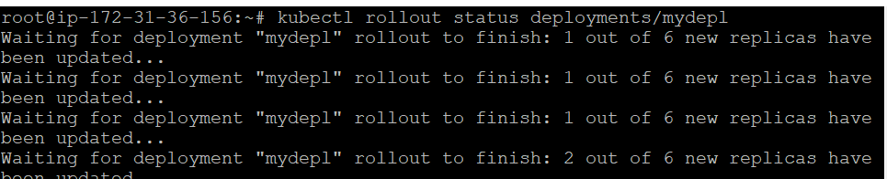

How to pause the deployments:

This command will pause the rollout of the specified deployment, preventing any further updates from being applied. It's useful for scenarios where you want to investigate an issue or perform some manual intervention before allowing the deployment to continue.

#ku rollout pause deployment/mydepl

How to resume the deployments:

The command you provided, kubectl rollout resume deployments, is used to resume a paused rollout of a Kubernetes Deployment. When a Deployment is paused, it means that further updates to the Deployment are halted, typically to investigate an issue or perform some manual intervention.

#ku rollout resume deployment/mydepl

NOTE: finally maxSurge and maxUnavailable are controlling the pods creation status.

Disadvantages of Deployments:  
1. There is no rule to run desired pods in all the nodes(may be it will run more then one pods in one node).

When we use deployment mode:

In Kubernetes, the Deployment resource is commonly used to manage and control the deployment of applications. Here are scenarios in which using the Deployment mode is beneficial:

1. Rolling Updates:

Scenario: When you need to update your application to a new version without causing downtime.

How Deployment Helps: Kubernetes Deployments support rolling updates, ensuring a smooth transition from the old version to the new one, with zero or minimal impact on availability.

1. Rollbacks:

Scenario: When a new version of your application has issues, and you need to revert to a previous, stable version.

How Deployment Helps: Deployments keep a revision history, allowing you to easily roll back to a previous version in case of problems.

3. Scaling:

Scenario: When you need to scale your application horizontally by adding or removing replicas.

How Deployment Helps: Deployments provide a simple way to scale the number of replicas, adjusting the desired state of your application.

1. Self-Healing:

Scenario: When one or more pods become unhealthy or crash, and you want the system to automatically recover.

How Deployment Helps: Deployments monitor the health of pods and automatically restart failed ones, contributing to the overall reliability of your application.

1. Declarative Configuration:

Scenario: When you want to define the desired state of your application in a declarative manner.

How Deployment Helps: Deployment configurations are defined in YAML files, making it easy to version control, reproduce environments, and apply changes declaratively.

1. Service Discovery and Load Balancing:

Scenario: When you need to ensure communication and load balancing between different components of your application.

How Deployment Helps: Deployments work seamlessly with Kubernetes Services, providing built-in service discovery and load balancing.

1. MinReadySeconds and MaxSurge/MaxUnavailable:

Scenario: When you want to control the deployment behavior, such as specifying a minimum time for a new pod to be ready (minReadySeconds) or controlling the rate of change during an update (maxSurge and maxUnavailable).

How Deployment Helps: Deployment configurations allow you to fine-tune these parameters to suit your application's requirements.

1. Pod Template Changes:

Scenario: When you need to make changes to the pod template (e.g., updating container images, environment variables).

How Deployment Helps: Deployments manage the rollout of these changes, ensuring consistency across all replicas.

Note: In deployment there is no dependency on name on the pod.

**What is A DaemonSet:**

DS Make sure it will run one pod for one host at any cost.

A DaemonSet ensures that all (or some) Nodes run a copy of a Pod. As nodes are added to the cluster, Pods are added to them. As nodes are removed from the cluster, those Pods are garbage collected. Deleting a DaemonSet will clean up the Pods it created.

IN the daemon set don not have a replicas option , because if have a 5 node cluster means it will run 5 pods in the cluser.

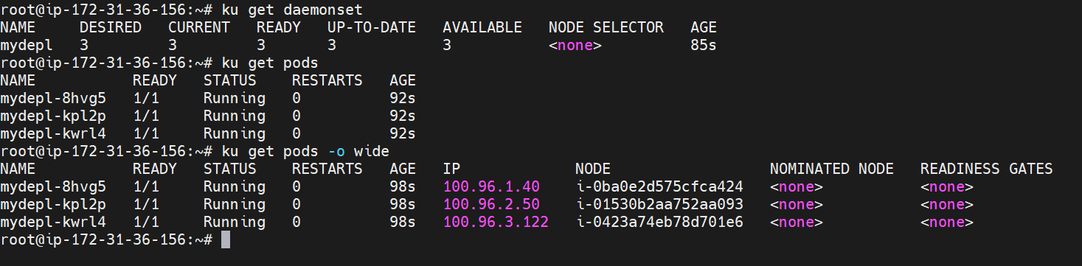

In the above dig, cluseter size is 3 node and have a deployed using deamonset, it’s created 3 pods in all 3 nodes. Here we are not used any replicas options, if you use the option will get an error.



**Statefulset**:

Manages the deployment and scaling of a set of Pods, and provides guarantees about the ordering and uniqueness of these Pods

# ku get statefulset

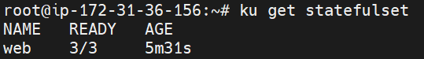

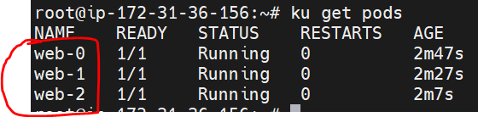

Note: If I delete any pod with name, it will recreate pod with the same name, why because pod saved in that existing name in the cluster.

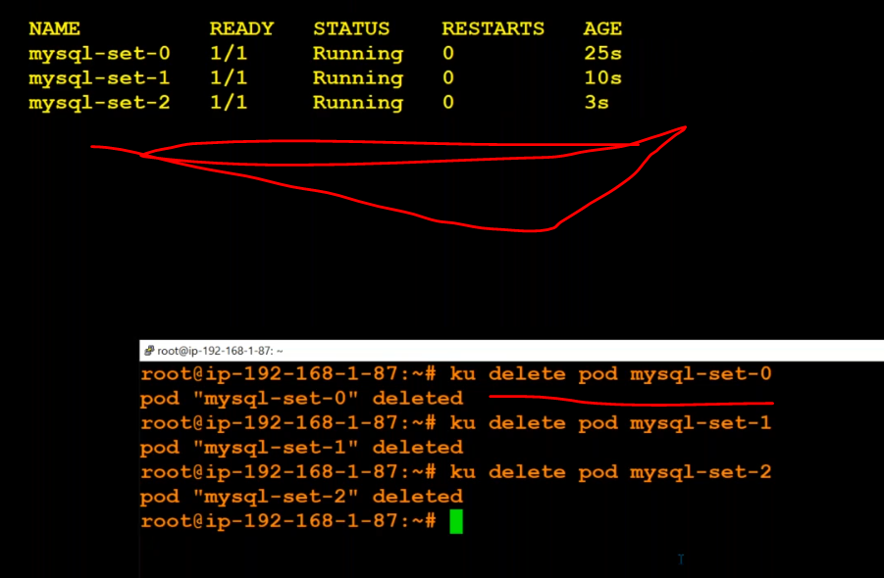

How to delete the cluster:

#kops delete cluster --name <cluster-name> --yes

#kops delete cluster --name k8stect.xyz --yes

**What is ReplicaSet**

A ReplicaSet's purpose is to maintain a stable set of replica Pods running at any given time. As such, it is often used to guarantee the availability of a specified number of identical Pods.

**Vid:6 Services**

In Kubernetes, a Service is a method for exposing a network application that is running as one or more Pods in your cluster.

How to create a service for existing pod.

ku expose deployment mydepl --port 80 --target-port 80 --type NodePort --dry-run -o yaml

apiVersion: v1

kind: Service

metadata:

labels:

app: mydepl

name: mydepl

spec:

ports:

- port: 80

protocol: TCP

targetPort: 80

selector:

app: mydepl

type: NodePort

When Image name is not correct , will get the below error.

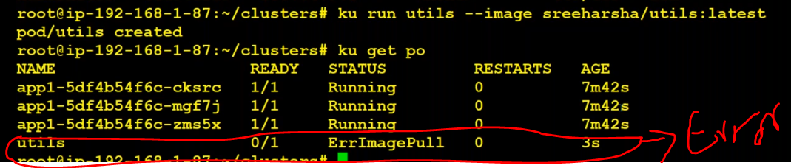

How to execute the pods:

#ku exec -it mydepl-75c5cd559d-89fmm -- bash

Now you are in pod.

Then execute env command in pod, will see all the env details.

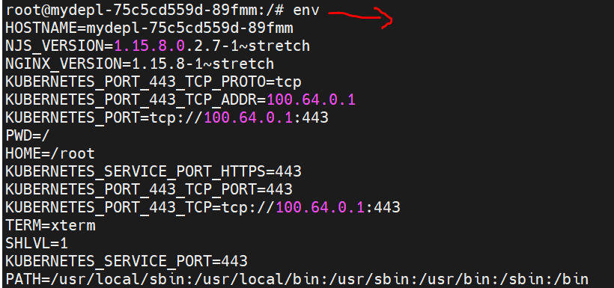

How to know all the details about service:

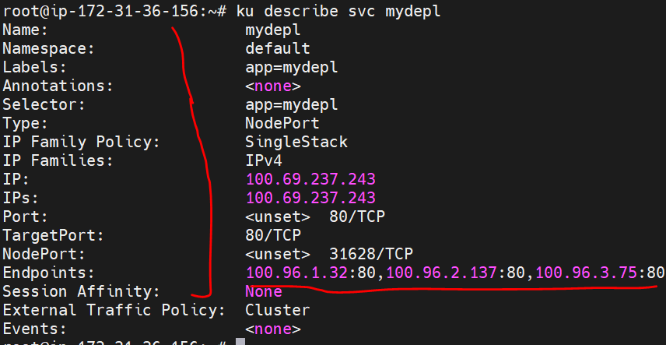

Here Endpoints are the pod ip’s.

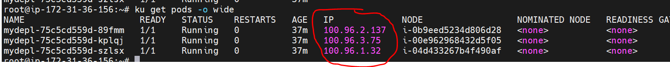

How to get all services end points:

# ku get endpoints

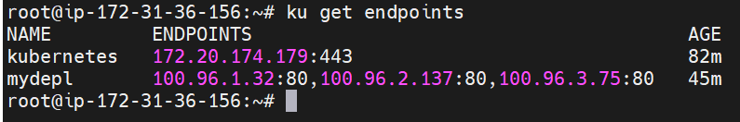

How to get svc end points and all the details in yaml:

#ku get endpoints -o yaml

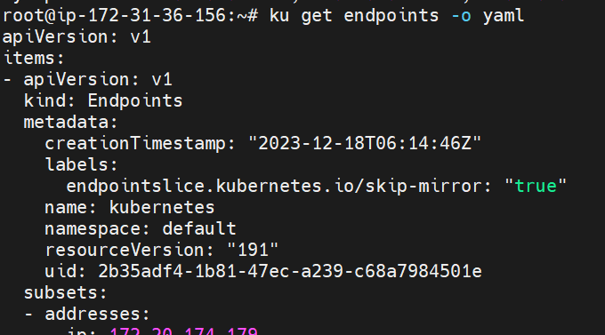

OR

# ku get endpoints -o json | jq ".items[].subsets[].addresses[].ip" –r

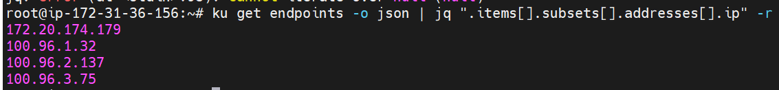

Above query reference:

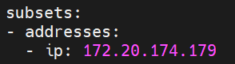

Service flow diagram:

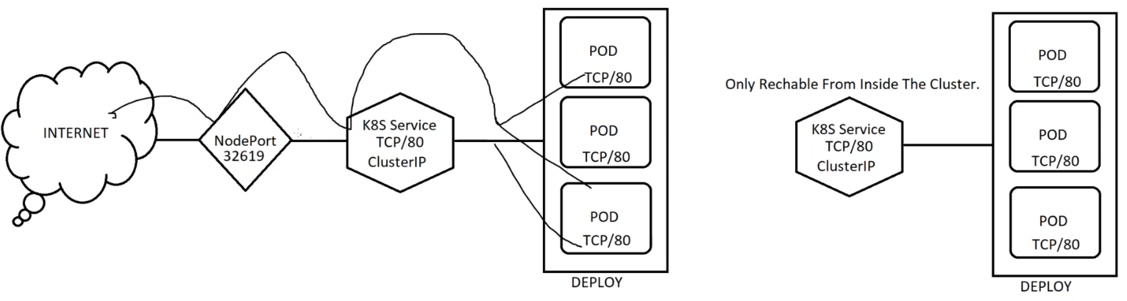

How can I provide a specific port to my service port?

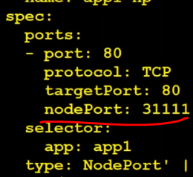

How to know how many pods are runnin gin kube-system name-space?

#ku get pods –n kube-system

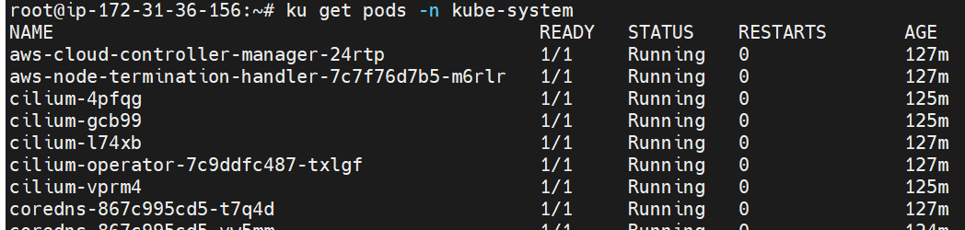

How to verify logs in particular pod in kube-system NS?

#ku logs <po-name> -n kube-system –f (f means follow the new logs)

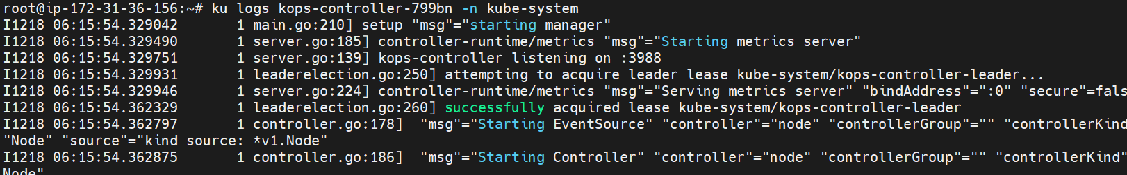

**Load balancer service:**

#ku expose deployment mydepl --name mydepl-lb --port 8080 --target-port 80 --type LoadBalancer --dry-run -o yaml

Verify : #ku logs aws-cloud-controller-manager-24rtp -n kube-system –f

Then verify LB in aws console.

NOTE: have some draw backs when we use the LB.

We have maintain micro services, so every pod will create one LB, so it’s very expensive. So that we have use ingress controller. Here we use one LB only. We have some restrictions when we create a LB, every region have some limitation (count) to create the LB.

**External Name service:**

In Kubernetes, an ExternalName service is a special type of service that acts as an alias to an external service, represented by a DNS name. This service type is typically used when you want to give a Kubernetes service a stable DNS name, but you don't want to expose it internally within the cluster. Instead, the ExternalName service redirects DNS queries to the specified external DNS name.

Simply, here we are providing service name so that it will not display cluster up address, and will display all the nodes ip, where the pods are running.

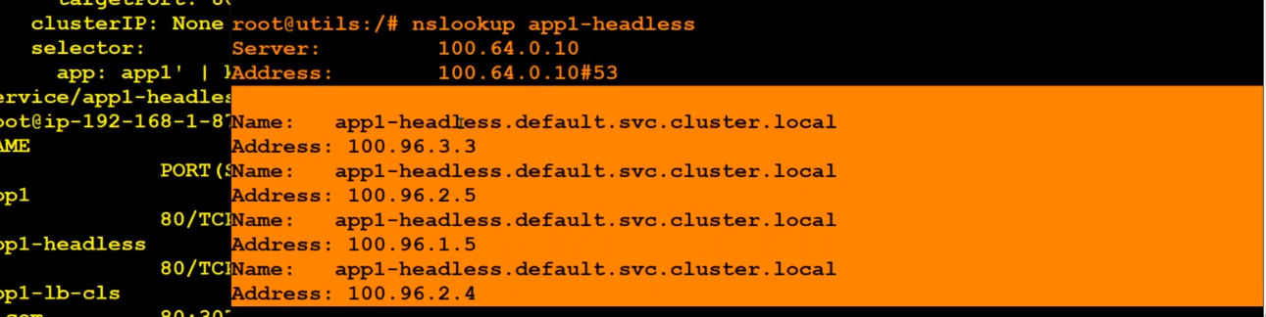

**Ingress controller- service:**

In Kubernetes, an Ingress controller is responsible for managing external access to services within the cluster. It acts as an API object that manages external access to services in a cluster, typically providing features like load balancing, SSL termination, and routing based on hostnames or paths.

Nginx is one of the popular Ingress controllers available for Kubernetes. When you deploy the Ingress-Nginx controller in your Kubernetes cluster, it brings several advantages:

Routing and Load Balancing: Ingress controllers, including Nginx, provide a way to route external traffic to different services within the cluster based on rules defined in the Ingress resource. This allows you to expose multiple services on different paths or hostnames.

SSL Termination: Ingress controllers often support terminating SSL/TLS connections, handling encryption and decryption on behalf of the services. This allows you to secure your applications with HTTPS without requiring each individual service to manage SSL certificates.

Path-Based Routing: You can define rules in the Ingress resource to route traffic to specific services based on URL paths. This makes it easy to expose different parts of your application under the same domain.

Host-Based Routing: Ingress controllers can route traffic based on hostnames, allowing you to host multiple services on the same IP address and port but under different domain names.

Rewrite Rules and URL Reconfiguration: Ingress controllers often provide features for URL rewriting and configuration, allowing you to modify the request and response paths and headers.

Centralized Management: Ingress controllers provide a centralized way to manage external access rules for your services. This is more convenient than managing individual service type LoadBalancer services for each service you want to expose.

By deploying an Ingress controller like Nginx, you abstract away the complexities of managing external access to your services, making it easier to expose and manage multiple services within your Kubernetes cluster. It also provides a consistent way to handle common networking concerns for your applications.

Note: when we deployed ingress LB, by default it will create NLB also.

Here we create Cluster IP service, but we will give ingress controllers.

If need to run ingress requird ssl/TSL certificates.

**How to create a ceritificate:**

CERTBOT on ubuntu 18.04 (or) 20.04:

sudo snap install --classic certbot

verify : certbot –h

# certbot certonly --manual --preferred-challenges=dns --key-type rsa --email naveen.jpsv@gmail.com \

--server https://acme-v02.api.letsencrypt.org/directory --agree-tos -d *.k8stech.xyz

After execute the above script will get below record, create a record in R53 use that name.

Go to R53🡪 crate record using below name:

_acme-challenge 🡪 copy until challenge( don’t copy entire line)

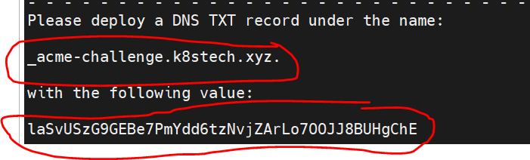

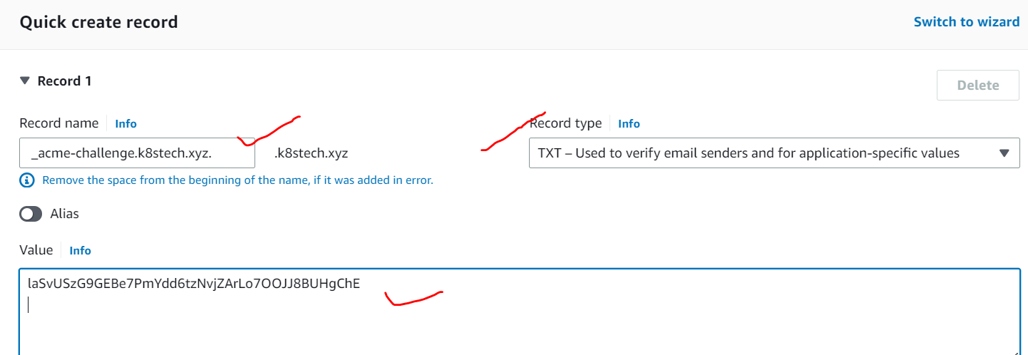

Steps: go to R53🡪 create record🡪 give the record name🡪choose record type(TXT used to verify…)🡪 give copy the value from the remote server and paste here in the place of value.

After one minute go to terminal and execute the remaining script( mean while it will verify the cluster)

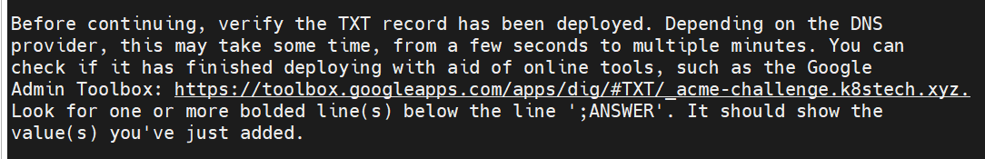

Verify : <https://toolbox.googleapps.com/apps/dig/#TXT/_acme-challenge.k8stech.xyz>

Use the above link ane verify the record is created or not .

After couple of minitus , will get the certificates.

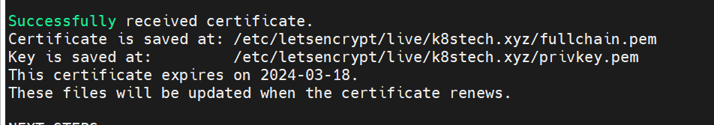

Switch in to /etc/letsencrypt/live/k8stech.xyz this path and see the certificate files.

Then save this all certificates in local machine. It’s validity 90 days.

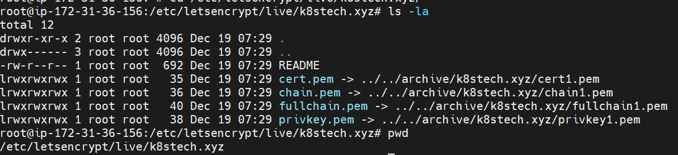

Take the copy privatekey.pem file content using vi editor. And open visual studio and save.

Then fullchain.pem file

How to know the cluster status using validate command:

#kops validate cluster

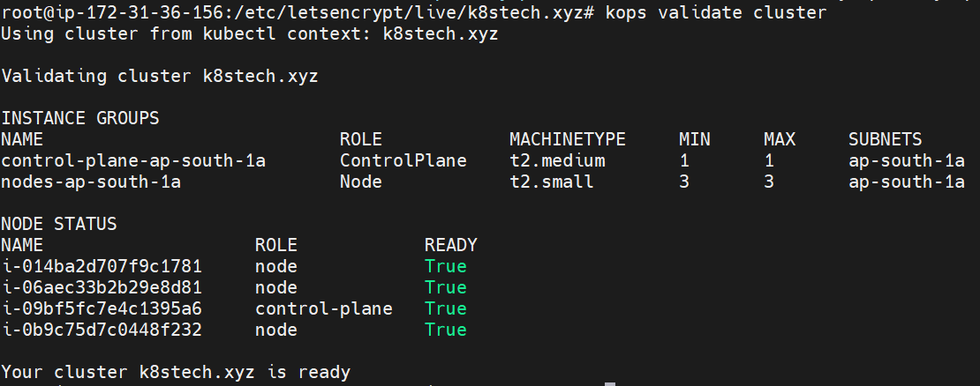

V7:

Ingress controller & SSL termination:

Ingress Controller can be in any namespace. But the Ingress Resource must be in the same Namespace where the application is deployed. For example, if prometheus and grafana are in monitoring namespace, the ingress must also be in the monitoring namespace. Thats means POD, Deployment, Service & Ingress must be in the same namespace.

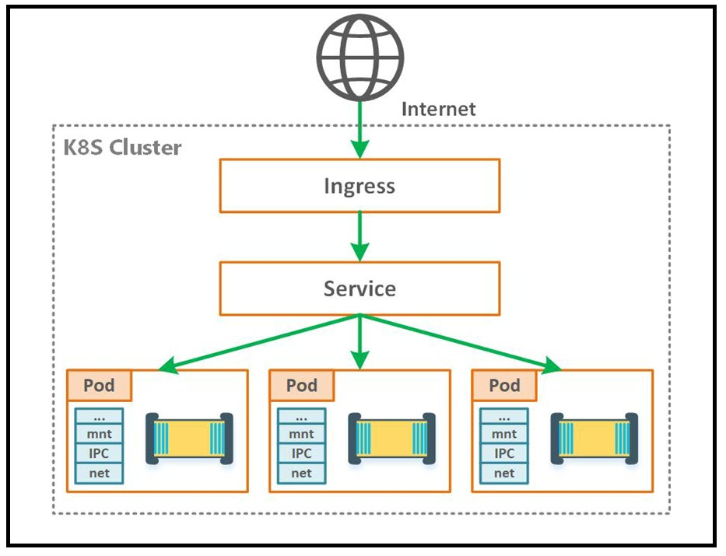

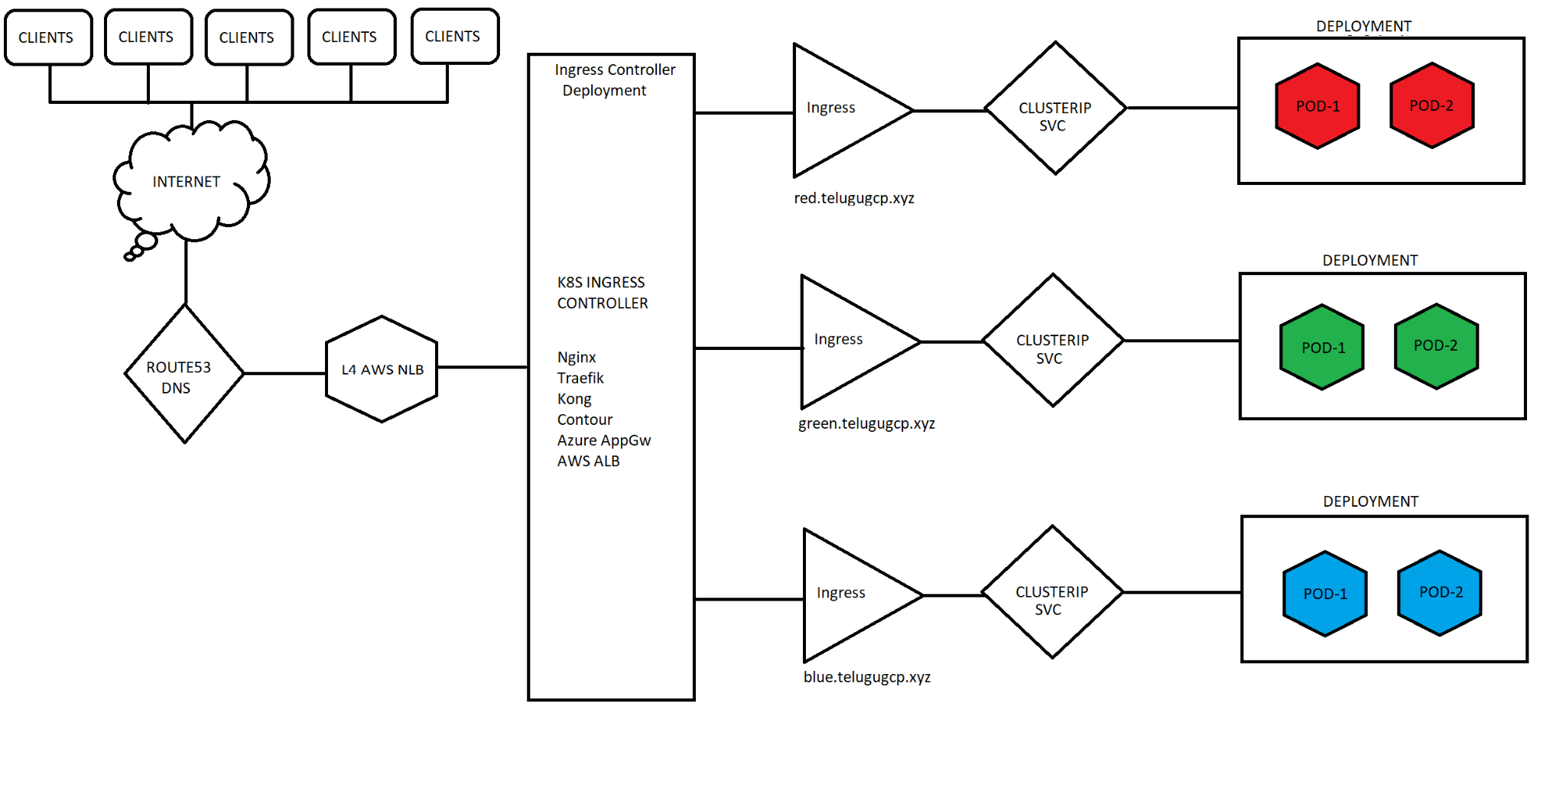

Now downloads the deployment manifest from the specified URL and applies it to your Kubernetes cluster. It deploys the Ingress-Nginx controller along with the required resources.

#kubectl apply -f <https://raw.githubusercontent.com/kubernetes/ingress-nginx/controller-v1.3.1/deploy/static/provider/aws/deploy.yaml>

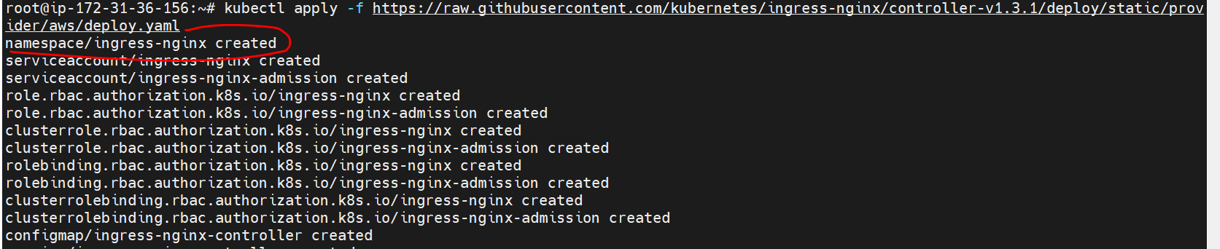

Here created NS and some other resources.

Then verify have any pods are created inside that ingress-nginx NS.

#ku get pods –n ingress-nginx

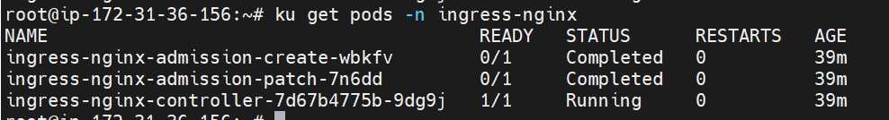

Verify in aws console LB is crated.

Then #cd /tmp

Create two file like 🡪 vi tls.key and tls.crt with that certificate values.

Then execute below command :

# kubectl create secret tls nginx-tls-default --key="tls.key" --cert="tls.crt"

Secrete is created.

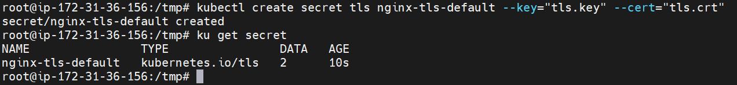

Verify:#ku get secret

Describe:# ku describe secret nginx-tls-default

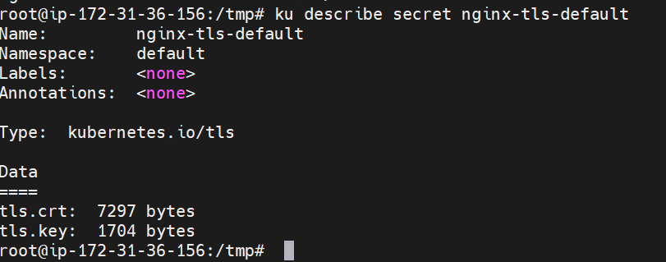

When we use secrets, must our docker images in private repository.

So create one private repository in docker hub.

Then pull one image from public repo and change the tag with the private repo name and push the new image to private repo.

# docker login

# docker pull sreeharshav/rollingupdate:v1

# docker tag sreeharshav/rollingupdate:v1 naveenbabuch/k8s-private:v1

# docker push naveenbabuch/k8s-private:v1

Like these pull and push :

docker pull sreeharshav/example-voting-app_result

docker pull sreeharshav/example-voting-app_worker

docker pull sreeharshav/example-voting-app_result

Then change the tag and push to private repo.

Take voting-app-Cluster.yaml file and edit the images with private images.

Then execute below command in /tmp

#ku apply –f vote.yaml (before execute need to create yaml file in this path)

Then verify pods, here will get error pod’s are not created reason images are not pull , it’s existed in private repository.

So need to create sexrets.

#ku create secret

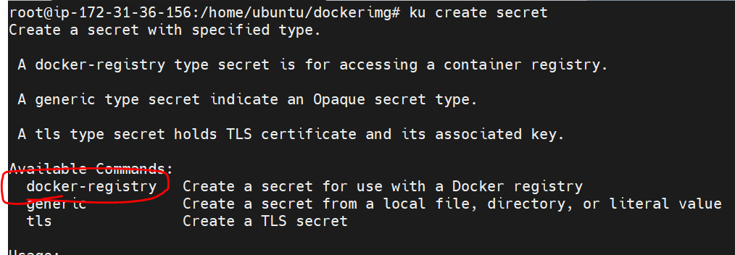

$ku create docker-registry –h

# ku create secret docker-registry –h

After execute the above command , you get a below script in the terminal.

kubectl create secret docker-registry my-secret --docker-server=DOCKER_REGISTRY_SERVER --docker-username=DOCKER_USER

--docker-password=DOCKER_PASSWORD --docker-email=DOCKER_EMAIL

kubectl create secret docker-registry my-secret --docker-server=https://hub.docker.com/repository/docker/naveenbabuch/k8s-private --docker-username=naveenbabuch

--docker-password=Lgfnani@123 [--docker-email=naveen.jpsv@gmail.com](mailto:--docker-email=naveen.jpsv@gmail.com)

Then add the secret in yaml file like below. Get secret from # # ku get secret

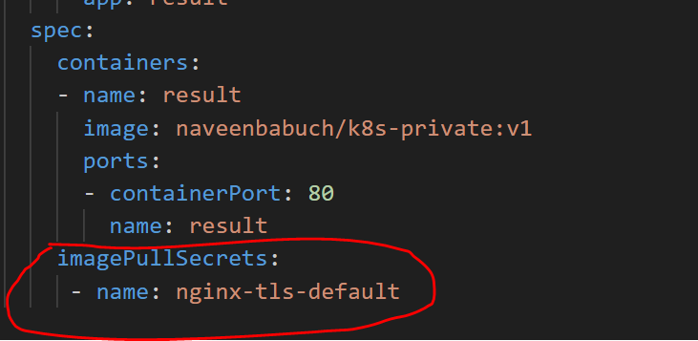

Have a 2 type of secrets :

1. Tls
2. 2. Image pull secret

After everything is done , verify pods and services.

Then create one record in r53, with any name and select route traffic via Network load balancer.

If you browse this record the traffic will route to actual domain .

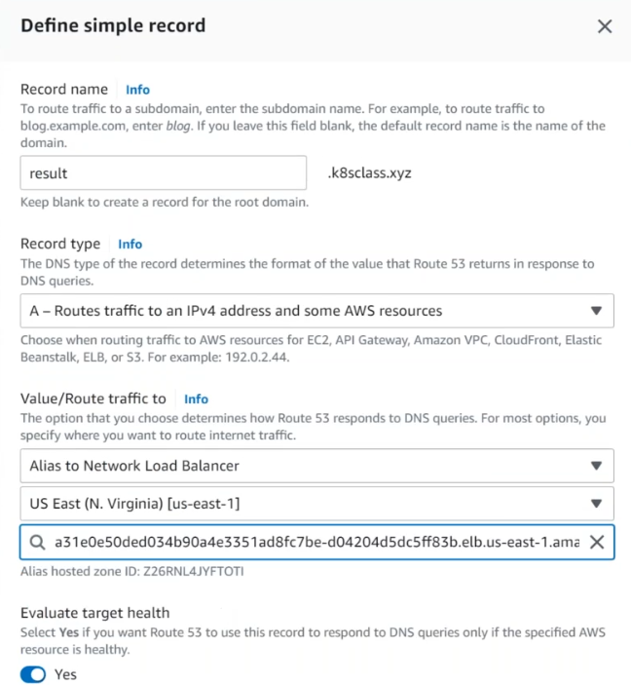

Then will execute below yaml with host names( what we have create now)

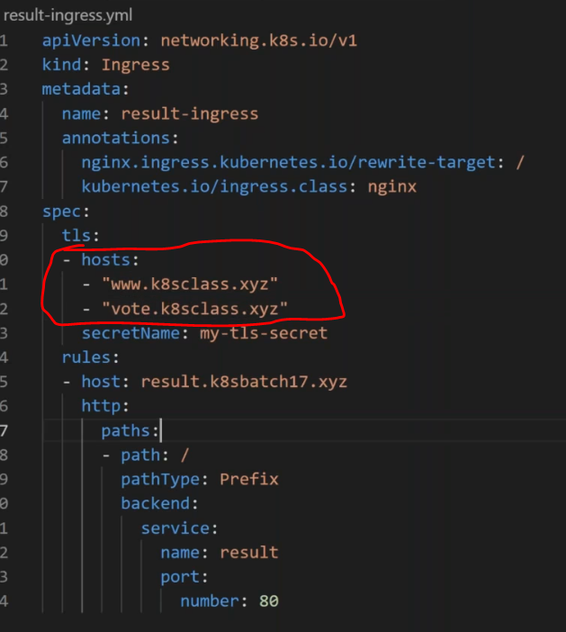

**Probes:**

n Kubernetes a "probe" typically refers to a mechanism for performing health checks on a container within a pod. Probes are used to determine the readiness and liveness of an application running in a Kubernetes cluster.

There are three types of probes in Kubernetes:

In Kubernetes (often abbreviated as K8s), a "probe" typically refers to a mechanism for performing health checks on a container within a pod. Probes are used to determine the readiness and liveness of an application running in a Kubernetes cluster.

There are three types of probes in Kubernetes:

1.Liveness Prob

2.Readiness Prob

3.Startup Prob

Benefits of Probes:

Automatic Healing: Probes enable Kubernetes to automatically restart containers that are unhealthy, improving the overall reliability of applications.

Gradual Traffic Shift: Readiness probes allow for a controlled rollout of updates by delaying traffic until the new version of an application is ready to serve requests.

Early Detection of Issues: Probes help detect issues early, preventing situations where an application may be running but is not able to handle requests effectively.

Customization: Probes can be configured based on the specific requirements of an application, such as custom endpoints, timeouts, and thresholds.

**Liveness Probe:**

* A liveness probe determines whether the container is running properly. If the liveness probe fails, Kubernetes considers the container to be unhealthy, and the container is restarted.
* This is useful for situations where an application might encounter a deadlock or other internal issue that causes it to stop responding.
* Liveness probes can be a powerful way to recover from application failures.
* Many applications running for long periods of time eventually transition to broken states, and cannot recover except by being restarted. Kubernetes provides liveness probes to detect and remedy such situations.

Purpose: Ensures that the container is running as expected.

Use Case: Detects and restarts containers that have become unresponsive or have entered a deadlock state.

Example: If an application hangs or encounters a critical issue, the liveness probe can detect this and trigger a restart.

**Readiness Probe:**

A readiness probe determines whether the container is ready to accept traffic. If the readiness probe fails, the pod is removed from service endpoints, and it won't receive new traffic.

This is useful during application startup or when an application needs some time to warm up

before it can handle requests.

Purpose: Determines whether the container is ready to receive requests or traffic.

Use Case: Delays sending traffic to a pod until the application inside the pod is fully initialized and ready to handle requests.

Example: If an application requires some time to warm up, the readiness probe prevents traffic from being directed to the pod until it's ready.

**Startup Probe:**

A startup probe is similar to a liveness probe, but it is designed to specifically check whether the application has started successfully. Once the startup probe succeeds once, it is no longer used.

This is useful when an application takes some time to initialize, and you want to avoid sending requests to it before it's fully ready.

Purpose: Similar to a liveness probe, but specifically designed to check whether the application has started successfully.

Use Case: Allows for additional checks during the startup phase, ensuring that the application is fully operational before marking it as healthy.

Example: If an application takes time to initialize resources or dependencies, a startup probe can verify its readiness before considering it live.

Conclusion:

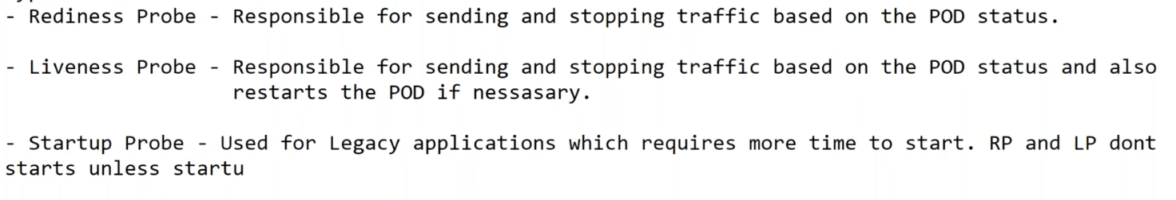

Rediness Lab:

Create one deployment using naveenbabuch/rollingupdate:latest

#ku create deployment mydepl --image naveenbabuch/rollingupdate:latest --dry-run -o yaml

spec:

      containers:

      - image: naveenbabuch/rollingupdate:latest

        name: example-voting-app-worker-n5tsf

        readinessProbe:

         httpGet:

          path: /

          port: 80

         initialDelaySeconds: 30

         periodSeconds: 10

         successThreshold: 1

         failureThreshold: 3

Add above readiness points into manifest file, then apply.

Then create NodePort service to that deployment.

#ku expose deployment mydepl –port 8080 –target-port 80 –type NodePort –replicas 3 –dry-run –o yaml

Verify application is access or not?

Then open one new putty terminal for testing.

#watch kubectl get nodes (one terminal)

#ku exec (pod) –it – bash (second terminal)

Now we are in side the pod, then remove the index.html file in the pad

root@voting-9f559bbd5-qnhxx:/usr/share/nginx/html# rm –rf index.html

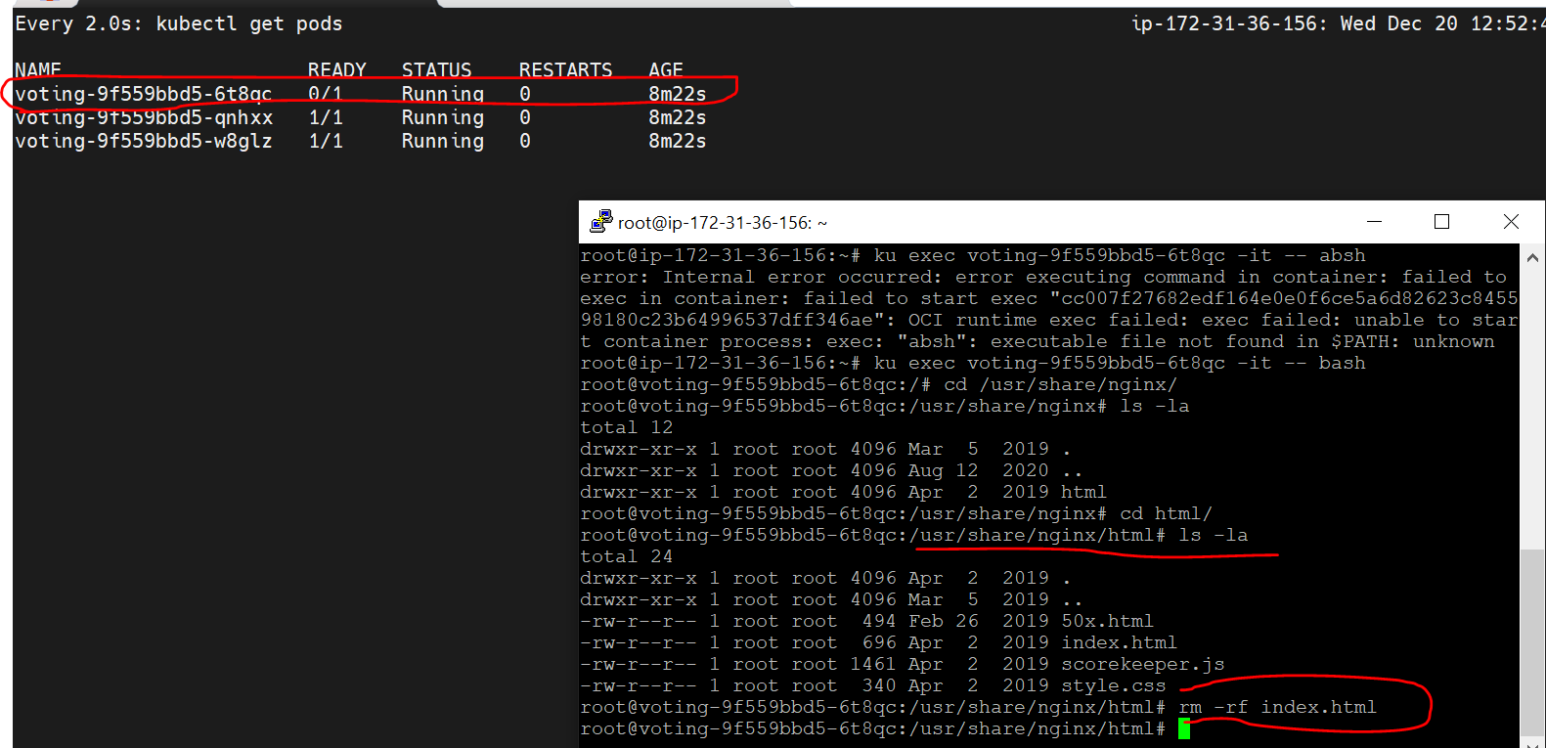

So when three pods are not active, rediness act here traffic will not send to that pods , until pods are healthy.

Now take one sample index.html file and create in all pods in the same path (/usr/share/nginx/html).

Note: when index.html file is created the pod is up and healthy. Then the traffic is route to that pod.

Note: some time pods are still not ready, so need to restart the pods , but readiness not do that task , so that will add the liveness probe as well.

 containers:

      - image: naveenbabuch/rollingupdate:latest

        name: example-voting-app-worker-n5tsf

        readinessProbe:

         httpGet:

          path: /

          port: 80

         initialDelaySeconds: 10

         periodSeconds: 10

         successThreshold: 1

         failureThreshold: 3

        livenessProbe:

         httpGet:

          path: /

          port: 80

         initialDelaySeconds: 20

         periodSeconds: 10

         successThreshold: 1

         failureThreshold: 3

again deploy and do same above..

if I delete the pod index.html file , pod is deleted and it automatically it will reboot the pod.

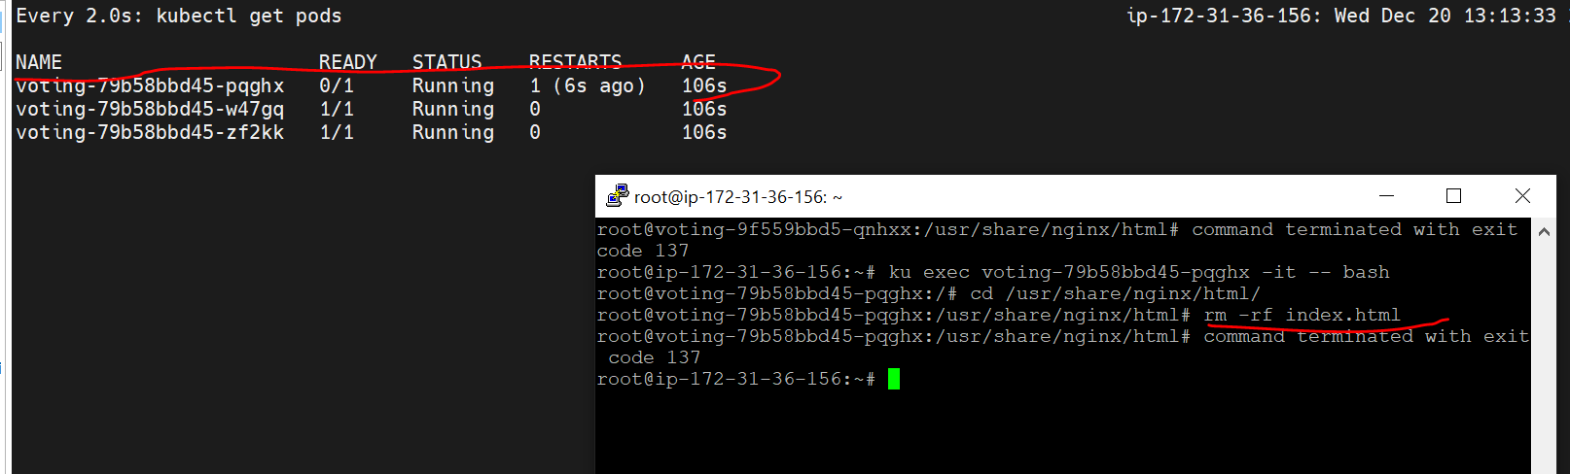

This is the advantage of readiness probe.

Note: directly will use liveness probe no need to use rediness probe.

Pod level HA we will use probes.

V:8

**Side car containers:**

* In Kubernetes, a sidecar container refers to a secondary container running in the same pod alongside the main or primary container. The term "sidecar" is borrowed from the motorcycle attachment, which is an additional seat or container attached to the side.
* Sidecar containers are used to extend or enhance the functionality of the main application container in a pod. They share the same network namespace and storage volumes with the main container, allowing them to communicate and share data easily. Sidecar containers are commonly used for various purposes, including logging, monitoring, data synchronization, and more.

Logging:

A sidecar container can be used to collect, process, and forward logs generated by the main application container. This separation allows you to use specialized log processing tools without modifying the application code.

**Monitoring:**

Sidecar containers can run monitoring agents to collect metrics, traces, or other telemetry data from the main application container. This separation keeps the monitoring logic separate from the application's business logic.

**Security:**

Security-related tasks, such as handling secrets, can be offloaded to a sidecar container. This helps in keeping security concerns isolated and modularized.

**File Sync:**

Sidecar containers can synchronize files or data between containers in a pod, providing a way for applications to share data or configuration files.

**Proxy or Adapter:**

A sidecar container can act as a proxy or adapter, transforming or forwarding requests before they reach the main application container.

What is init containers:

In Kubernetes, an init container is a special type of container that runs before the main application container starts within a Pod. The primary purpose of init containers is to perform setup tasks or preconditions that are necessary for the main application container to run successfully.

Key characteristics of init containers:

Order of Execution: Init containers are executed in the order in which they are defined in the Pod configuration. Each init container must successfully complete before the next one starts, and all init containers must complete successfully before the main application container starts.

Use Cases:

Data Initialization: Downloading data or initializing a shared volume that the main container will later use.

Wait for Dependencies: Waiting for a database or external service to be ready before starting the main application.

A [Pod](https://kubernetes.io/docs/concepts/workloads/pods/) can have multiple containers running apps within it, but it can also have one or more init containers, which are run before the app containers are started.

Init containers are exactly like regular containers, except:

* Init containers always run to completion.
* Each init container must complete successfully before the next one starts.
* If a Pod's init container fails, the kubelet repeatedly restarts that init container until it succeeds. However, if the Pod has a restartPolicy of Never, and an init container fails during startup of that Pod, Kubernetes treats the overall Pod as failed.
* If you specify multiple init containers for a Pod, kubelet runs each init container sequentially. Each init container must succeed before the next can run. When all of the init containers have run to completion, kubelet initializes the application containers for the Pod and runs them as usual

**Differences from sidecar containers:**

* init containers do not support lifecycle, livenessProbe, readinessProbe, or startupProbe whereas sidecar containers support all these probes to control their lifecycle.
* Init containers share the same resources (CPU, memory, network) with the main application containers but do not interact directly with them.

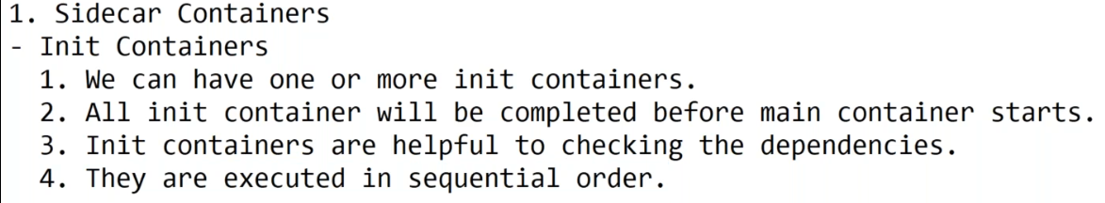

**What is Adapter Containers:**

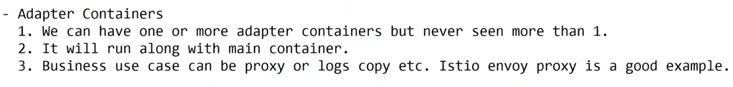

**Ambassador Container:**

An Ambassador container is a sidecar container that is in charge of proxying connections from the application container to other services. However, while the Adapter container acts as a reverse proxy, the Ambassador container acts as a client proxy. You might be wondering, why do we need to proxy the application connection requests? Because we need to follow the separation of concerns principle. Each container should do its task and do it well. If there are other tasks that require the application’s function in order to work correctly, we may hand those tasks to the sidecar container.

For example, almost all applications need a database connection at some phase. In a multi-environment place, there would be a test database, a staging database, and a production database. When writing the Pod definition for their application’s container, developers must pay attention to which database they’ll be connecting to. A database connection string can be easily changed through an environment variable or a configMap. We could also use a sidecar pattern that proxies DB connections to the appropriate server depending on where it runs. Developers needn’t change the connection string, they could leave the DB server at localhost as usual. When deployed to a different environment, the Ambassador container detects which environment it is running on (possibly through the Reflection pattern), and connects to the correct serve.

**Kubernetes Namespaces, Resource Quota, and Limits for QoS in Cluster:**

url: [Kubernetes Namespaces, Resource Quota, and Limits for QoS in Cluster - DZone](https://dzone.com/articles/kubernetes-namespaces-resource-quota-and-limits-fo)

Have two custom NS, it talks one to one each other.

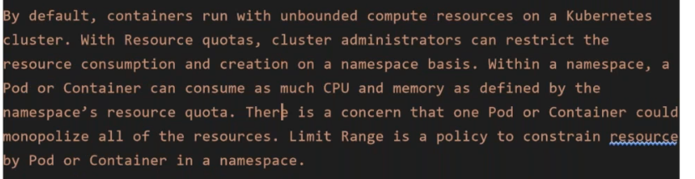

So that need to assign some amount of volume to NS for particular application.

Create two custom NS

#k create ns apple

#k create ns window

Then create resources to that two NS.

apiVersion: v1

kind: ResourceQuota

metadata:

 name: windows-ns-quota

 namespace: windows

spec:

 hard:

   #compute-resources

   requests.cpu: "1000m"

   limits.cpu: "2000m"

   requests.memory: 1Gi

   limits.memory: 2Gi

   #object-counts

   count/deployments.apps: "1"

   count/pods: "4"

   count/replicasets.apps: "1"

   count/secrets: "4"

   count/services: "1"

What is request.cpu (CPU Requests):

The request.cpu is the amount of CPU resources that a container is guaranteed to receive when running. It represents the minimum amount of CPU that the container is entitled to use.

When a container specifies a CPU request, it indicates the minimum amount of CPU resources it expects to be allocated. Kubernetes uses this information for scheduling decisions.

It is expressed in CPU units, such as milliCPU units (m), where 1000 milliCPU units equal 1 CPU core.

limit.cpu (CPU Limits):

The limit.cpu is the maximum amount of CPU resources that a container can use. It represents an upper bound on the CPU usage of the container.

If a container tries to use more CPU than specified in the limit, it may be throttled or terminated, depending on the container runtime and configuration.

Same as create resource-quote file to apple as well ,just change the name.

Note: Here we are restrict the deploymetns, pods, services, rs count.

Then verify NS and resourcequotas.

#k get resourcequotas –n apple

#k get resourcequotas –n apple

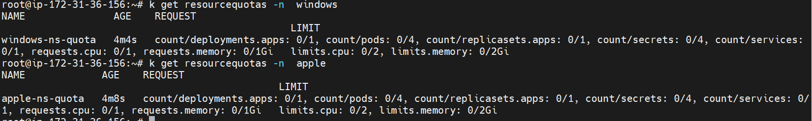

How to describe quotas:

#k describe ns apple

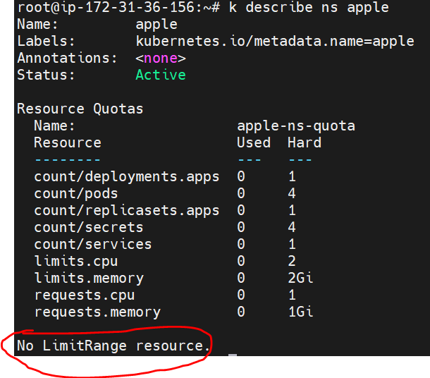

How to know my current NS, which ns I am working?

# kubectl config view --minify | grep namespace

How to switch one NS to another:

#kubens <NS-name>

NOTE: sometimes it’s asking need to install kubectx, so just install with below command.

# snap install kubectx --classic

Now try to create a deployment in apple NS.

# k create deployment mydepl –image nginx:latest

Here deployment is created but it’s not up because need to create **No Limit range resource**.

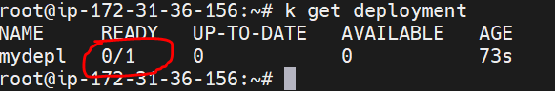

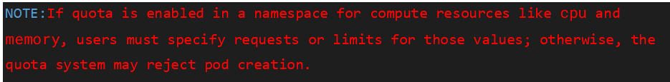

Need to write a resource file for resource limit.

NOTE: how to know which “apiVersion” version I need to use in the manifest file.

#k api-resources | grep –I Deployment / ReplicaSet / limit

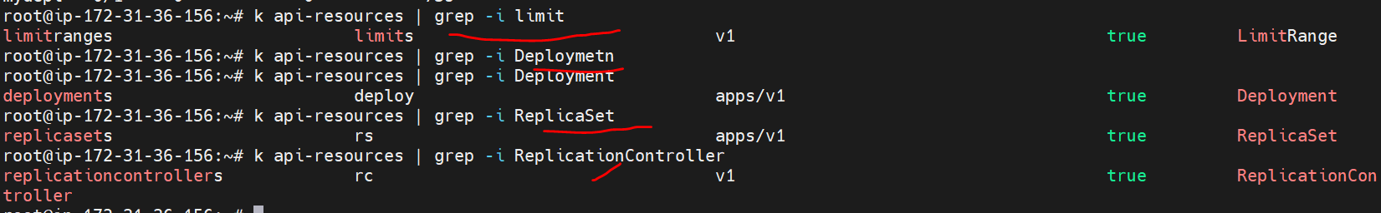

How to create limitrange file:

apiVersion: v1

kind: LimitRange

metadata:

  name: resource-limits

spec:

  limits:

  - type: Pod

    max:

      cpu: 2

      memory: 1Gi

    min:

      cpu: 200m

      memory: 64Mi

  - type: Container

    max:

      cpu: 2

      memory: 1Gi

    min:

      cpu: 100m

      memory: 4Mi

    default:

      cpu: 300m

      memory: 200Mi

    defaultRequest:

      cpu: 200m

      memory: 100Mi

    maxLimitRequestRatio:

      cpu: 10

Verify:

# k get limitrange

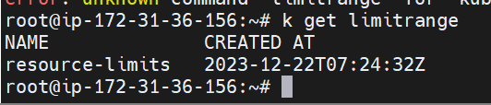

#k describe limitrange

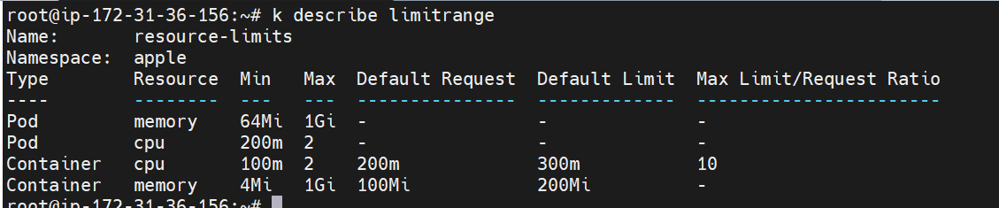

Note: We give resources in the pod creation level also.

How to get complete details about NS:

#k describe ns <ns-name>

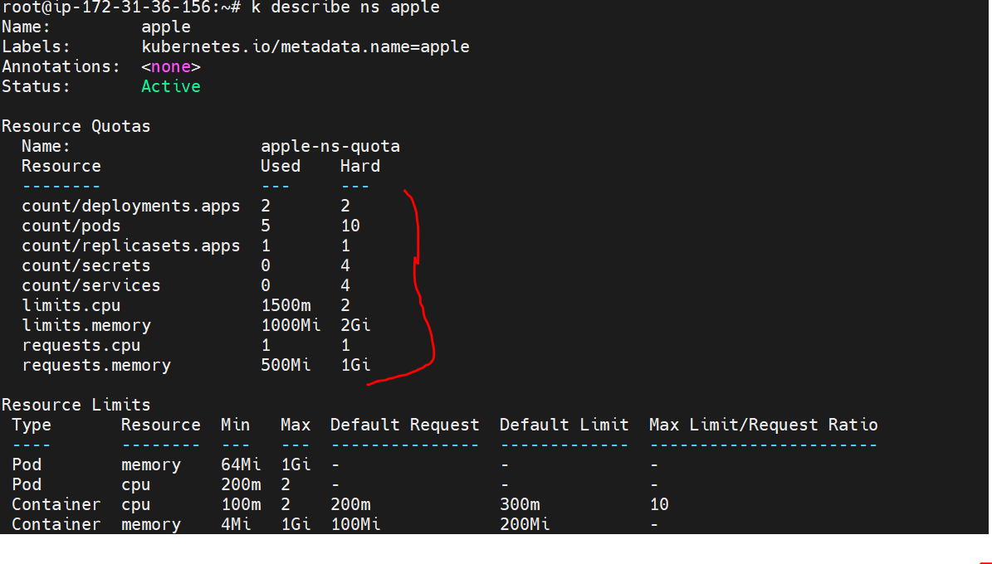

How to define resources in the deployment creation level:

apiVersion: apps/v1

kind: Deployment

metadata:

  creationTimestamp: null

  labels:

    app: deployment

  name: deployment

  namespace: apple

spec:

  replicas: 5

  selector:

    matchLabels:

      app: deployment

  strategy: {}

  template:

    metadata:

      labels:

        app: deployment

    spec:

      containers:

      - image: ashokit/javawebapp

        name: javawebapp

        resources:

          limits:

            cpu: 250m

            memory: 700Mi

**Jobs & Cron Jobs:**

In Kubernetes (K8s), Jobs and CronJobs are two types of controllers that facilitate the execution of tasks or jobs within a cluster. These controllers help manage and automate various tasks, and they are particularly useful for running batch processes or periodic jobs.

How to know apiVersion for the jobs.

**JOB:**

A Job in Kubernetes is a controller that manages the execution of a single task or a set of parallel tasks (pods).

The primary purpose of a Job is to ensure that a specified number of pod replicas successfully complete their tasks before marking the job as complete.

Jobs are useful for one-off or finite tasks that need to run to completion, such as data processing, backups, or any task that doesn't need to run continuously.

**CronJob:**

A CronJob is a controller in Kubernetes that creates Jobs based on a time schedule specified using the cron syntax.

CronJobs are useful for running periodic or recurring tasks at specified intervals, similar to cron jobs in traditional Unix-like systems.

Each time the cron schedule triggers, a new Job is created and managed by the CronJob controller.

**Verify you are in which NS.**

# kubectl config view --minify | grep namespace

Then switch to your custom NS.

#kubens <your-NS>

Then execute the jobs manifest file

**How to know what is the apiVersion for jobs.**

#k api-resources | grep -i job

apiVersion: batch/v1

kind: Job

metadata:

  name: samplejob

spec:

  template:

    spec:

      containers:

      - name: utils1

        image: sreeharshav/utils

        command: ["/bin/ping"]

        args: ["-c 30", "www.google.com"]

      restartPolicy: Never

#k get pods

$k get jobs

Now deploy one mysql with service:

apiVersion: apps/v1

kind: Deployment

metadata:

  labels:

    run: mysql1

  name: mysql1

spec:

  replicas: 1

  selector:

    matchLabels:

      run: mysql1

  template:

    metadata:

      labels:

        run: mysql1

    spec:

      containers:

      - image: mysql:latest

        name: mysql1

        env:

          - name: MYSQL_ROOT_PASSWORD

            value: India@12345

        volumeMounts:

          - name: mysql-volume

            mountPath: /var/lib/mysql

      volumes:

      - name: mysql-volume

        emptyDir: {}

---

apiVersion: v1

kind: Service

metadata:

  labels:

    run: mysql1

  name: mysql1

spec:

  ports:

  - port: 3306

    protocol: TCP

    targetPort: 3306

  selector:

    run: mysql1

verify pods and svc

#k get pods

#k get svc

Then switch into pod, then connect to Mysql DB

# k exec -it mysql1-6958fc7c8b-xfc4n -- bash



#mysql –u root –p (press enter button, then it will ask password enter the password: “India@12345” password in manifest file).

Mysql> show databases;

Then run the script( script is existed in manifest file folder).

Mysql> show databases;

Mysql> use <u r custom db>;

Mysq> show tables;

Mysql> select * from <u r table>;

After created the dband tables, need to take back for that using job.

Now create a job.

apiVersion: batch/v1

kind: Job

metadata:

  name: mysqldump

spec:

  template:

    spec:

      containers:

      - name: mysqldump1

        image: centos/mysql-57-centos7

        command: ["/bin/sh","-c",  "/opt/rh/rh-mysql57/root/usr/bin/mysqldump --single-transaction --routines -u $MYSQL_USER $MYSQL_DB -h $MYSQL_HOST | gzip > /tmp/dump`date '+%Y%m%d_%H%M%S'`.sql.gz"]

        env:

         - name: MYSQL_USER

           value: "root"

         - name: MYSQL_PWD

           value: "India@12345"

         - name: MYSQL_HOST

           value: "mysql1"

         - name: MYSQL_DB

           value: "myflixdb"

        volumeMounts:

            - mountPath: /tmp

              name: dbdumpsvol

              subPath: mysql-backup

      restartPolicy: Never

      volumes:

         - name: dbdumpsvol

           hostPath:

             path: /tmp/

      nodeSelector:

        kubernetes.io/hostname: "i-0fc7f302b5c0ddb45"

then create a job using above manifest file.

NOTE: here we have give back-up server instance ID(kubernetes.io/hostname: "i-0fc7f302b5c0ddb45"_

NOTE : now need to make automate job using cronjob.

Cronjob manifest file:

apiVersion: batch/v1

kind: CronJob

metadata:

  name: crondbdump1

spec:

  schedule: "* * * * *"

  successfulJobsHistoryLimit: 7

  jobTemplate:

    spec:

      template:

        metadata:

          labels:

            parent: "crondumpifrs"

        spec:

          containers:

          - name: mysqldump1

            image: centos/mysql-57-centos7

            command: ["/bin/sh","-c",  "/opt/rh/rh-mysql57/root/usr/bin/mysqldump --single-transaction --routines -u $MYSQL_USER $MYSQL_DB -h $MYSQL_HOST | gzip > /tmp/dump`date '+%Y%m%d_%H%M%S'`.sql.gz"]

            env:

             - name: MYSQL_USER

               value: "root"

             - name: MYSQL_PWD

               value: "India@12345"

             - name: MYSQL_HOST

               value: "mysql1"

             - name: MYSQL_DB

               value: "myflixdb"

            volumeMounts:

                - mountPath: /tmp

                  name: dbdumpsvol

                  subPath: mysqlbackupcron

          restartPolicy: Never

          volumes:

             - name: dbdumpsvol

               hostPath:

                 path: /tmp/

          nodeSelector:

            kubernetes.io/hostname: "i-0fc7f302b5c0ddb45"

* ["/bin/sh", "-c", "..."]: This specifies that the shell should execute the following command.
* /opt/rh/rh-mysql57/root/usr/bin/mysqldump: This is the path to the mysqldump executable, which is used for creating a MySQL database dump.
* --single-transaction: This option ensures that the entire dump is done within a single transaction, making the dump consistent at a single point in time.
* --routines: This option includes stored routines (procedures and functions) in the dump.
* -u $MYSQL_USER: Specifies the MySQL user to use for the connection.
* $MYSQL_DB: Specifies the MySQL database to dump.
* -h $MYSQL_HOST: Specifies the MySQL host.
* | gzip > /tmp/dumpdate '+%Y%m%d_%H%M%S'.sql.gz": This part of the command pipes the output of the mysqldump command through gzip to compress it and then redirects the compressed output to a file in the /tmp/ directory. The filename is constructed with the current date and time in the format %Y%m%d_%H%M%S.

Then verify the Jobs:

#k get jobs # k get cronjobs

Verify schedule is every one minute take back-up.

#watch kubectl get jobs

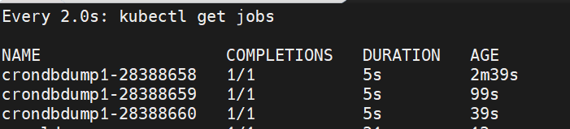

Then verify the back-up in the given server:

Cd /tmp🡪 ls –la

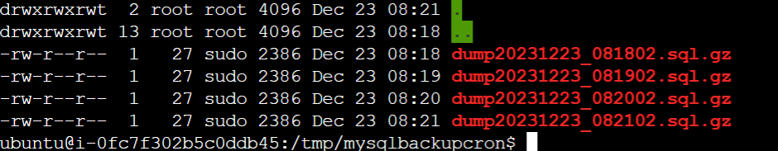

Every one minute back-up.

V-9

**RBAC(Role Base Access Control)**

RBAC, or Role-Based Access Control, is a security feature in Kubernetes (K8s) that enables administrators to control access to resources and actions within a cluster. RBAC allows you to define fine-grained permissions and policies for users, groups, or service accounts, specifying what actions they are allowed to perform on specific resources.

Key components of RBAC in Kubernetes include:

* 1. Roles and ClusterRoles:

Role: Defines a set of permissions within a specific namespace. For example, a role might grant read access to pods and services in a particular namespace.

ClusterRole: Similar to a role but applies across the entire cluster, not just within a namespace. It can grant permissions for cluster-wide resources.

* 1. RoleBindings and ClusterRoleBindings:

RoleBinding: Binds a role to a user, group, or service account within a specific namespace.

ClusterRoleBinding: Binds a cluster role to a user, group, or service account across the entire cluster.

* 1. Subjects:

Users, groups, or service accounts that are granted permissions through roles or cluster roles.

* 1. Verbs:

Actions or operations that can be performed on resources, such as "get," "list," "watch," "create," "update," and "delete."

#kubectl api-resources

The kubectl api-resources command is used to list the available API resources in a Kubernetes cluster. This command provides a quick overview of the various resource types that you can interact with using Kubernetes.

How to know how many resources we are creating in NS?

#k api-resources –namespace=true

The kubectl api-resources --namespaced=true option is used to list only the Kubernetes API resources that are namespaced. Namespaced resources are those that are associated with a particular namespace in a Kubernetes cluster.

How to know the k8s cluster related resources like non-Ns( not related to NS).

#k api-resources –namespace =false

The kubectl api-resources --namespaced=false option is used to list only the Kubernetes API resources that are not namespaced. Non-namespaced resources are those that are not associated with a particular namespace in a Kubernetes cluster, and they are typically cluster-wide.

Where the certificate files existed in k8s master node?

#cd /etc/kubernetes/kops-controller

Here will find all the files.

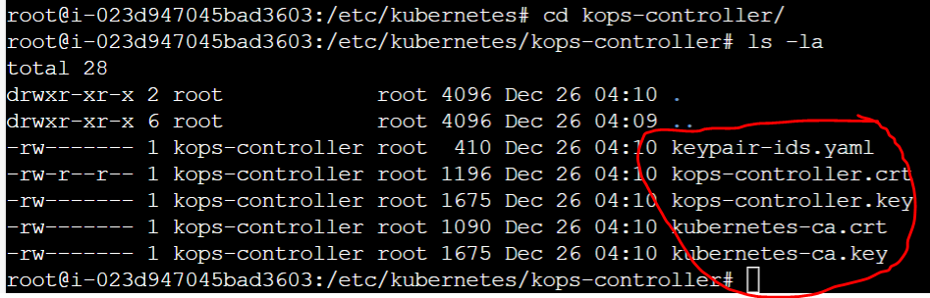

V10

**Kubernetes Secrets:**

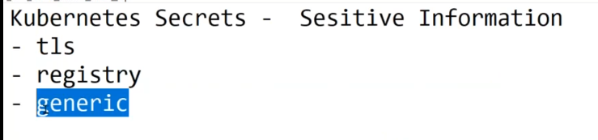

Mainly have 3 type of secrets

1. Tls ( for Ingress controller)
2. Register ( for docker )
3. Generic (for Iam)

Kubernetes Secrets are a way to manage sensitive information, such as passwords, API keys, and other confidential data, within Kubernetes clusters. Secrets provide a mechanism to decouple sensitive information from the application code and configuration files, improving security and maintainability.

A Secret is an object that contains a small amount of sensitive data such as a password, a token, or a key. Such information might otherwise be put in a [Pod](https://kubernetes.io/docs/concepts/workloads/pods/) specification or in a [container image](https://kubernetes.io/docs/reference/glossary/?all=true#term-image). Using a Secret means that you don't need to include confidential data in your application code.

Because Secrets can be created independently of the Pods that use them, there is less risk of the Secret (and its data) being exposed during the workflow of creating, viewing, and editing Pods. Kubernetes, and applications that run in your cluster, can also take additional precautions with Secrets, such as avoiding writing sensitive data to nonvolatile storage.

Secrets are similar to [ConfigMaps](https://kubernetes.io/docs/concepts/configuration/configmap/) but are specifically intended to hold confidential data.

**Caution:**

Kubernetes Secrets are, by default, stored unencrypted in the API server's underlying data store (etcd). Anyone with API access can retrieve or modify a Secret, and so can anyone with access to etcd. Additionally, anyone who is authorized to create a Pod in a namespace can use that access to read any Secret in that namespace; this includes indirect access such as the ability to create a Deployment.

In order to safely use Secrets, take at least the following steps:

1. [Enable Encryption at Rest](https://kubernetes.io/docs/tasks/administer-cluster/encrypt-data/) for Secrets.
2. [Enable or configure RBAC rules](https://kubernetes.io/docs/reference/access-authn-authz/authorization/) with least-privilege access to Secrets.
3. Restrict Secret access to specific containers.
4. [Consider using external Secret store providers](https://secrets-store-csi-driver.sigs.k8s.io/concepts.html#provider-for-the-secrets-store-csi-driver).

**Uses for Secrets:**

You can use Secrets for purposes such as the following:

Set environment variables for a container.

Provide credentials such as SSH keys or passwords to Pods.

Allow the kubelet to pull container images from private registries.

The Kubernetes control plane also uses Secrets; for example, bootstrap token Secrets are a mechanism to help automate node registration

How to push docker image to qws ecr?

Create ecr in aws with private.

Then open🡪 view push commands🡪 follow that commands based on your requirement.

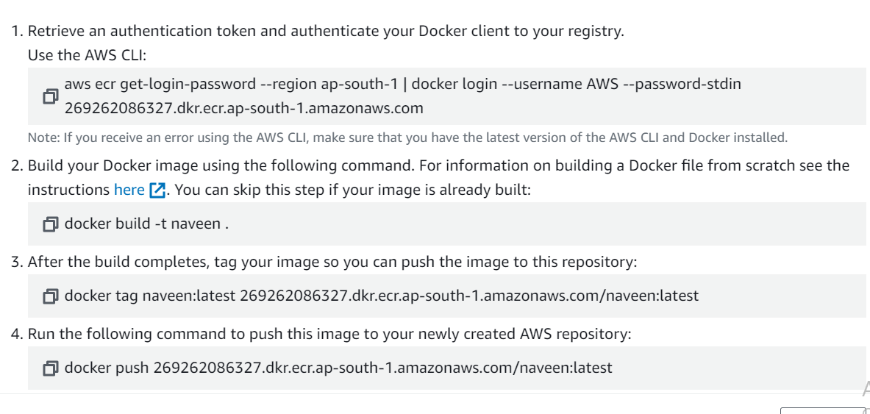

#docker pull sreeharshav/rollingupdate

The change the TAG with ecr creds

# docker tag sreeharshav/rollingupdate:v5 269262086327.dkr.ecr.ap-south-1.amazonaws.com/naveen:latest

Then push to aws ecr private repository.

# docker push 269262086327.dkr.ecr.ap-south-1.amazonaws.com/naveen:latest

After that verify in aws ecr.

Now how to pull my custom docker image from my ecr private registery?

# k create deployment mydepl3 --image 269262086327.dkr.ecr.ap-south-1.amazonaws.com/naveen:latest --replicas 3

Getting error, because access is restricted for pull the image.

So need to create secret.

How to create secret?

kubectl create secret docker-registry <secret-name> \

  --docker-username=k8sb09acr \

  --docker-password=gkqc3frJooO88cK8Ktf0a8e1JQez/e18 \

  --docker-email=mavrick202@gmail.com \

  --docker-server=k8sb09acr.azurecr.io

kubectl create secret docker-registry myregistrykey \

# --docker-server= 269262086327.dkr.ecr.ap-south-1.amazonaws.com --docker-username=k8sb10acr \

# --docker-password=6p516LKKNoWe5ZvnDgsEfAXm/il0L1cP

When we create the manifest file, here we give the secrests.

spec:

      containers:

      - image: k8sb10acr.azurecr.io/rollingupdate:v5

        name: rollingupdate

      imagePullSecrets:

        - name: myregistrykey

Verify: k describe pod <pod-name>

Here see docker image pulled from which repository.

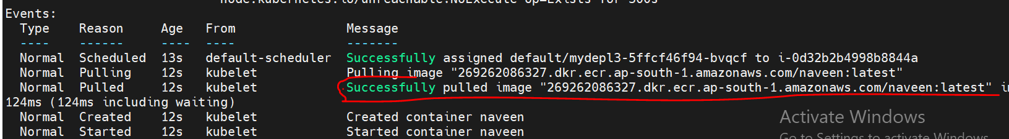

In the real time mostly used private repos.

**Generic Secrets(Opaque):**

The **Opaque** type allows you to store arbitrary data in key-value pairs, making it a versatile choice for various use cases. You can use generic secrets to store sensitive information such as passwords, API keys, and certificates.

How to create secrets for IAM:

Create user with access key/secret key

Encode that values using base64

**#echo <accesskey> | base64**

**#echo <secret-key> | base64**

Then create manifest file using these encode values.

apiVersion: v1

kind: Secret

metadata:

  name: aws-access-keys

type: Opaque

data:

  AWS_ACCESS_KEY_ID: QUtJQVJBNFk3VVhRWENSVVlJT0M=

  AWS_SECRET_ACCESS_KEY: S0c2dC9OLzNhODBidEU4RWRZZUxvMG02Y1RtT0pacGxLaUEwQ2NURQ==

Then create deployment using this secret.

apiVersion: apps/v1

kind: Deployment

metadata:

  name: awscli-deploymentnew

  labels:

    app: awscli1

spec:

  replicas: 1

  selector:

    matchLabels:

      app: awscli1

  template:

    metadata:

      labels:

        app: awscli1

    spec:

      containers:

        - name: awscli1

          image: sreeharshav/utils:latest

          env:

            - name: AWS_ACCESS_KEY_ID

              valueFrom:

                secretKeyRef:

                  name: aws-access-keys

                  key: AWS_ACCESS_KEY_ID

            - name: AWS_SECRET_ACCESS_KEY

              valueFrom:

                secretKeyRef:

                  name: aws-access-keys

                  key: AWS_SECRET_ACCESS_KEY

            - name: AWS_DEFAULT_REGION

              valueFrom: "us-east-1"

#k get secrets

#k get deployments

# k get pods

#k exec –it <pod> -- bash

Now execute aws command inside the pode.

#aws s3 ls

#env

Now get the all aws commands execute here.

**Secrets are Immutable:**

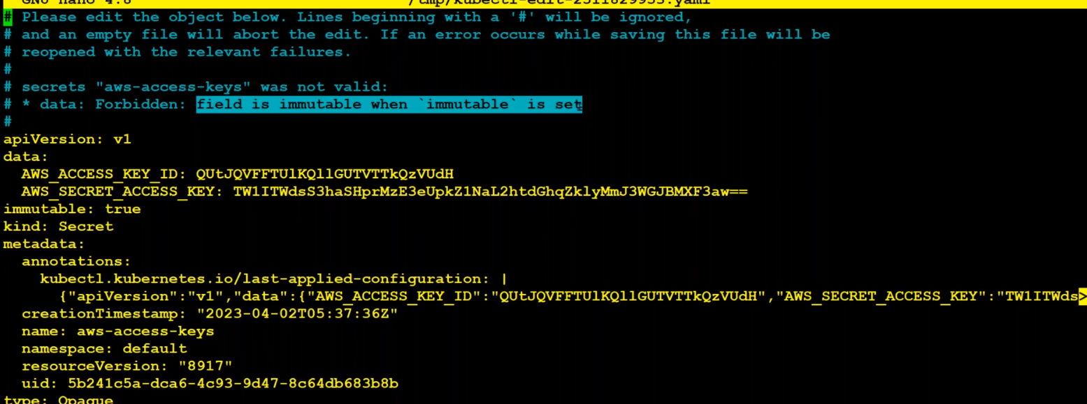

In Kubernetes, secrets are indeed considered immutable. Once a secret is created, its data cannot be modified directly. If you need to update a secret, the recommended approach is to create a new secret with the updated data and then update the reference to the new secret in your deployments, pods, or other resources.

**What is ESO (External Secret Operations):**

External Secrets typically refer to solutions or tools that integrate with Kubernetes to handle secrets in an external and centralized way.

External Secrets Controller:

The External Secrets Controller is part of the External Secrets project. It allows you to use Kubernetes resources to reference external secret values stored in external secret management systems (e.g., HashiCorp Vault, AWS Secrets Manager).

**What is ConfigMaps:**

In Kubernetes, a ConfigMap is a resource object used to store configuration data in key-value pairs. It provides a way to decouple configuration artifacts from container images, allowing you to manage configurations separately from your application code.

**v-11 Storage**

In Kubernetes, storage refers to the management of data storage resources within a cluster. Storage is crucial for persisting data across containerized applications and ensuring that data is available even if a container or a node fails.

**Types of Storage (volumes)**

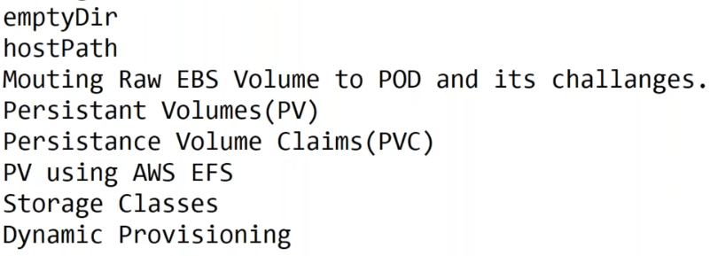

In Kubernetes, an "emptyDir" volume is a type of volume that is initially empty and is created when a Pod is assigned to a node. This volume is used to share files between containers running in the same Pod. It's called "emptyDir" because it starts as an empty directory and can be used to temporarily store data that needs to be shared among containers within the same Pod.

**Note:** A container crashing does not remove a Pod from a node. The data in an emptyDir volume is safe across container crashes.

Volumes:

On-disk files in a container are ephemeral, which presents some problems for non-trivial applications when running in containers. One problem occurs when a container crashes or is stopped. Container state is not saved so all of the files that were created or modified during the lifetime of the container are lost. During a crash, kubelet restarts the container with a clean state. Another problem occurs when multiple containers are running in a Pod and need to share files. It can be challenging to setup and access a shared filesystem across all of the containers. The Kubernetes volume abstraction solves both of these problems. Familiarity with Pods is suggested

Background:

Kubernetes supports many types of volumes. A Pod can use any number of volume types simultaneously. Ephemeral volume types have a lifetime of a pod, but persistent volumes exist beyond the lifetime of a pod. When a pod ceases to exist, Kubernetes destroys ephemeral volumes; however, Kubernetes does not destroy persistent volumes. For any kind of volume in a given pod, data is preserved across container restarts.

Create manifest file:

apiVersion: apps/v1

kind: Deployment

metadata:

  name: nginx-deployment

  labels:

    app: nginx

spec:

  replicas: 1

  selector:

    matchLabels:

      app: nginx

  template:

    metadata:

      labels:

        app: nginx

    spec:

      containers:

      - name: utils

        image: sreeharshav/utils:latest

        volumeMounts:

          - name: myemptydir

            mountPath: /etc/myemptydir

      - name: nginx

        image: nginx

        ports:

        - containerPort: 80

        volumeMounts:

            - mountPath: /tmp/myemptydir

              name: myemptydir

      volumes:

        - name: myemptydir

          emptyDir: {}

Then apply. After that get deployment and pods.

#k get pods (here have 2 containers running)

**QNS: here I have given 2 images , but why its showing one pod only?**

#k describe deployment <deployment-name>

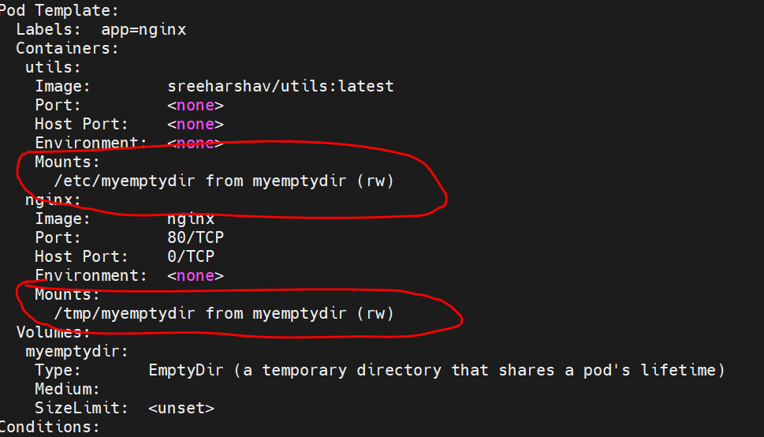

Now switch to container. We have two containers.

#k exec <pod> -c <container-name> -- bash

#k exec pod –c nginx -- bash

In container # cd /etc/myemptydir

Here create some test files for verification .

#touch FILE {1…5}

Then login to second container for verify.

Verify in path: # ls –la /tmp/myemptydir

Here find the files, what we have created in first container.

NOTE: For testing purpose only. If pod is deleted it’s lost the data.

**2.HOSTPATH:**

In Kubernetes, the hostPath volume type is a way to mount a directory from the host node's filesystem into a Pod. This means that the storage is shared between the host and the containers within the Pod. While hostPath volumes can be useful in certain scenarios, it's important to understand their limitations and potential security implications.

**Warning:**

HostPath volumes present many security risks, and it is a best practice to avoid the use of HostPaths when possible. When a HostPath volume must be used, it should be scoped to only the required file or directory, and mounted as ReadOnly.

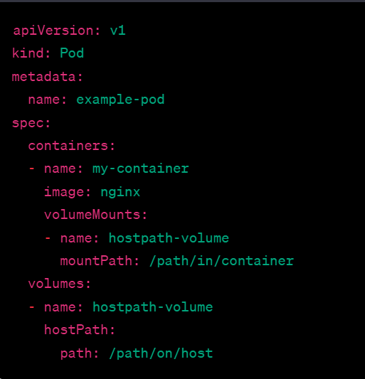

**3.Mount Raw EBS Volume to POD and its challenges:**

A simple use case consist of when we need to deploy a stateful container with a database that needs an existing persistent volume so your container can access to the data whenever is scheduled or restarted.

1.Create a EBS Volume in the AZ where u want to deploy the POD.

2. Add Tag to the EBS VOlume as below.

Tag Name: KubernetesCluster Value=<YourClusterName>

Eg: EBS Tags => KubernetesCluster: trainingk8s.xyz

Create one EBS volume in aws console.



# kubectl validate cluster

Add the tag

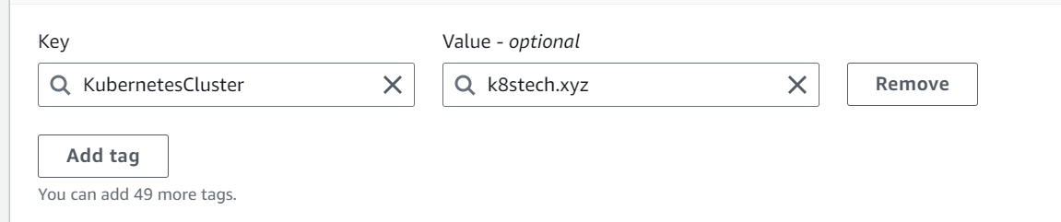

How to decide, which node my pod is deployed:

kubernetes.io/hostname: i-0a7e2c2269441bb10 (use this in manifest file)

below manifest file, need to change the volume id and hostname.

apiVersion: apps/v1

kind: Deployment

metadata:

name: mongo-deployment

labels:

app: mongodb

spec:

replicas: 1

selector:

matchLabels:

app: mongodb

name: mongodb

template:

metadata:

labels:

app: mongodb

name: mongodb

spec:

containers:

- image: mongo

name: mongodb

imagePullPolicy: Always

volumeMounts:

- name: mongodb-data

mountPath: /data/db

volumes:

- name: mongodb-data

awsElasticBlockStore:

volumeID: vol-0755d708d698d035a

fsType: ext4

nodeSelector:

kubernetes.io/hostname: i-0a7e2c2269441bb10

execute manifest file.

#k describe pod <pod-name>

Here observe attachment-ebs

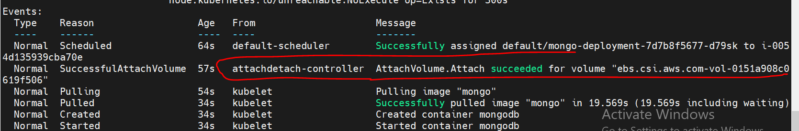

Now create some data inside pod, for conformation.

#k exec –it pod – bash

apt update && apt install mongodb-clients -y

Exec in to the container and type mongosh to open the mongo shell.

#mongosh (inside pod)



5. Execute following commands to create the DB and create test data.

> use k8sclass #This will create a db called k8sclass

db.movie.insert({"name":"Fast & Furious 1"})

db.movie.insert({"name":"Fast & Furious 2"})

db.movie.insert({"name":"Fast & Furious 3"})

db.movie.insert({"name":"Fast & Furious 4"})

db.movie.insert({"name":"Fast & Furious 5"})

db.movie.insert({"name":"Fast & Furious 6"})

> show dbs

Now delete the pod, observe it will re-create after created the pod switch in to pod and verify db is existed or not.

#k delete pod <pod-name>

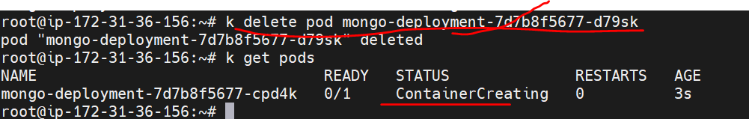

Switch to new pod and verify dbs.

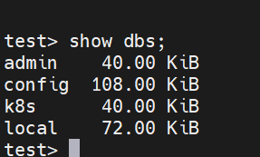

What Is the dis-adv of this volume?

May be aws admin and k8s admin both are different, that situation, must they should share the volume details, so here have some dependencies is there. So that have concept Persistent volumes.

EBS is a persistent block storage with a defined size (It is however possible to change it later).

It is fully configurable and could be the most performant solution of Amazon.

The major drawback is that it can be only mounted to one EC2 instance.

This also means that it can't be shared between multiple pods.

https://kubernetes.io/docs/concepts/storage/persistent-volumes/

<https://blog.abyssale.com/shared-storage-volume-on-amazon/>

Mapping a RAW Disk

a. EBS Volume is available in only one AZ.

b. Developers need knowledge on AWS to create vol or vol-id.

c. No data protection in case of AZ Failure.

d. Since EBS is also not shared between the EC2 VM, multiple PODs

cannot write at the same time.

**Persistence Volumes:**

A PersistentVolume (PV) is a piece of storage in the cluster that has been provisioned by an administrator or dynamically provisioned using Storage Classes. It is a resource in the cluster just like a node is a cluster resource. PVs are volume plugins like Volumes, but have a lifecycle independent of any individual Pod that uses the PV.

Key characteristics of Persistent Volumes include:

1. Manual or Dynamic Provisioning:PVs can be provisioned manually by a cluster administrator or dynamically using Storage Classes. Manual provisioning involves creating and configuring the PV resource, while dynamic provisioning is an automated process triggered by a Persistent Volume Claim (PVC) when storage is requested.

2.Storage Classes:Storage Classes are used to define different classes or types of storage with specific characteristics. When a PVC is created without specifying a Storage Class, it uses the default Storage Class. Storage Classes provide a way to dynamically provision storage based on predefined policies.

3.Access Modes:PVs have access modes that define how the volume can be mounted by Pods. The three common access modes are:

ReadWriteOnce (RWO): The volume can be mounted as read-write by a single node.

ReadOnlyMany (ROX): The volume can be mounted as read-only by multiple nodes.

ReadWriteMany (RWX): The volume can be mounted as read-write by multiple nodes.

4.Lifecycle and Retention:PVs have a lifecycle that includes phases such as Available, Bound, Released, and Failed. PVs can be reclaimed and reused after being released by a PVC, or they can be manually deleted by an administrator. The retention policy is specified in the PV reclaim policy.

5.Binding with Persistent Volume Claims (PVCs):Persistent Volume Claims are requests made by Pods for a specific amount of storage with certain access modes. PVs are bound to PVCs when a claim matches the requirements of a PV.

Create 5 volumes using below script:

Go to cloud shell🡪 then execute the script

aws ec2 create-volume --volume-type gp2 --size 2 --availability-zone ap-south-1a --tag-specifications 'ResourceType=volume,Tags=[{Key=KubernetesCluster,Value=telugugcp.xyz},{Key=Name,Value=aws-pv1}]' && \

aws ec2 create-volume --volume-type gp2 --size 4 --availability-zone ap-south-1a --tag-specifications 'ResourceType=volume,Tags=[{Key=KubernetesCluster,Value=telugugcp.xyz},{Key=Name,Value=aws-pv2}]' && \

aws ec2 create-volume --volume-type gp2 --size 6 --availability-zone ap-south-1a --tag-specifications 'ResourceType=volume,Tags=[{Key=KubernetesCluster,Value=telugugcp.xyz},{Key=Name,Value=aws-pv3}]' && \

aws ec2 create-volume --volume-type gp2 --size 8 --availability-zone ap-south-1a --tag-specifications 'ResourceType=volume,Tags=[{Key=KubernetesCluster,Value=telugugcp.xyz},{Key=Name,Value=aws-pv4}]' && \

aws ec2 create-volume --volume-type gp2 --size 9 --availability-zone ap-south-1a --tag-specifications 'ResourceType=volume,Tags=[{Key=KubernetesCluster,Value=telugugcp.xyz},{Key=Name,Value=aws-pv5}]'

After create the volume need to create one layer (persistent volume).

If we access the PV it will display all the volumes.



apiVersion: v1

kind: PersistentVolume

metadata:

  name: aws-pv1

  labels:

    type: aws-pv1

spec:

  storageClassName: gp2

  persistentVolumeReclaimPolicy: Delete

  capacity:

    storage: 2Gi

  accessModes:

  - ReadWriteOnce

  awsElasticBlockStore:

    volumeID: vol-0b7cc4cc501220406

    fsType: ext4

---

apiVersion: v1

kind: PersistentVolume

metadata:

  name: aws-pv2

  labels:

    type: aws-pv2

spec:

  storageClassName: gp2

  persistentVolumeReclaimPolicy: Delete

  capacity:

    storage: 2Gi

  accessModes:

  - ReadWriteOnce

  awsElasticBlockStore:

    volumeID: vol-0e1fbe212d1fc937a

    fsType: ext4

---

apiVersion: v1

kind: PersistentVolume

metadata:

  name: aws-pv3

  labels:

    type: aws-pv3

spec:

  storageClassName: gp2

  persistentVolumeReclaimPolicy: Delete

  capacity:

    storage: 2Gi

  accessModes:

  - ReadWriteOnce

  awsElasticBlockStore:

    volumeID: vol-0022799f8cb9a8cd3

    fsType: ext4

---

apiVersion: v1

kind: PersistentVolume

metadata:

  name: aws-pv4

  labels:

    type: aws-pv4

spec:

  storageClassName: gp2

  persistentVolumeReclaimPolicy: Delete

  capacity:

    storage: 2Gi

  accessModes:

  - ReadWriteOnce

  awsElasticBlockStore:

    volumeID: vol-0e554c989c496a2e0

    fsType: ext4

---

apiVersion: v1

kind: PersistentVolume

metadata:

  name: aws-pv5

  labels:

    type: aws-pv5

spec:

  storageClassName: gp2

  persistentVolumeReclaimPolicy: Delete

  capacity:

    storage: 2Gi

  accessModes:

  - ReadWriteOnce

  awsElasticBlockStore:

    volumeID: vol-0431690ed47c623d5

    fsType: ext4

#k apply –f yamlfile

#k get pv

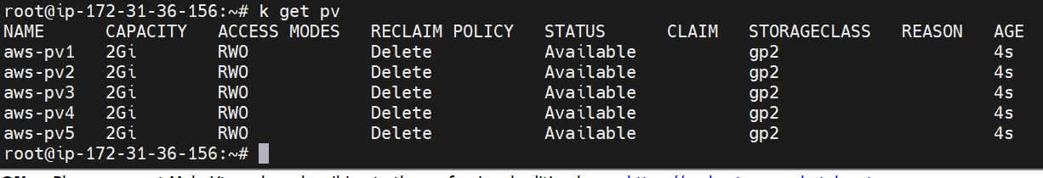

Here STATUS is available.

Persistent volume is a abstraction.

PVS:

In Kubernetes, PVC stands for Persistent Volume Claim. A Persistent Volume Claim is a resource that represents a request for a certain amount of storage resources from a Persistent Volume (PV). PVs are actual storage resources within the cluster, and PVCs act as a way for Pods to request access to and use those resources.

A PersistentVolumeClaim (PVC) is a request for storage by a user. It is similar to a Pod. Pods consume node resources and PVCs consume PV resources. Pods can request specific levels of resources (CPU and Memory). Claims can request specific size and access modes (e.g., they can be mounted ReadWriteOnce, ReadOnlyMany, ReadWriteMany, or ReadWriteOncePod, see [AccessModes](https://kubernetes.io/docs/concepts/storage/persistent-volumes/#access-modes)).

Execute pvs manifest file:

apiVersion: v1

kind: PersistentVolumeClaim

metadata:

  name: task-pv-claim1

spec:

  storageClassName: gp2

  accessModes:

    - ReadWriteOnce

  resources:

    requests:

      storage: 2Gi

**---**

apiVersion: v1

kind: PersistentVolumeClaim

metadata:

  name: task-pv-claim2

spec:

  storageClassName: gp2

  accessModes:

    - ReadWriteOnce

  resources:

    requests:

      storage: 3Gi

**---**

apiVersion: v1

kind: PersistentVolumeClaim

metadata:

  name: task-pv-claim3

spec:

  storageClassName: gp2

  accessModes:

    - ReadWriteOnce

  resources:

    requests:

      storage: 4Gi

**---**

apiVersion: v1

kind: PersistentVolumeClaim

metadata:

  name: task-pv-claim4

spec:

  storageClassName: gp2

  accessModes:

    - ReadWriteOnce

  resources:

    requests:

      storage: 6Gi

**---**

apiVersion: v1

kind: PersistentVolumeClaim

metadata:

  name: task-pv-claim5

spec:

  storageClassName: gp2

  accessModes:

    - ReadWriteOnce

  resources:

    requests:

      storage: 5Gi

# k delete pv all --all

#k get pvc

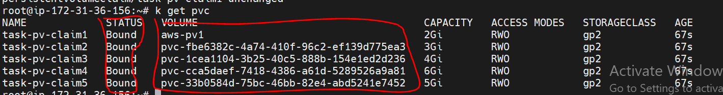

Note: One PV it create one PVC only.

* RWO - ReadWriteOnce
* ROX - ReadOnlyMany
* RWX - ReadWriteMany

**How to mount the pvc using PV?**

Here give the storage in the manifest file, what’s the required storage.

apiVersion: v1

kind: PersistentVolumeClaim

metadata:

  name: task-pv-claim1

spec:

  storageClassName: gp2

  accessModes:

    - ReadWriteOnce

  resources:

    requests:

      storage: 2Gi

---

apiVersion: v1

kind: PersistentVolumeClaim

metadata:

  name: task-pv-claim2

spec:

  storageClassName: gp2

  accessModes:

    - ReadWriteOnce

  resources:

    requests:

      storage: 3Gi

---

apiVersion: v1

kind: PersistentVolumeClaim

metadata:

  name: task-pv-claim3

spec:

  storageClassName: gp2

  accessModes:

    - ReadWriteOnce

  resources:

    requests:

      storage: 4Gi

---

apiVersion: v1

kind: PersistentVolumeClaim

metadata:

  name: task-pv-claim4

spec:

  storageClassName: gp2

  accessModes:

    - ReadWriteOnce

  resources:

    requests:

      storage: 6Gi

---

apiVersion: v1

kind: PersistentVolumeClaim

metadata:

  name: task-pv-claim5

spec:

  storageClassName: gp2

  accessModes:

    - ReadWriteOnce

  resources:

    requests:

      storage: 5Gi

**#k get pvc**

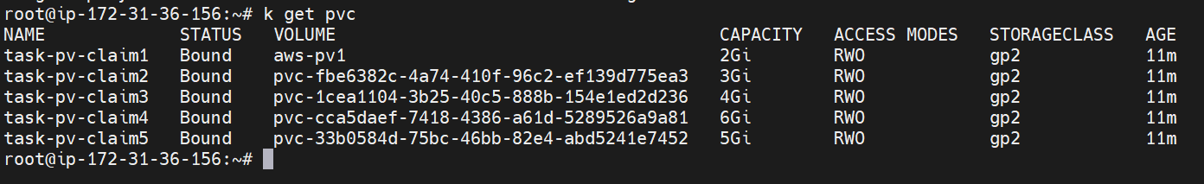

**How to delete pvc: #k delete pvc --all**

**# k delete pvc <pvc-name)**

**How to deploy with pvc?**

apiVersion: apps/v1

kind: Deployment

metadata:

  name: mongo-deployment

  labels:

    app: mongodb

spec:

  replicas: 1

  selector:

    matchLabels:

      app: mongodb

      name: mongodb

  template:

    metadata:

      labels:

        app: mongodb

        name: mongodb

    spec:

      containers:

      - image: mongo

        name: mongodb

        imagePullPolicy: Always

        volumeMounts:

        - name: mongodb-data1

          mountPath: /data/db

        - name: mongodb-data2

          mountPath: /tmp/db1

        - name: mongodb-data3

          mountPath: /tmp/db2

        - name: mongodb-data4

          mountPath: /tmp/db3

      volumes:

      - name: mongodb-data1

        persistentVolumeClaim:

           claimName: task-pv-claim1

      - name: mongodb-data2

        persistentVolumeClaim:

           claimName: task-pv-claim2

      - name: mongodb-data3

        persistentVolumeClaim:

           claimName: task-pv-claim3

      - name: mongodb-data4

        persistentVolumeClaim:

           claimName: task-pv-claim4

      nodeSelector:

          kubernetes.io/hostname: i-0d19af9669bc0e611

here kubernetes.io/hostname: i-0d19af9669bc0e611 is we decide ,pod is deployed in this particular node.

A PersistentVolumeClaim (PVC) is a request for storage by a user. It is similar to a Pod. Pods consume node resources and PVCs consume PV resources. Pods can request specific levels of resources (CPU and Memory).

While PersistentVolumeClaims allow a user to consume abstract storage resources, it is common that users need PersistentVolumes with varying properties.

Lifecycle of a volume and claim:

There are two ways PVs may be provisioned: statically or dynamically.

Static:

A cluster administrator creates a number of PVs. They carry the details of the real storage, which is available for use by cluster users. They exist in the Kubernetes API and are available for consumption.

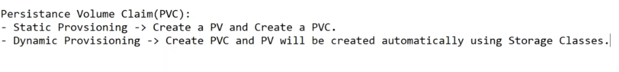

A Dynamic Persistent Volume Claim allows the automatic provisioning of storage resources without pre-allocating them.

Reclaiming

When a user is done with their volume, they can delete the PVC objects from the API that allows reclamation of the resource. The reclaim policy for a PersistentVolume tells the cluster what to do with the volume after it has been released of its claim. Currently, volumes can either be Retained, Recycled, or Deleted.

kubectl patch pv aws-pv$I -p '{"spec":{"claimRef": null}}'

**12-v Network policies:**

Network Policies in Kubernetes provide a way to specify how pods are allowed to communicate with each other and with other network endpoints. They allow you to define rules that control the traffic flow at the IP and port level. Network Policies are used to enforce segmentation and isolation of pods within a Kubernetes cluster.

Key concepts and features of Network Policies include:

**PodSelector:**

Network Policies use labels to select pods. You can define rules based on labels assigned to pods.

**Ingress and Egress Rules:**

Ingress rules control incoming traffic to pods, while egress rules control outgoing traffic from pods. You can specify allowed sources and destinations based on pod labels.

**Port-Level Policies:**

You can define rules based on specific ports and protocols, controlling which pods can communicate over specific network ports.

**Default Deny**:

By default, a Network Policy denies all traffic. You must explicitly define rules to allow communication between pods.

**Namespace Scope:**

Network Policies are applied at the namespace level. This allows for isolation and segmentation within different namespaces in a Kubernetes cluster.

Network Plugin Dependency:

The implementation of Network Policies depends on the underlying network plugin used in the Kubernetes cluster. Network plugins like Calico, Cilium, and others provide the necessary functionality to enforce Network Policies.

How to create a cluster using network ploicy:

#vi privatecluster.sh

Then execute the script:

#bash <file-name> Ex: bash privatecluster.sh

#!/bin/bash

kops create cluster --name=k8stech.xyz \

--state=s3://k8stech.xyz --zones=ap-south-1a \

--node-count=3 --master-count=1 --node-size=t2.small --master-size=t2.medium \

--master-zones=ap-south-1a --master-volume-size 10 --node-volume-size 10 \

--topology private --networking calico \

--ssh-public-key ~/.ssh/id_rsa.pub \

--dns-zone=k8stech.xyz --yes

Then verify the cluster: #k get nodes

Create two utils images:

# k run utils1 --image=sreeharshav/utils:latest -n default

# k run utils2 --image=sreeharshav/utils:latest -n default

# k get pods -o wide

# k get pods -n default

Verify connection:

# k exec -it utils2 -- ping -c 6 100.98.41.194 (pod IP)

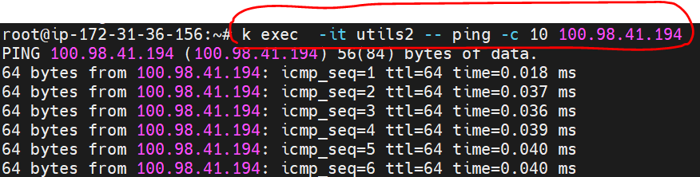

**How to create network pol:**

kind: NetworkPolicy

apiVersion: networking.k8s.io/v1

metadata:

  name: deny-ingress

  namespace: default

spec:

  podSelector:

    matchLabels:

      run: utils1

  policyTypes:

  - Ingress

Then verify:

# k exec -it utils1 -- ping -c 6 100.98.41.194

How to get networl pols:

# k get netpol

Then create egress netpol:

kind: NetworkPolicy

apiVersion: networking.k8s.io/v1

metadata:

  name: deny-egress

  namespace: default

spec:

  podSelector:

    matchLabels:

      run: utils1

  policyTypes:

  - Egress

Now verify connection:

# k exec -it utils1 -- ping -c 6 100.98.41.194



How to delete all netpol:

#k delete netpol –all

Now create some NS & Pods & utils:

#Creating Namespaces & Utilpods

kubectl create ns alpha

kubectl create ns bravo

kubectl create ns charlie

now creating labels for that ns:

#Labling Namespaces

kubectl label ns alpha nsp=alpha

kubectl label ns bravo nsp=bravo

kubectl label ns charlie nsp=charlie

how to get all labels:

# k get ns --show-labels

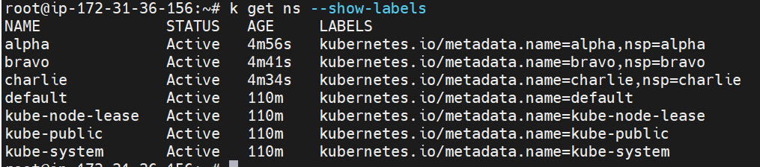

Then deploy 2 utisl in each NS:

#k run –n <NS> <pod-name> --image<image> -1 ns=alpha

#Deploy UTILS pod in all namespaces

ku run -n alpha alphautils1 --image=naveeenbabuch/utils -l ns=alpha

ku run -n alpha alphautils2 --image=sreeharshav/utils -l ns=alpha

ku run -n bravo bravoutils1 --image=sreeharshav/utils -l ns=bravo

ku run -n bravo bravoutils2 --image=sreeharshav/utils -l ns=bravo

verify all pods on alpha ns and bravo ns:

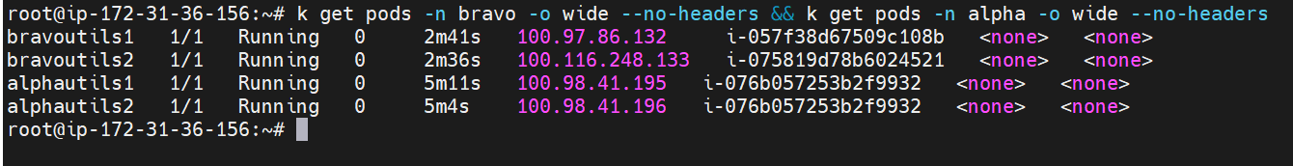

Now verify the network connection between alpha ns and bravo ns:

# k exec -it alphautils1 -n alpha -- ping -c 3 <bravoutils-podip>

# # k exec -it alphautils1 -n alpha -- ping -c 3 100.97.86.132

Connection is established from alpha to bravo.

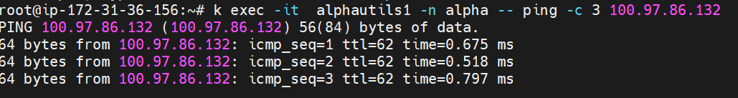

NOTE: connection is established. Finally network connection established between NS.

Now how to block input/output connection to alpha ns(all the pods):

kind: NetworkPolicy

apiVersion: networking.k8s.io/v1

metadata:

  name: deny-all-traffic-alpha

  namespace: alpha

spec:

  podSelector: {}

  policyTypes:

  - Ingress

  - Egress

Then verify connection in and put:

# k exec -it bravoutils1 -n bravo -- ping -c 3 100.98.41.195

# k exec -it alphautils1 -n alpha -- ping -c 3 100.97.86.132

NOTE: connection is refused, because blocked the ingress and egress connection.

**NOTE: have a two pods in alpha NS, can I connect these pods? No because blocked the input and output connection.**

Pod ping it self.

To get the network policies applied to your cluster:

#kubectl get networkpolicies --all-namespaces

# kubectl get networkpolicies -n <namespace>

How to delete particular networkpolicies from NS?

# k delete networkpolicies allow-traffic-within-alpha-namespace -n alpha

How to give ingres/egres connection in alpha ns only. All pods will communicate one to each in alpha ns.

#This Policy Will Allow Traffic Between PODs in Alpha NS with Label ns=alpha

---

kind: NetworkPolicy

apiVersion: networking.k8s.io/v1

metadata:

  name: allow-traffic-within-alpha-namespace

  namespace: alpha

spec:

  podSelector:

   matchLabels:

    ns: alpha

  policyTypes:

  - Ingress

  - Egress

  ingress:

  - from:

    - podSelector:

        matchLabels:

          ns: alpha

  egress:

  - to:

    - podSelector:

        matchLabels:

          ns: alpha

then verify connection pods to pods.

# k exec -it alphautils2 -n alpha -- ping -c 3 100.98.41.195

NOTE: after delete the policy, once cross verify?

Con: n/w policies work n labels only.

**3-1 v-13**

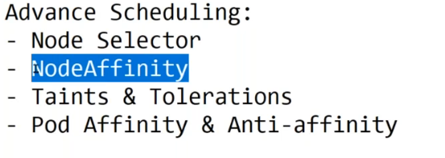

**Node Swlector:** When we use node selector?

In Kubernetes, a node selector is a field of a pod specification that specifies a set of node labels. Node selectors are used to constrain which nodes the pod is eligible to be scheduled based on the labels assigned to nodes in the cluster. This allows you to influence the placement of your pods on specific nodes that satisfy the node selector requirements.

**1.Define Node Labels:** Before you can use a node selector, you need to have nodes labeled with specific key-value pairs

#kubectl label nodes <node-name> <label-key>=<label-value>

# k label node i-075819d78b6024521 high-perf-cpu=yes

#kubectl label nodes node-1 environment=production

**2.Use Node Selector in Pod Definition:** In your pod YAML file, you can specify a node selector using the **nodeSelector** field. This field should contain the labels that a node must have to be considered a candidate for scheduling the pod.

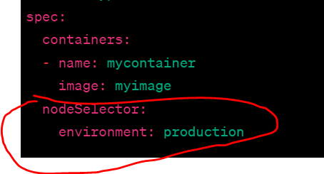

How t get node description:

# k describe node <node-ip>

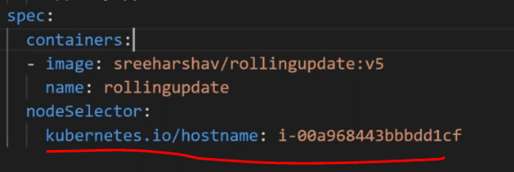

OR

How to add labels to select nodes to deploy.

#ku label node <node-ip> high-perf-cpu=yes

# k label node i-075819d78b6024521 high-perf-cpu=yes

Then verify node labesl:

# k get nodes i-057f38d67509c108b --show-labels

**Now create one manifest file using labels to deploy particular nodes only. Before deploy need to create lables to nodes, which nodes you deploy the pods.**

apiVersion: apps/v1

kind: Deployment

metadata:

  labels:

    app: myapp02

  name: myapp02

spec:

  replicas: 4

  selector:

    matchLabels:

      app: myapp02

  template:

    metadata:

      labels:

        app: myapp02

    spec:

      containers:

      - image: sreeharshav/rollingupdate:v1

        name: rollingupdate

      nodeSelector:

        high-perf-cpu: "yes"

Then verify : # k get pods –o wide

**NODE AFFINITY:**

URL: [Working With Node Affinity In Kubernetes | by @pramodAIML | SysopsMicro | Medium](https://medium.com/the-programmer/working-with-node-affinity-in-kubernetes-40bc79d16f2f)

**What is Node Affinity?**

Node affinity is objectively used to perform the same task as nodeSelector where it allows you to constrain which nodes your pod is eligible to be scheduled on, based on labels on the node. But it differs in its ability to make this constraint become more expressive

The affinity language in node affinity offers the protocols or matching rule based on logical OR/ AND operation, NOT operations, etc..

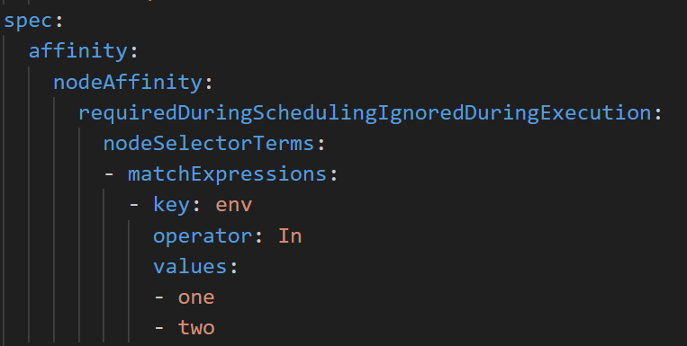

In node selector, we used nodeSelector field under the Spec, but here in the pod definition, it is replaced by more complex terms.

affinity is used to define nodeAffinity parameter which encompasses the complex sentence like the term.

**requiredDuringSchedulingIgnoredDuringExecution**:

This sentence encompasses **nodeSelectorTerms,**

whichin turn holds the field

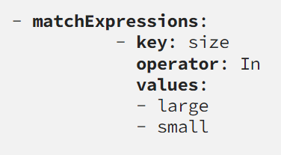

it is the place where you manage the logical AND, OR, NOT expression to define more expressive constraints for the pod. If you carefully observe the - **matchExpressions**

key: which defines the parameter like size

operator: here we place the operator: In, it can also have the values like NotIn, Exists. There are more operators which one need to refer to in the Kubernetes doc

value: which defines values for the keys like, large, medium, medium and small, medium or large, only medium, not small, etc..



Now create labels to nodes:

# kubectl label node i-057f38d67509c108b env=one

# kubectl label node i-075819d78b6024521 env=two

apiVersion: apps/v1

kind: Deployment

metadata:

  labels:

    run: required-hard

  name: required-hard

spec:

  replicas: 8

  selector:

    matchLabels:

      run: required-hard

  template:

    metadata:

      labels:

        run: required-hard

    spec:

      affinity:

        nodeAffinity:

          requiredDuringSchedulingIgnoredDuringExecution:

            nodeSelectorTerms:

            - matchExpressions:

              - key: env

                operator: In

                values:

                - one

                - two

      containers:

      - image: nginx:latest

        name: required-hard

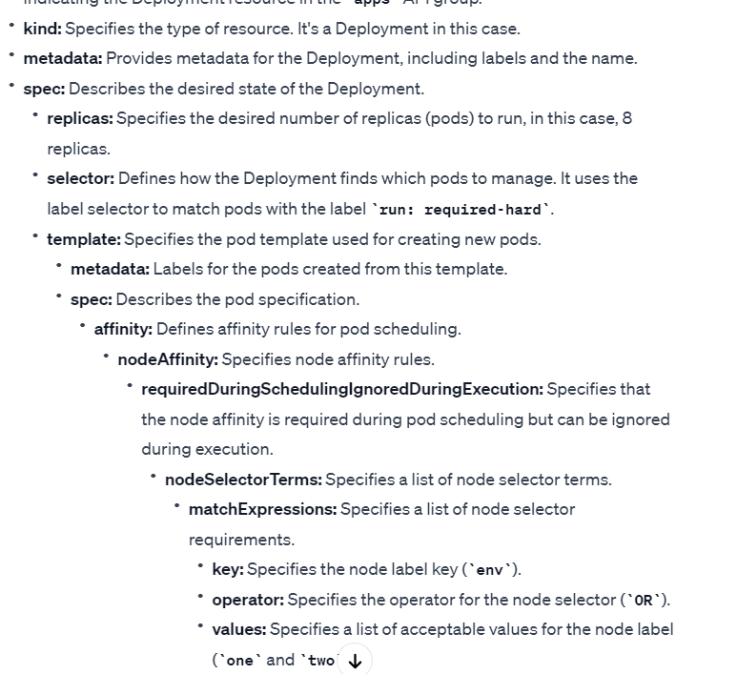

# k get pods -o wide --no-headers

# k scale deployment required-hard --replicas 4

**CORDON:**

In Kubernetes, the **kubectl cordon** command is used to mark a node as "unschedulable." When a node is cordoned, it signals to the Kubernetes scheduler that no new pods should be scheduled onto that node. However, existing pods running on the node continue to operate.

#kubectl cordon <node-name>

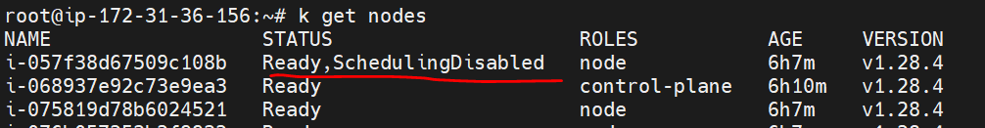

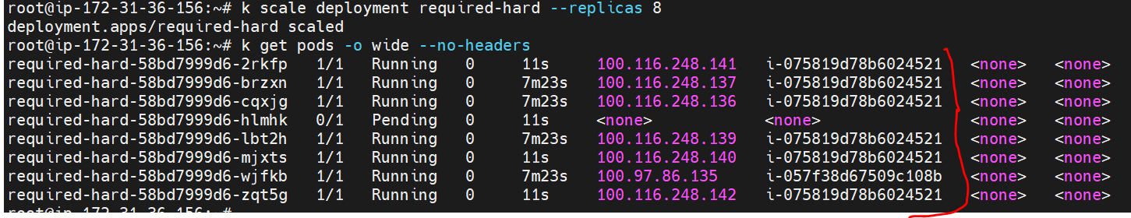

Once a node is cordoned, the scheduler will not place new pods on it unless the pods have specific tolerations that match the cordoned node's conditions.

Cordoning a node is useful in scenarios such as maintenance, when you want to ensure that no new workloads are scheduled onto a node before performing maintenance tasks.

To uncordon a node and make it schedulable again, you can use the **kubectl uncordon** command:

#kubectl uncordon <node-name>

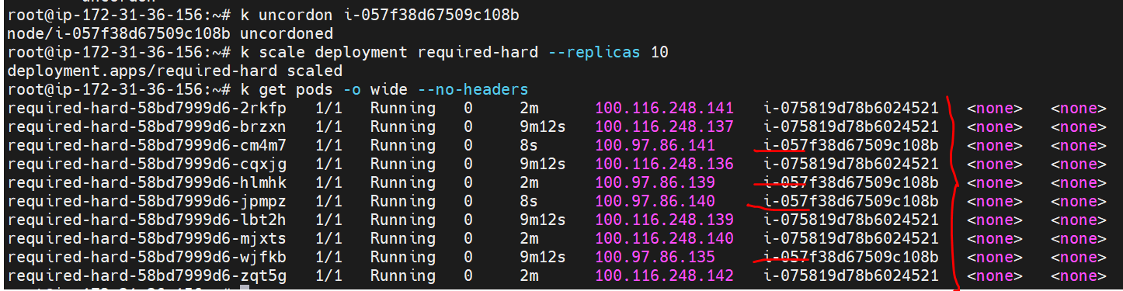

Uncordoning a node allows the scheduler to resume normal operations, allowing new pods to be scheduled on the node.

Node Affinity Type:

The types of Node affinity actually define the behavior of our scheduler with respect to Node affinity and based on the stage of our Pod’s lifecycle.

There are two major categories of Node Affinity

Available:

It has two types of node affinity :

requiredDuringSchedulingIgnoredDuringExecution

and

preferredDuringSchedulingIgnoredDuringExecution

2. Planned:

requiredDuringSchedulingrequiredDuringExecution

Let’s understand each of these in detail, by breaking these terms up to make more sense.

Available:

- requiredDuringSchedulingIgnoredDuringExecution:

- preferredDuringSchedulingIgnoredDuringExecution:

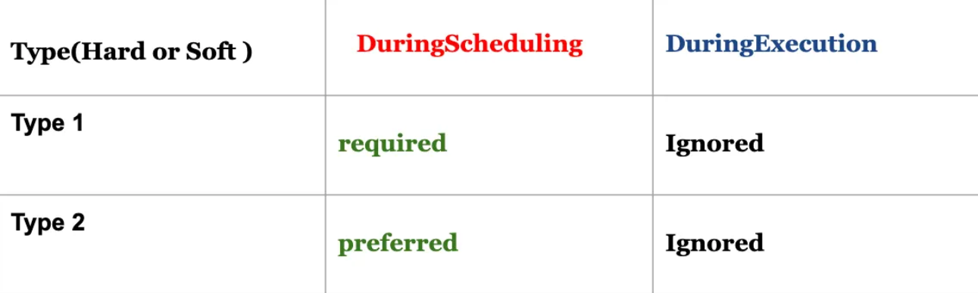

DuringScheduing:

It is the state when the POD is being created for the first time

so if we have the situation where at the time of pod creation, there is no matching Node label, Kubernetes refers to the type parameter as shown in the table above to enforce decisions on pod’s scheduling.

required:

If the parameter is of the type required: In that case, the scheduler will mandate the POD to be scheduled based on the given Affinity rule, so if there are no matching label at the Node side, this pod will not be scheduled in the Node by our scheduler. That is why we can call this a “Hard” type of enforcement rule.

Preferred:

If the parameter is of the type preferred: In that case, the scheduler will try to enforce the but will not guarantee, so there are chances that POD may be allowed to schedule in the Node. That is why it also is known as a soft kind of rule, here we have given a choice to the scheduler that placement of pod is not as important as executing the workload.

DuringExecution:

This is a state where POD is already running in the given NODE.

In this state, if someone by mistake removed the node label, the already POD will be managed by scheduler based on the available Node affinity parameter

“ignored” DuringExecution, as shown in fig1.0

which tells the scheduler to ignore this situation and keep running the POD in the node.

There is also another type of Node Affinity which is kind of Planned and that is :

Planned Type:

" requiredDuringSchedulingrequiredDuringExecution"

Here at the time of POD execution, one can also define it to be of Type requiredDuringExecution

instead of ignoredDuringExecution.

which tells the scheduler to evict the running POD, if the NODE in which is was scheduled has been modified and there is no matching label available.

Let’s Understand all that we discussed by the POD definition below:

**Weight Field:**

Node Affinity and Anti-Affinity:

Node Affinity: Node affinity is a way to constrain which nodes a pod is eligible to be scheduled based on node labels. It allows you to influence the scheduling decisions so that pods are placed on nodes that satisfy certain conditions.

Anti-Affinity: Node anti-affinity, on the other hand, specifies rules to avoid placing pods on nodes with specific characteristics. It discourages co-locating pods on nodes with the same labels.

Weight Field:

When defining node affinity or anti-affinity rules, you can specify multiple conditions using nodeSelectorTerms. The weight field is used to assign relative importance to these terms.

The weight field is a positive integer value. The higher the weight, the more important the corresponding term is when considering node placement.

When the scheduler evaluates multiple node affinity or anti-affinity rules, it uses the weight field to prioritize them. Rules with higher weights are given more importance, and the scheduler tries to satisfy them first.

kubectl label node i-007d6a517ab67f906 env=one

kubectl label node i-080151329a9fb1c6d env=two

kubectl label node i-08fd11925e913b080 env=three

apiVersion: apps/v1

kind: Deployment

metadata:

  labels:

    run: preferred-soft

  name: preferred-soft

spec:

  replicas: 4

  selector:

    matchLabels:

      run: preferred-soft

  template:

    metadata:

      labels:

        run: preferred-soft

    spec:

      affinity:

        nodeAffinity:

          preferredDuringSchedulingIgnoredDuringExecution:

          - weight: 40

            preference:

              matchExpressions:

              - key: env

                operator: In

                values:

                - one

          - weight: 20

            preference:

              matchExpressions:

              - key: env

                operator: In

                values:

                - two

          - weight: 10

            preference:

              matchExpressions:

              - key: env

                operator: In

                values:

                - three

      containers:

      - image: nginx

        name: deploy01

Difference between node selector and node affinity:

Node Selector:

Definition: Node selector is a simple way to constrain which nodes a pod can be scheduled based on node labels.

How it works: When you define a pod's specification, you can specify a set of node labels using the nodeSelector field. The pod is then scheduled only on nodes that have labels matching the specified criteria.

Usage: Node selector provides a straightforward way to schedule pods on nodes with specific labels but lacks advanced matching and prioritization capabilities.

Node Affinity:

Definition: Node affinity is a more advanced and flexible mechanism for influencing pod scheduling based on node attributes.

How it works: Node affinity rules are specified using the affinity.nodeAffinity field. They allow you to express more complex requirements, combining multiple node selector terms with logical operators (AND, OR) and introducing a weight field to prioritize terms.

Usage: Node affinity is suitable for scenarios where you need to express more nuanced scheduling requirements. It allows you to specify multiple conditions and prioritize them based on weights.

Key Differences:

Flexibility:

Node selector is more straightforward but less flexible, as it supports simple equality-based matching.

Node affinity is more flexible, allowing you to use logical operators and weights to express complex conditions.

Expressiveness:

Node selector expresses simple requirements using equality-based matching.

Node affinity allows you to express complex requirements by combining multiple node selector terms with logical operators.

Matching:

Node selector is more limited in terms of matching capabilities.

Node affinity provides advanced matching capabilities, allowing for more nuanced scheduling decisions.

**Taint:**

Taints are a Kubernetes node property that enable nodes to repel certain pods. Tolerations are a Kubernetes pod property that allow a pod to be scheduled on a node with a matching taint.

QNS: in k8s why pods are not deployed in controlplane?

#k describe node <control-plance-IP>

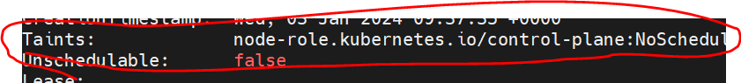

#ku taint node 007d6a517ab67f906 high-cpu=yes:NoSchedule

#ku taint node 007d6a517ab67f906 med-cpu=yes:NoSchedule

#ku taint node 007d6a517ab67f906 low-cpu=yes:NoSchedule

# k describe nodes i-057f38d67509c108b | grep -i high

NOTE: when we taint the nodes, existing pods don’t have any problem.

Now try to create deployment:

# k create deployment mydepl --image=nginx:latest --replicas 6

But pods are not creating. It’s showing pending status.

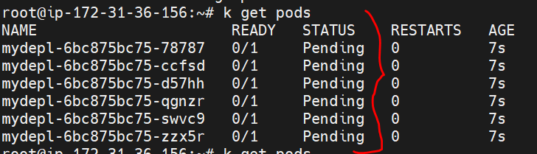

#k describe pod <pod>

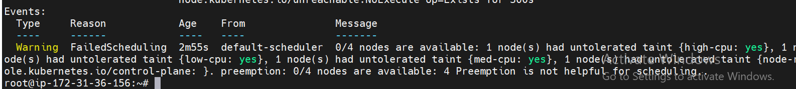

NOTE: it will not touch existing pods.

How to untaint:

# k taint node i-057f38d67509c108b high-cpu-

# k taint node i-075819d78b6024521 med-cpu-

# k taint node i-076b057253b2f9932 low-cpu-

NoExecute:

In Kubernetes, the NoExecute taint effect is used to repel and evict existing pods from a node that is tainted. Unlike NoSchedule and PreferNoSchedule effects, which prevent the scheduling of new pods on a tainted node, the NoExecute effect is applied to enforce the eviction of existing pods from a node after it has been tainted.

# k taint node i-057f38d67509c108b high-cpu=yes:NoExecute

# k taint node i-075819d78b6024521 med-cpu=es:NoExecute

# k taint node i-076b057253b2f9932 low-cpu=es:NoExecute

How to remove the taints:

# k taint node i-057f38d67509c108b high-cpu-

# k taint node i-075819d78b6024521 med-cpu-

# k taint node i-076b057253b2f9932 low-cpu-

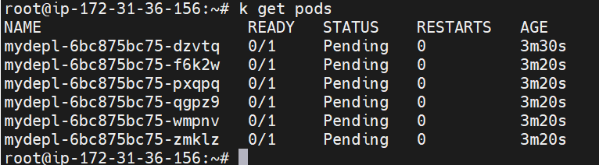

**Tolerations:**

The tolerations defined on pods make the pods tolerant to be scheduled on the specified tainted node.

Note: tolerations do not make a pod exclusive to the tainted node, infact it simply means that the pod with toleration towards a taint can be scheduled on the tainted node as well as the other normal nodes.

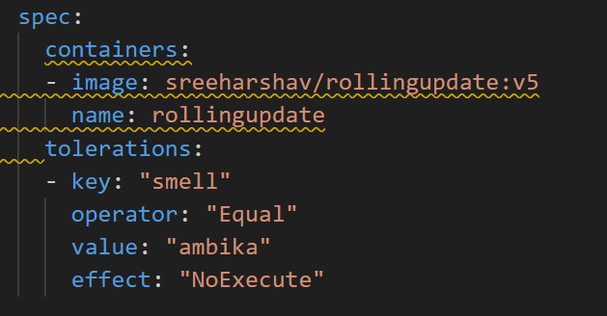

Key: The key of the taint to tolerate. This is the string that identifies the taint on the node.

Operator: Specifies the operator for the toleration. Common operators include Exists, Equal, and DoesNotExist.

Exists: Tolerate any value for the specified key.

Equal: Tolerate only the exact value specified for the key.

DoesNotExist: Tolerate the absence of the specified key.

Value: An optional value associated with the key. It is used with the Equal operator to specify the exact value that should be tolerated.

Effect: Specifies the effect of the taint to tolerate. This includes NoSchedule, PreferNoSchedule, and NoExecute.

NoSchedule: Tolerate scheduling on nodes with the specified taint.

PreferNoSchedule: Prefer scheduling on nodes without the specified taint but tolerate scheduling on nodes with the taint if necessary.

NoExecute: Tolerate existing pods running on nodes with the specified taint to prevent eviction.

Now I deployed pod in taint=high-cpu

apiVersion: apps/v1

kind: Deployment

metadata:

  labels:

    app: nottaint2

  name: nottaint2

spec:

  replicas: 4

  selector:

    matchLabels:

      app: nottaint2

  template:

    metadata:

      labels:

        app: nottaint2

    spec:

      containers:

      - image: sreeharshav/rollingupdate:v5

        name: rollingupdate

      tolerations:

      - key: "high-cpu"

        operator: "Equal"

        value: "yes"

        effect: "NoExecute"

how to know which node is high-cpu taint:

# k describe node <node-ip>

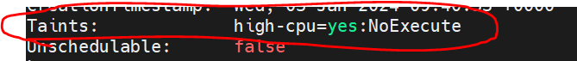

NOTE: try to create deployment without toleration? Will getting pod is pending only.

# k create deployment naveen --image=nginx:latest

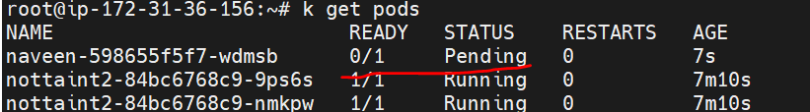

we can use both combination(taint & toleration):

NOTE: when we use cordon it will add taint=NoSchedule to that particular node.

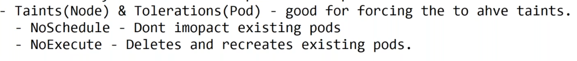

**Pod Affinity:**

In Kubernetes, pod affinity is a feature that allows you to influence the scheduling of pods based on the presence of other pods. It defines rules specifying how pods should be scheduled relative to other pods.

NOTE: related pods are deployed in same node.

Anti-affinity rules are used to express preferences or requirements for the separation of pods. The purpose is to distribute or isolate pods across nodes to achieve better availability, fault tolerance, or performance.

NOTE: pods are in different nodes.

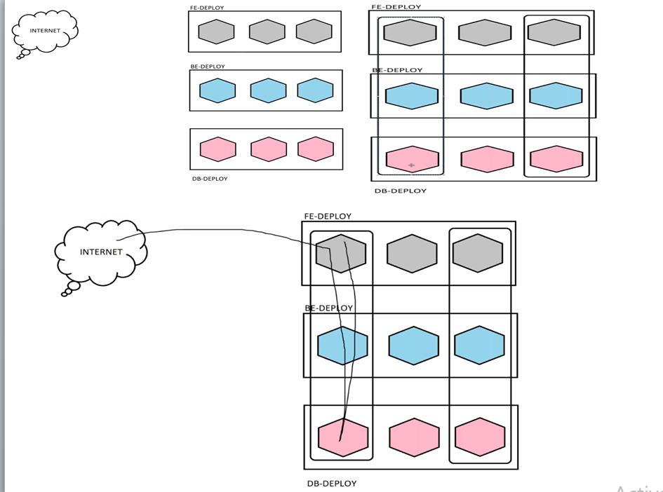

**v-14 Istio-ServiceMesh:**

For Arch: https://www.youtube.com/watch?v=2uluzXqcrWY

Istio is an open-source service mesh platform that provides a set of tools for managing and securing microservices in a Kubernetes (K8s) environment. A service mesh is a dedicated infrastructure layer for handling service-to-service communication, offering features such as traffic management, load balancing, service discovery, and security.

**Key components of Istio include:**

Envoy Proxy: Istio uses Envoy as its data plane proxy. Envoy is a high-performance proxy that is deployed alongside each service instance to handle the communication between services.

Control Plane: The Istio control plane consists of various components that manage and configure the behavior of the Envoy proxies. Some of the core control plane components include Pilot (managing service discovery and traffic management), Mixer (handling policy checks, telemetry, and reporting), and Citadel (managing security).

Traffic Management: Istio allows for sophisticated traffic management through features like intelligent routing, load balancing, and canary releases. This enables fine-grained control over the flow of traffic between microservices.

Security: Istio provides security features such as mutual TLS (mTLS) authentication, access control policies, and encryption to enhance the overall security of microservices communication.

Observability: Istio collects telemetry data from all the Envoy proxies and provides powerful monitoring and tracing capabilities. This helps in gaining insights into the performance and behavior of microservices.

Istio is designed to be platform-agnostic and can be integrated with various orchestration platforms, but it is commonly associated with Kubernetes. It adds an additional layer to Kubernetes deployments, addressing challenges related to microservices communication, observability, and security. With Istio, developers and operators can manage and secure their microservices-based applications more effectively.

[Istio](https://istio.io/) is an open source [service mesh](https://www.redhat.com/en/topics/microservices/what-is-a-service-mesh) platform that provides a way to control how [microservices](https://www.redhat.com/en/topics/microservices/what-are-microservices) share data with one another. It includes [APIs](https://www.redhat.com/en/topics/api/what-are-application-programming-interfaces) that let Istio [integrate](https://www.redhat.com/en/topics/integration/what-is-integration) into any logging platform, telemetry, or policy system. Istio is designed to run in a variety of environments: on-premise, cloud-hosted, in [Kubernetes](https://www.redhat.com/en/topics/containers/what-is-kubernetes) [containers](https://www.redhat.com/en/topics/containers), in services running on [virtual machines](https://www.redhat.com/en/topics/virtualization/what-is-a-virtual-machine), and more.

* **Traffic management** - Traffic routing and rules configuration in Isitio allow you to control the flow of traffic and API calls between services.
* **Security** - Istio provides the underlying communication channel and manages authentication, authorization, and encryption of service communication at scale. With Istio, you can enforce policies consistently across multiple protocols and runtimes with minimal application changes. When using Istio with Kubernetes (or infrastructure) network policies, the benefits include the ability to secure pod-to-pod or service-to-service communication at the network and application layers.
* [**Observability**](https://www.redhat.com/en/topics/devops/what-is-observability) - Get insights into your service mesh deployment with Istio’s tracing, monitoring, and logging features. Monitoring lets you see how service activity impacts performance upstream and downstream. Custom dashboards provide visibility into the performance of all your services.

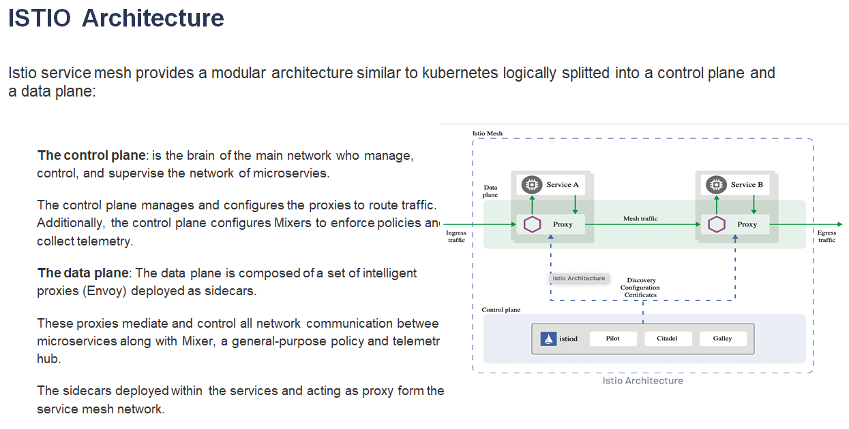

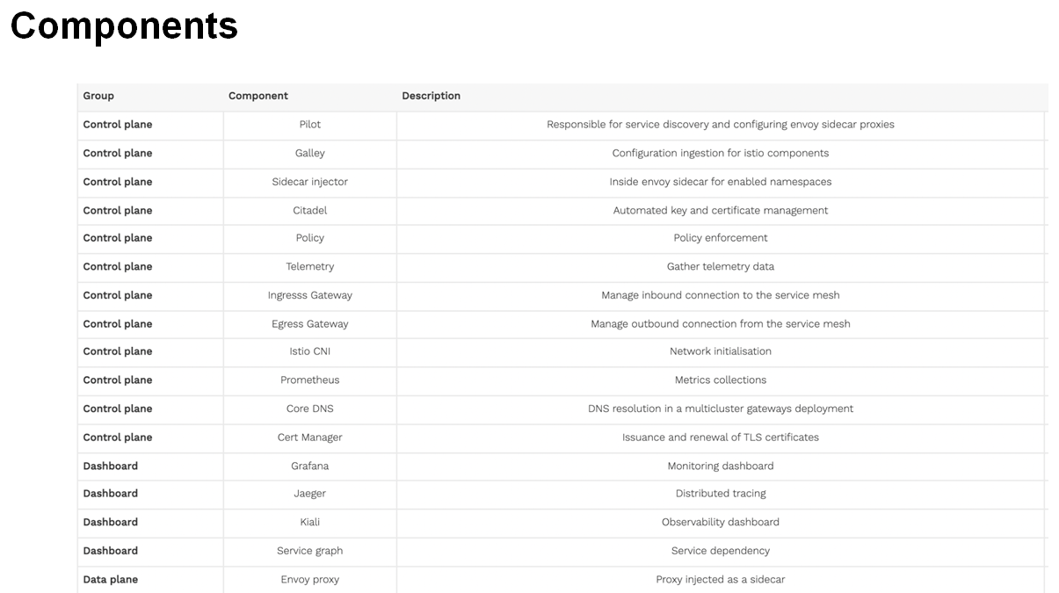

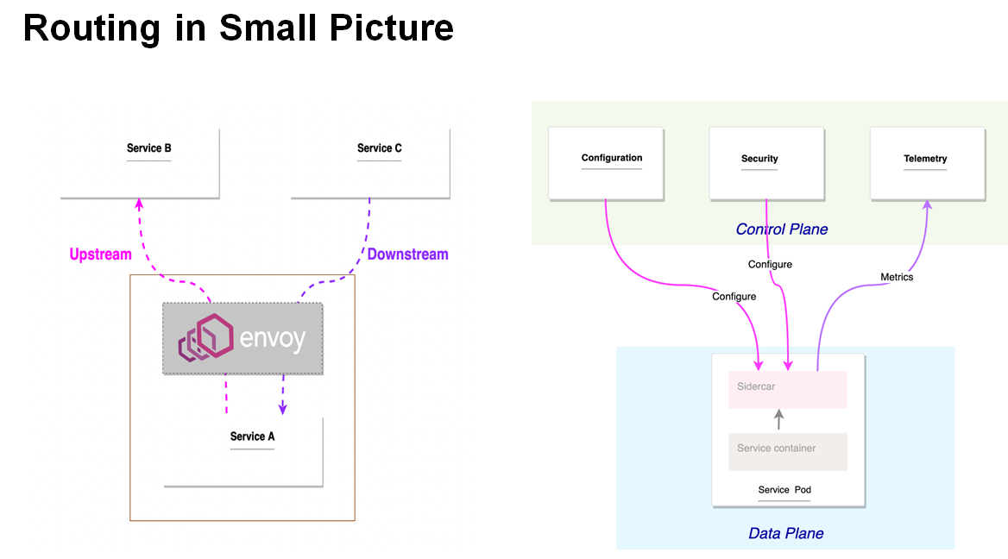

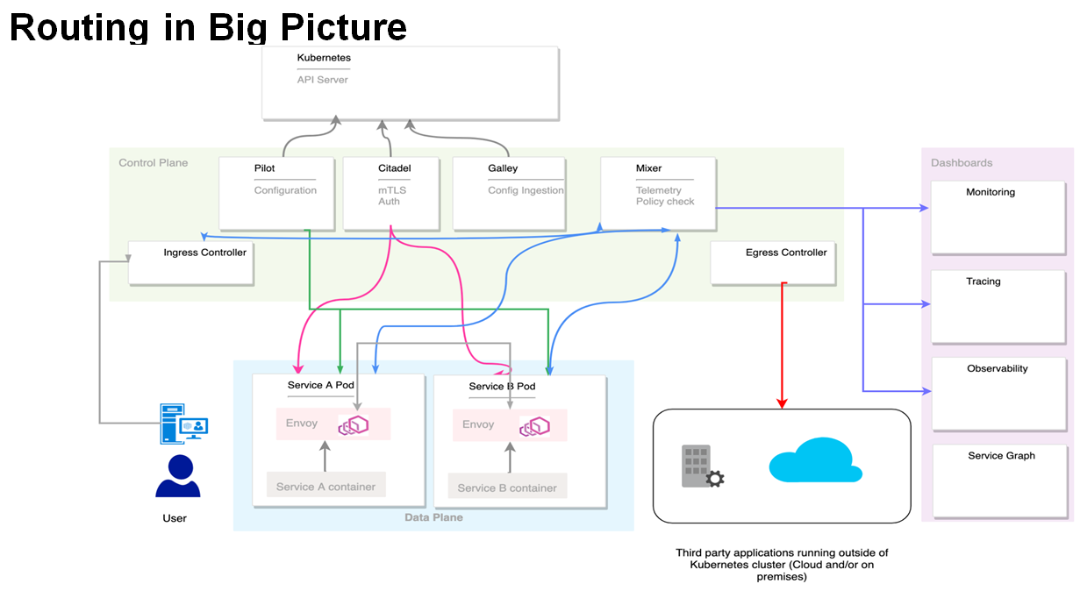

* The ingress controller is responsible for allowing and redirecting the inbound traffic to the services running inside the service mesh.
* The egress controller is responsible for allowing outbound traffic from the service mesh. If an application should connect, for example, to an external database or service, such configuration should be explicitly defined for the egress controller.
* Pilot and Galley are responsible for the mesh configuration: they pull data from Kubernetes API Server and mix it with the local configuration defined within the mesh then push the configuration to different proxies forming the mesh.
* Citadel push tls certificate to services enabling mutual TLS.
* Mixer has two roles: gather metrics from the different components and enforce policy by double check each request. In a high level deployment scenario Telemetry and Policy check should be deployed separately.
* Dashboards gather metrics from the telemetry service and display it in a user friendly format.

**How to install Istio:**

DOwnload Istio and Copy istioctl to /usr/local/bin

url: https://istio.io/latest/docs/setup/getting-started/#download

curl -L https://istio.io/downloadIstio | sh -

curl -L https://istio.io/downloadIstio | ISTIO_VERSION=1.20.1 TARGET_ARCH=x86_64 sh –

cd istio-1.20.1

export PATH=$PWD/bin:$PATH

istioctl install --set profile=demo –y

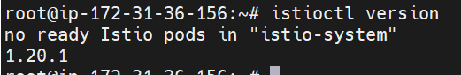

Switch to istio-system NS

# kubens istio-system

# k get pods

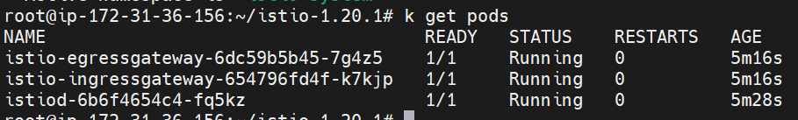

Load balancer is created:

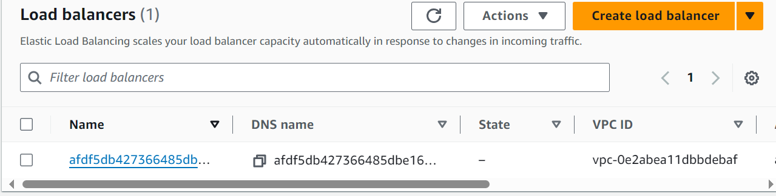

**What is kiali:**

Kiali is an open-source observability and management platform designed for Istio, which is a popular service mesh solution for Kubernetes. Kiali provides a graphical user interface (GUI) that allows users to visualize, monitor, and manage the traffic between services in a microservices architecture.

**Key features of Kiali include:**

1.Service Graph Visualization:

Kiali offers a graphical representation of the microservices and their relationships within an Istio service mesh. It helps users understand how services communicate with each other.

Traffic Flow Monitoring: Kiali provides real-time monitoring of the traffic flow between services, allowing users to see the request and response rates, error rates, and latencies for each service.

Dependency Mapping: Users can explore the dependencies between microservices, helping them identify potential bottlenecks, understand the flow of requests, and troubleshoot issues.

Istio Configuration Management: Kiali allows users to view and manage Istio configuration details such as virtual services, destination rules, and gateways. This simplifies the process of configuring and updating Istio features.

Health and Metrics Monitoring: Kiali provides health status and metrics for each microservice in the service mesh. It helps users monitor the overall health of their applications and identify any anomalies or issues.

Tracing Integration: Kiali integrates with distributed tracing systems like Jaeger, allowing users to trace requests across microservices and analyze performance bottlenecks.

Security Dashboard: Kiali includes features for monitoring and managing security aspects of Istio, such as mutual TLS (mTLS) configuration and service authentication.

User Authentication and Authorization: Kiali supports user authentication and authorization, ensuring that only authorized users can access the platform and view sensitive information.

Kiali simplifies the management and monitoring of microservices deployed in a Kubernetes cluster with Istio.

**For kiali we need prometheus. Install using the following command:**

#kubectl apply -f <https://raw.githubusercontent.com/istio/istio/release-1.16/samples/addons/prometheus.yaml>

After install prometheus verify the pods:

Switch to istio-system NS then get pods

# k get pods

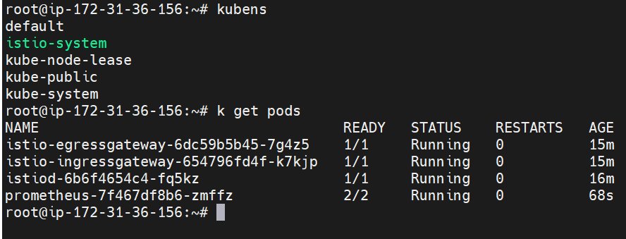

**Enable ISTIO on Default Namespace:**

*#kubectl label namespace default istio-injection=enabled*

*# k create deployment naveen --image nginx:latest*

*# k get pods*

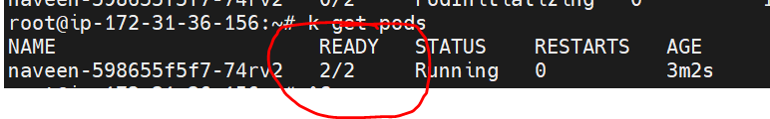

Previously it’s showing 1/1, but now it’s showing 2/2.

#k describe pods <pod> (here you will observer container deatails and istio-proxy details as well.

We need to use AWS NLB before Istio Ingress Controller. Create a new file with name istio-ingressgateway.yml and copy below to it.

apiVersion: install.istio.io/v1alpha1

kind: IstioOperator

metadata:

  name: istio-ingressgateway

spec:

  profile: empty # Do not install CRDs or the control plane

  components:

    ingressGateways:

    - name: ingressgateway

      namespace: istio-system

      enabled: true

      k8s:

        serviceAnnotations:

          service.beta.kubernetes.io/aws-load-balancer-type: "nlb"

      label:

        istio: ingressgateway

  values:

    gateways:

      istio-ingressgateway:

        injectionTemplate: gateway

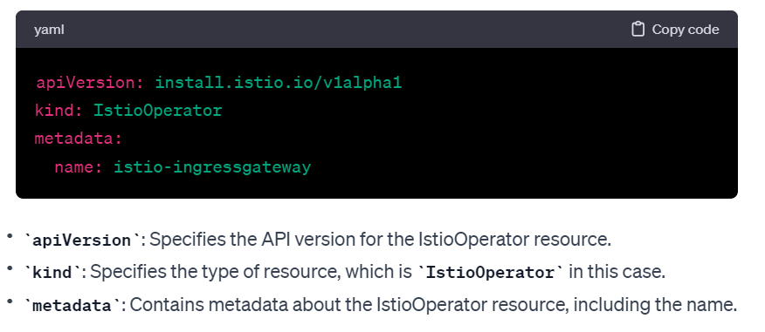

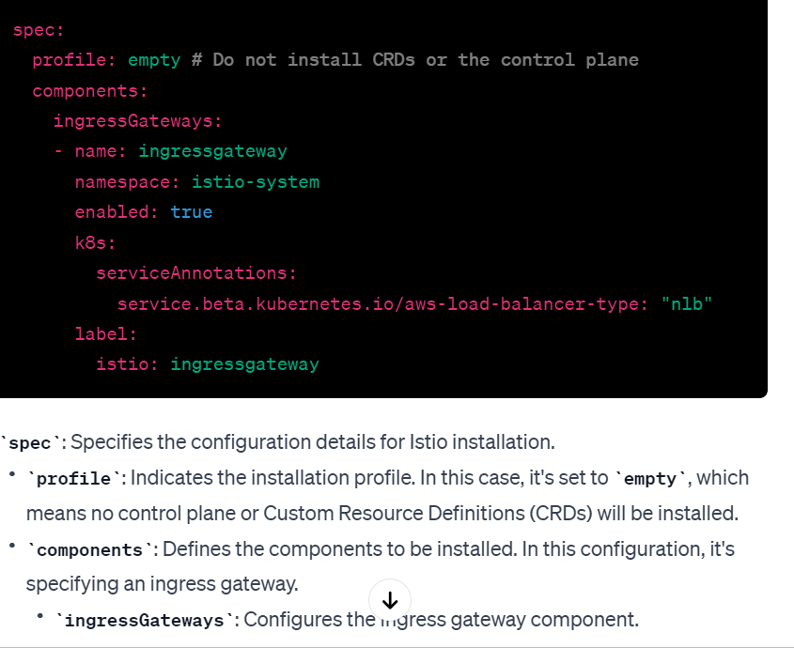

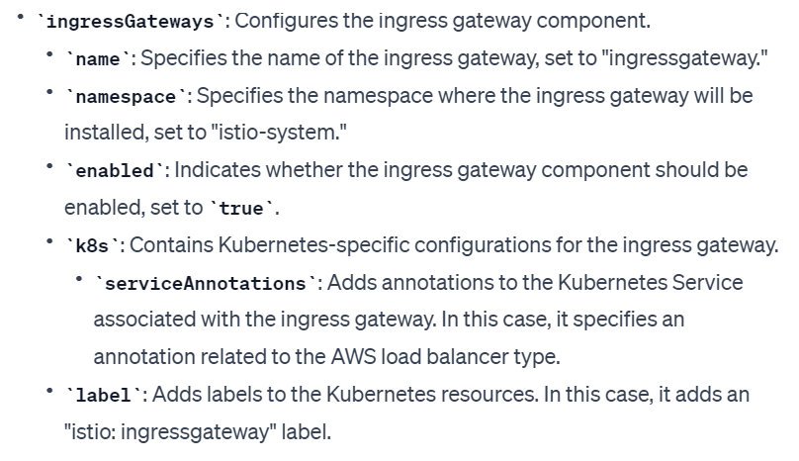

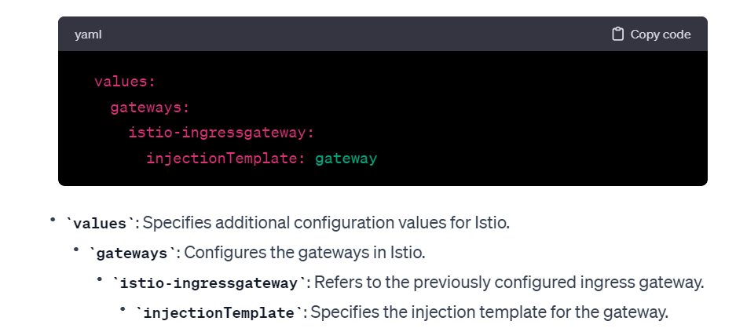

To Install ISTIO with AWS NLB as a load balancer, run the following command:

*#istioctl install --set profile=minimal -f istio-ingressgateway.yml*

Uninstall istio:

istioctl manifest generate | kubectl delete -f –

*kubectl delete namespace istio-system*

*v-15 Promethues- Grafanna-EFK*

What is Prometheus?

An open-source monitoring tool called Prometheus is used to gather and aggregate metrics as time series data. Simply put, every item in a Kubernetes Prometheus store is a metric event that comes with a timestamp.

Events are recorded in real time by Prometheus. Any event that is pertinent to your program can be included in this list, including memory usage, network activity, and specific inbound requests.

"Metrics" are the basic unit of data. Each measure has a name that can be used to refer to it as well as a number of labels. The metrics in your database can be filtered using labels, which are arbitrary key-value data pairs.

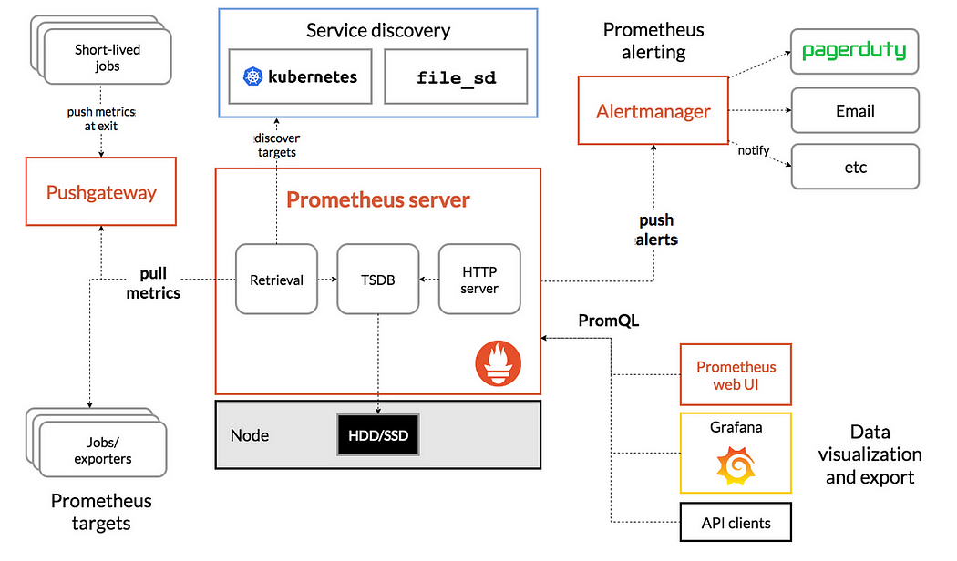

1. Prometheus Server:

This core component handles data collection, storage, querying, and metrics processing. It operates on a multi-dimensional data model, collecting metrics at specified intervals, evaluating rule expressions, and potentially triggering alerts.

1. Data Storage: Utilizing a time-series database (TSDB), Prometheus stores metrics efficiently. This TSDB organizes data into blocks containing compressed time-series information, optimized for fast-read operations and historical data access. Its data retention system allows setting specific data retention time frames and expiration policies.
2. Alertmanager: Managing alerts from the Prometheus server, Alertmanager handles routing, silencing, and aggregation of notifications, supporting various channels like email, Slack, PagerDuty, and OpsGenie.
3. Client Libraries: These are used to instrument application code. by exposing a URL, Prometheus will read that URL and fetch the metrics from it. Prometheus provides client libraries for several languages to instrument code and expose metrics.
4. Push Gateway: To accommodate jobs unsuitable for scraping, like batch jobs, the Push Gateway serves as an intermediary. Batch/short-lived jobs push metrics to this gateway, from which Prometheus retrieves the data.
5. Exporters: For services that don’t provide Prometheus metrics out of the box, exporters can be used. These are agents that translate metrics from third-party systems into Prometheus format. Common examples include the Node Exporter for hardware and OS metrics, and the MySQL Exporter for database metrics.
6. Service Discovery: Prometheus dynamically discovers scrape targets through systems like Kubernetes, AWS EC2, etc. This feature is particularly useful in Kubernetes environments, enabling Prometheus to identify endpoints for metric scraping.
7. PromQL (Prometheus Query Langauge): This powerful query language allows real-time selection and aggregation of time series data. PromQL facilitates complex monitoring queries, such as calculating averages, quantiles, and predictions, and is used by third-party services like Grafana and the Prometheus UI for data visualization

LAB:

Helm install:

# snap install helm –classic

Now add the Helm chart repository for the Prometheus Community charts to your local Helm configuration. This repository contains Helm charts for various Prometheus-related tools and configurations.

#helm repo add prometheus-community <https://prometheus-community.github.io/helm-charts>

Then verify: # helm repo list

#helm repo update

Create prom NS: #kubectl create ns prom

#kubens

#kubens prom (switch to prom NS)

ku get pods (verify the pods in prom NS)

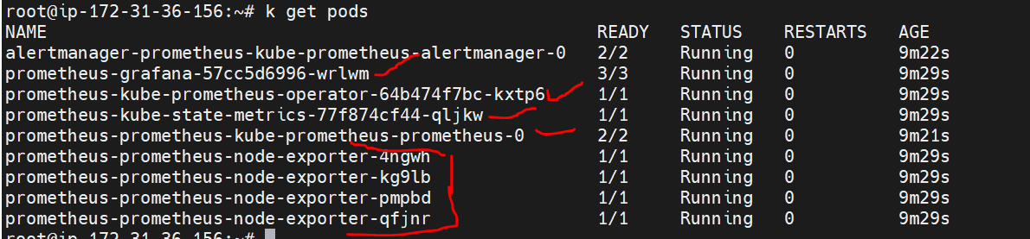

**What node exporter:**

Node exporter exports hardware and OS metrics for *NIX kernels. By default, Kubernetes does not expose node level monitoring metrics. To collect, monitoring metrics for Kubernetes nodes, we need Prometheus node exporter running on all nodes. It collects all the system monitoring metrics and expose them via /metrics web path on port 9100. It needs to be deployed as a Daemon set so that Kubernetes runs it on each and every cluster node.

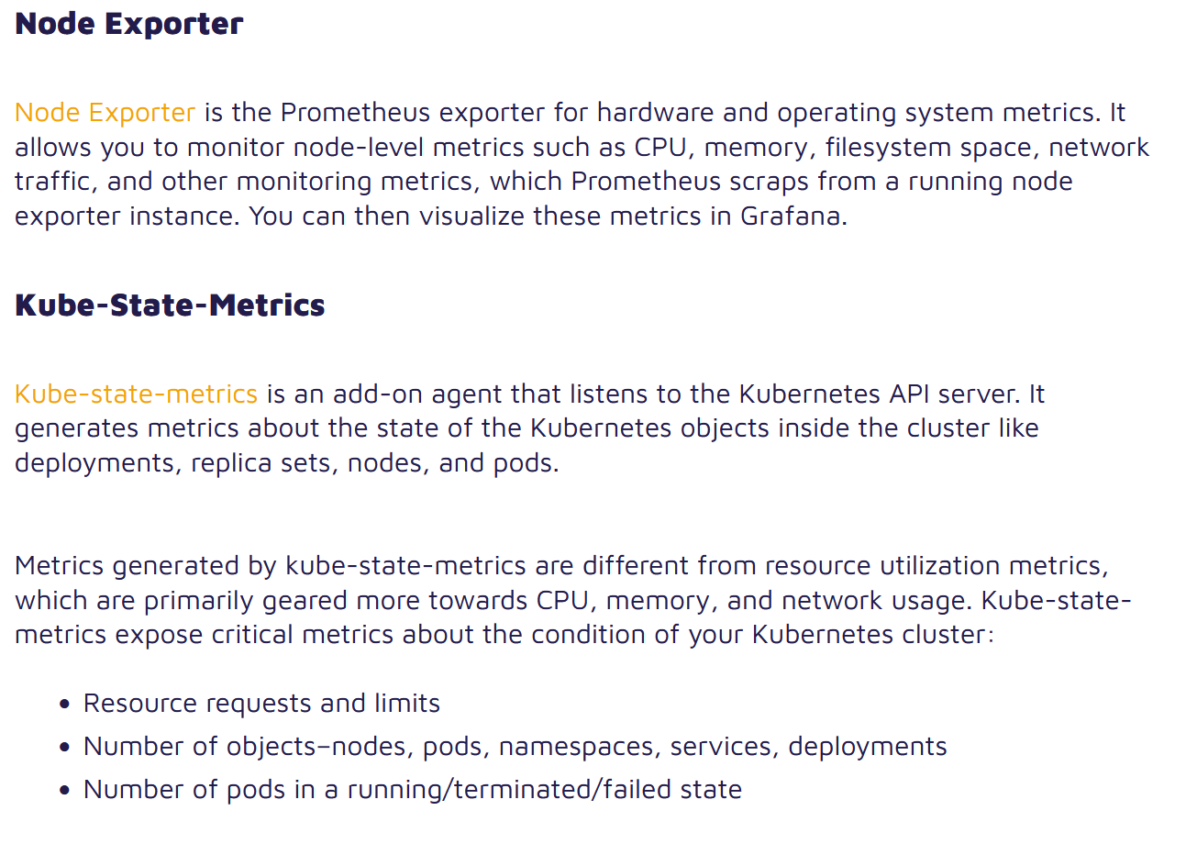

How to verify promethues daemons set:

#k get ds

NOTE: In SG allow the alltraffic for allow the incoming traffic.

Verify the services:

#k get svc

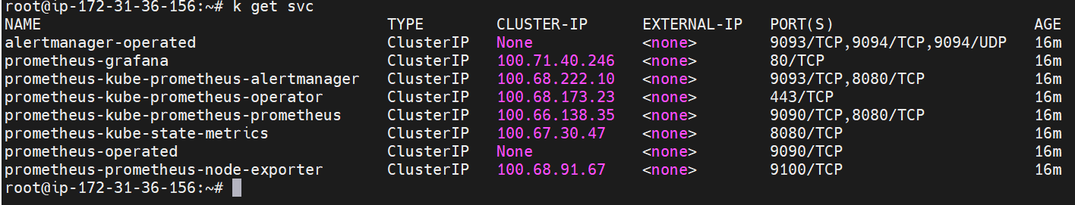

Verify in browser with nodeIP and port 9100

NOTE: for verification go to lens and add the cluster and verify.

**What is Lens:**

Lens is a Kubernetes-native integrated development environment (IDE) tool designed to simplify and streamline Kubernetes cluster management. It provides a graphical user interface (GUI) for interacting with and managing Kubernetes clusters, making it more accessible to developers and administrators.

Open lenscart🡪 file🡪 add cluster🡪 copy paste .kube/config file (cluster added)

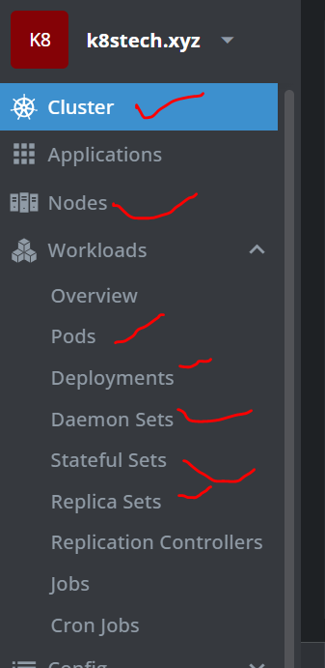

Port forward for access in local host:

Execute below command in lens terminal:

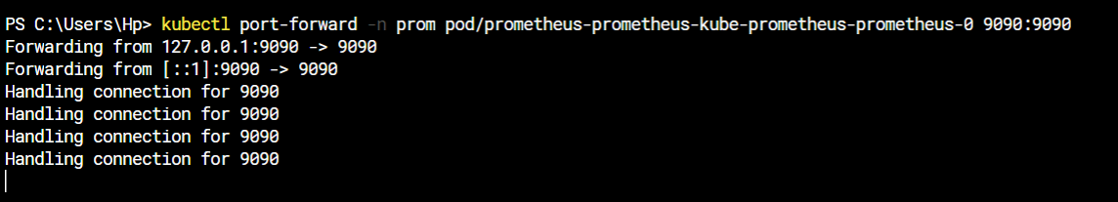

#kubectl port-forward -n prom pod/prometheus-prometheus-kube-prometheus-prometheus-0 9090:9090

Then go to browser : localhost:9090

You will see the details.

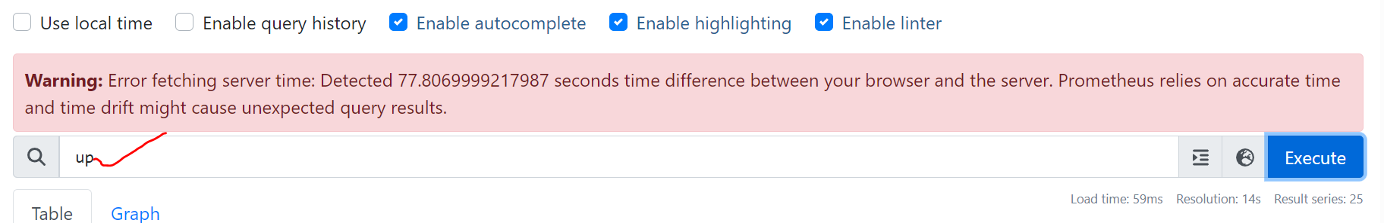

Give up and execute, will see the all nodes details like json format.

Here will check all the details like memory ram,Cpu….

**Grafanna:**

Grafana is an open-source analytics and monitoring platform that integrates with various data sources, including time-series databases, to help users visualize and understand their data. It is widely used for creating interactive and customizable dashboards, making it a popular tool for monitoring and observability.

Run below command in lens terminal for portforward:

#kubectl.exe port-forward -n prom pod/prometheus-grafana-57cc5d6996-wrlwm 3000

Got to browser: localhost:3000

Will see the grafanna dashboard.

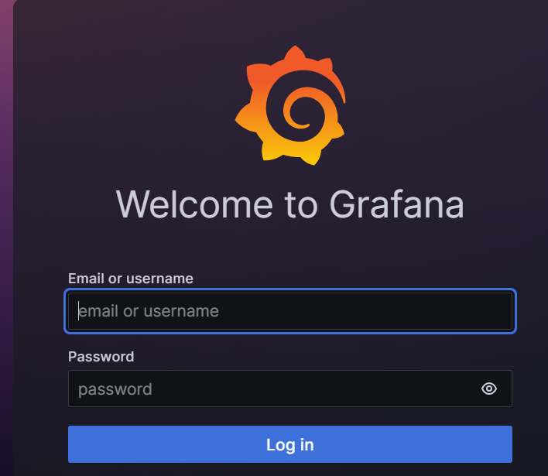

Username: admin

Password: prom-operator (without any spaces)

**How to collect any node logs:**

If my pod is deleted automatically all logs are deleted for that pod.

#ku logs <pod>

#ku logs <pod> --previous (see the previous logs as well)

**Logging: EFK**

EFK stands for Elasticsearch, Fluentd, and Kibana, which together form a popular open-source log management and analysis stack. Each component in the EFK stack serves a specific purpose in collecting, storing, and visualizing log data:

**Elasticsearch:**

Role: Elasticsearch is a distributed, RESTful search and analytics engine. It is used as the storage backend for log data in the EFK stack.

Features:

Supports full-text search, real-time analytics, and complex querying.

Provides horizontal scalability, making it suitable for handling large volumes of log data.

**2.Fluentd:**

Role: Fluentd is an open-source data collector designed to unify the logging infrastructure. It collects, processes, and forwards log data to Elasticsearch for indexing.

Features:

Supports various input sources and output destinations, making it highly versatile.

Enables log enrichment and transformation before sending data to Elasticsearch.

Acts as a log shipper, collecting logs from various sources such as application containers, system logs, and more.

**3.Kibana:**

Role: Kibana is a web-based user interface that allows users to visualize and explore log data stored in Elasticsearch. It provides a powerful and intuitive interface for log analysis and monitoring.

**Features**:

Offers real-time visualization of log data through charts, graphs, and dashboards.

Supports ad-hoc querying and filtering of log events.

Enables the creation of custom dashboards for specific use cases.

The EFK stack is commonly used in containerized environments, such as Kubernetes, to manage and analyze log data generated by applications and infrastructure components. Here's a typical flow within the EFK stack:

Fluentd Collects Logs:

Fluentd collects logs from various sources, including application containers, and enriches or transforms the log data if necessary.

Fluentd Forwards Logs to Elasticsearch:

Fluentd forwards the processed log data to Elasticsearch for indexing and storage.

Kibana Visualizes Logs:

Kibana retrieves log data from Elasticsearch and provides a user interface for users to visualize, search, and analyze the logs through dashboards and visualizations.

Create one NS:

# ku create ns kube-logging

What is the advantages of statefull sets:

Pod names comes with series, If delete any pod the new pod will recreate with same name (ip address pick random), bu tin deployment or recreate it will not like that , will create random name.

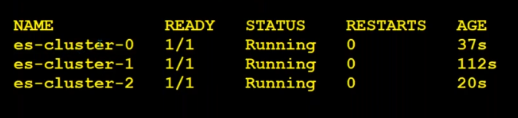

**v-16 Helm-Customize**

==================================================================================================

**17-v EKS-with Jenkins Integration**

Create one server with t2.large

Create one IAM user🡪 with accesskey and security key

Install AWS Cli in Jenkins server

apt-get update

#aws s3 ls

# curl "https://awscli.amazonaws.com/awscli-exe-linux-x86_64.zip" -o "awscliv2.zip"

# ls -la

# apt install unzip

# unzip awscliv2.zip

# sudo ./aws/install

# ./aws/install -i /usr/local/aws-cli -b /usr/local/bin

# aws --version

# aws s3 ls

**Then configure with IAM acces.**

#aws configure

# aws s3 ls

**Then download kubectl and Install :**

#curl -LO [https://storage.googleapis.com/kubernetes-release/release/$(curl -s https://storage.googleapis.com/kubernetes-release/release/stable.txt)/bin/linux/amd64/kubectl](https://storage.googleapis.com/kubernetes-release/release/$(curl%20-s%20https://storage.googleapis.com/kubernetes-release/release/stable.txt)/bin/linux/amd64/kubectl)

#sudo mv ./kubectl /usr/local/bin/kubectl

#chmod 777 /usr/local/bin/kubectl

#kubectl version

**Then download EKSCTL:**

#curl --silent --location "https://github.com/weaveworks/eksctl/releases/latest/download/eksctl_$(uname -s)_amd64.tar.gz" | tar xz -C /tmp

#sudo mv /tmp/eksctl /usr/local/bin

#sudo chmod 700 /usr/local/bin/eksctl

#eksctl version

**Creat EKS cluster:**

First deploy control plane node

#eksctl create cluster \

--name k8seks \

--version 1.26 \

--zones=ap-south-1a,ap-south-1b,ap-south-1c \

--without-nodegroup (it’s taking some time ) mean while install open jdk for Jenkins

#sudo apt install openjdk-11-jdk –y

Then install jenkins: url: [Linux (jenkins.io)](https://www.jenkins.io/doc/book/installing/linux/)

#sudo wget -O /usr/share/keyrings/jenkins-keyring.asc \

<https://pkg.jenkins.io/debian-stable/jenkins.io-2023.key>

#echo deb [signed-by=/usr/share/keyrings/jenkins-keyring.asc] \

https://pkg.jenkins.io/debian-stable binary/ | sudo tee \

/etc/apt/sources.list.d/jenkins.list > /dev/null

#sudo apt-get update -y

#sudo apt-get install jenkins –y

Afte installed the jenkins verify the version: #jenkins –version

Then Unlock the jenkins:

Go to ec2 jenkins server copy public DNS open in browser with port 8080 (need to open port in SG)

Then enter the password:

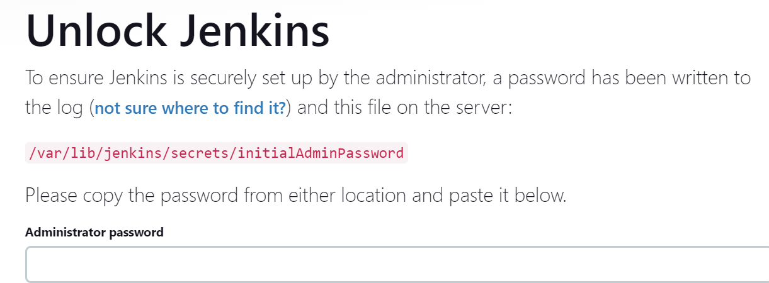

#cat /var/lib/jenkins/secrets/initialAdminPassword

Then install all plugins.

Then manage jenkins🡪 plugind🡪 aws (install ec2, pipeline)

Execute below command for control plane kubecfg file.

Then export kubecfg file in server:

# export KUBECONFIG=/root/.kube/config

export: This command is used in Unix-like operating systems to set environment variables. In this context, it's setting the environment variable KUBECONFIG.

KUBECONFIG: This environment variable is used by Kubernetes command-line tools (such as kubectl) to determine the location of the Kubernetes configuration file. The configuration file typically contains details about the Kubernetes cluster, including server endpoint, certificates, and authentication information.

/root/.kube/config: This is the path to the Kubernetes configuration file. The file is usually named config and resides in the .kube directory within the home directory of the user.

By setting KUBECONFIG to the specified file path, any subsequent kubectl commands will use the configuration from this file. This is particularly useful when dealing with multiple Kubernetes clusters, as it allows you to switch between configurations easily.

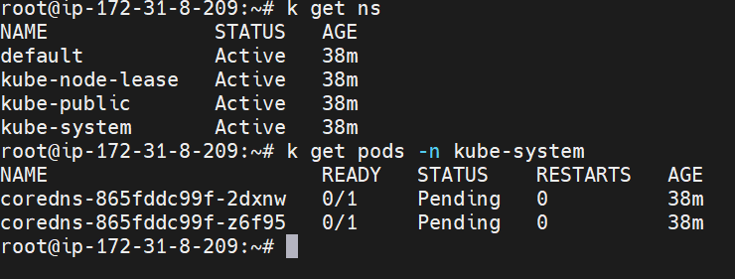

Here we cann’t seeall the system pods like managed cluster.

Then install utils: it’s not important

#eksctl utils associate-iam-oidc-provider \

--region ap-south-1 \

--cluster k8seks \

--approve

Now create Node Group:

Create SSH-key : #ssk-keygen

Then execute the below script for node-group

eksctl create nodegroup --cluster=k8seks\

 --region=ap-south-1 \

 --name=k8seks-cluster-ng-1 \

 --node-type=t2.medium \

 --nodes=2 \

 --nodes-min=2 \

 --nodes-max=3 \

 --node-volume-size=10 \

 --ssh-access \

 --ssh-public-key ~/.ssh/id_rsa.pub \

 --managed \

 --asg-access \

 --external-dns-access \

 --full-ecr-access \

 --appmesh-access \

 --alb-ingress-access

Worker nodes are created.

Verify in console and eks as well.

#k get pods –A

# k get all -n kube-system

# List EKS Clusters

eksctl get clusters

Capture Node Group name

eksctl get nodegroup --cluster=<clusterName>

# eksctl get nodegroup --cluster=k8seks

**Now set credentials with EKS:**

Jenkins🡪 manage plugins🡪 credentials🡪 system🡪 global🡪 add credentials🡪 kind🡪 aws credentials🡪

How to get my creds:

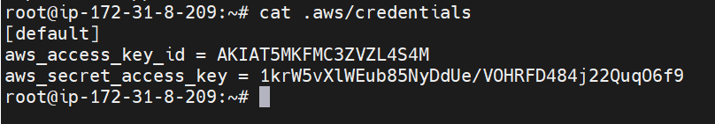

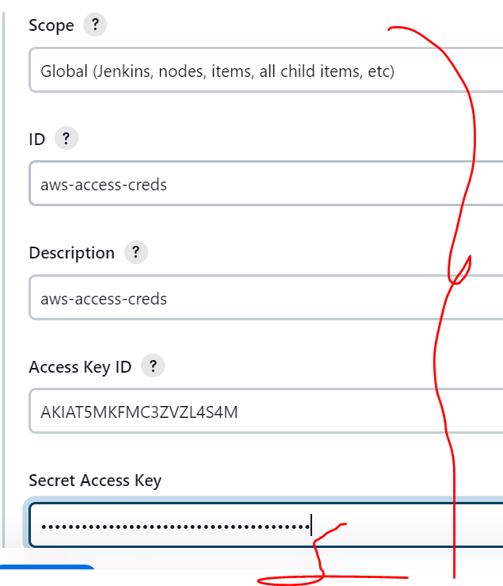

Integrate jenkins with eks:

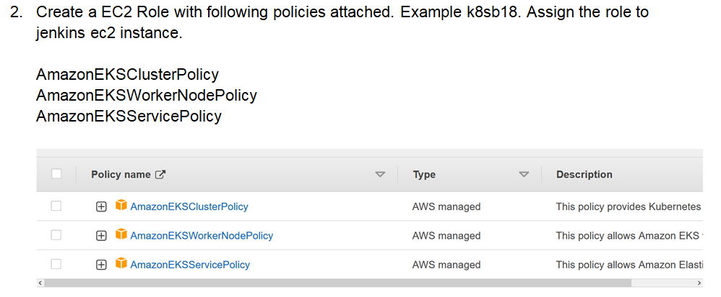

How to generate the Jenkins pipeline script:

Go to jenkins🡪 new item🡪 pipeline 🡪ok🡪 pipelinesyntax🡪 samplestep🡪 choose (with credentials : Bind creds to variables)🡪 generate pipeline (script generated).

How to delete nodegroup:

# Capture Node Group name

eksctl get nodegroup --cluster=<clusterName>

# Delete Node Group

#eksctl delete nodegroup --cluster=<clusterName> --name=<nodegroupName>

# Delete Cluster

#eksctl get clusters

eksctl delete cluster --name=<clusterName>

How to get api-resources:

#k api-resources